## Unit 4 Lesson 3: Addition and Subtraction with Tens

### WU How Many Do You See: Groups of 10 (Warm up)

#### Student Task Statement

How many do you see?  
How do you see them?

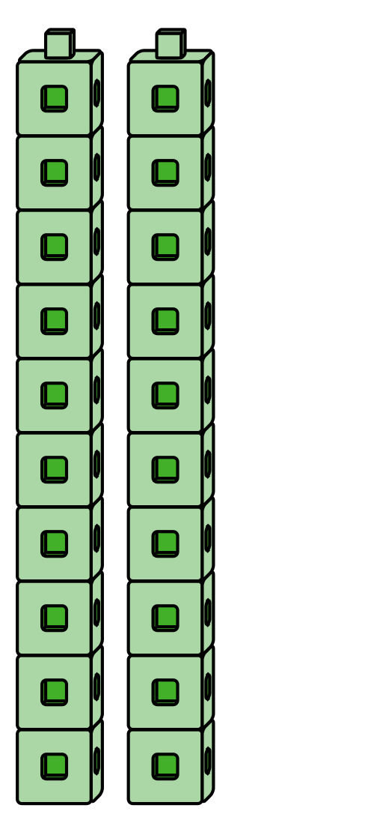

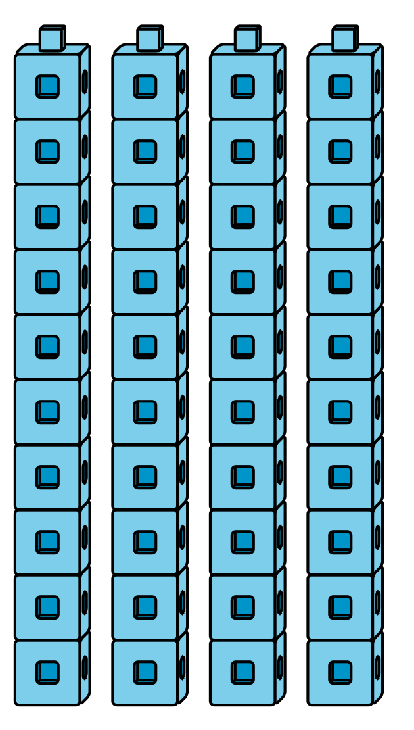

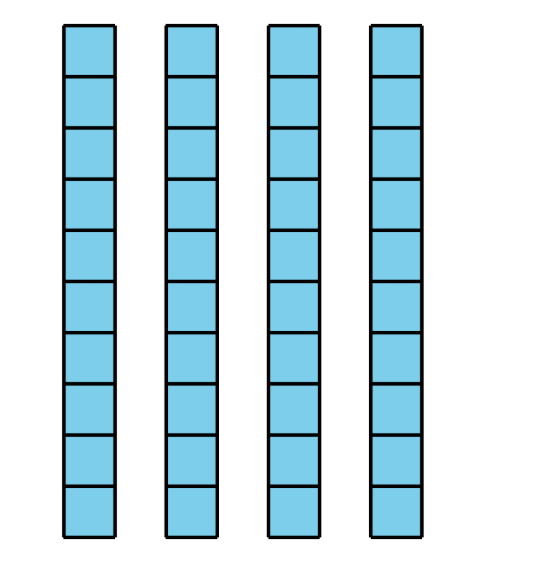

### 1 How Many Tens Now?

#### Student Task Statement

* 1. Show 1 ten.  
     Add a ten.  
     How many do you have now?
  2. Add another ten.  
     How many do you have now?  
     Show your thinking using drawings, numbers, or words.
  3. Add another ten.  
     How many do you have now?  
     Show your thinking using drawings, numbers, or words.
  4. Add another ten.  
     How many do you have now?  
     Show your thinking using drawings, numbers, or words.
  5. Add another ten.  
     How many do you have now?  
     Show your thinking using drawings, numbers, or words.
  6. Add another ten.  
     How many do you have now?  
     Show your thinking using drawings, numbers, or words.
  7. Add another ten.  
     How many do you have now?  
     Show your thinking using drawings, numbers, or words.
  8. Add another ten.  
     How many do you have now?  
     Show your thinking using drawings, numbers, or words.
  9. Show 9 tens  
     Take away a ten.  
     How many do you have now?  
     Show your thinking using drawings, numbers, or words.
  10. Take away another ten.  
      How many do you have now?  
      Show your thinking using drawings, numbers, or words.
  11. Take away another ten.  
      How many do you have now?  
      Show your thinking using drawings, numbers, or words.
  12. Take away another ten.  
      How many do you have now?  
      Show your thinking using drawings, numbers, or words.
  13. Take away another ten.  
      How many do you have now?  
      Show your thinking using drawings, numbers, or words.
  14. Take away another ten.  
      How many do you have now?  
      Show your thinking using drawings, numbers, or words.
  15. Take away another ten.  
      How many do you have now?  
      Show your thinking using drawings, numbers, or words.
  16. Take away another ten.  
      How many do you have now?  
      Show your thinking using drawings, numbers, or words.

### 2 Introduce Five in a Row, Add or Subtract 10

#### Student Task Statement

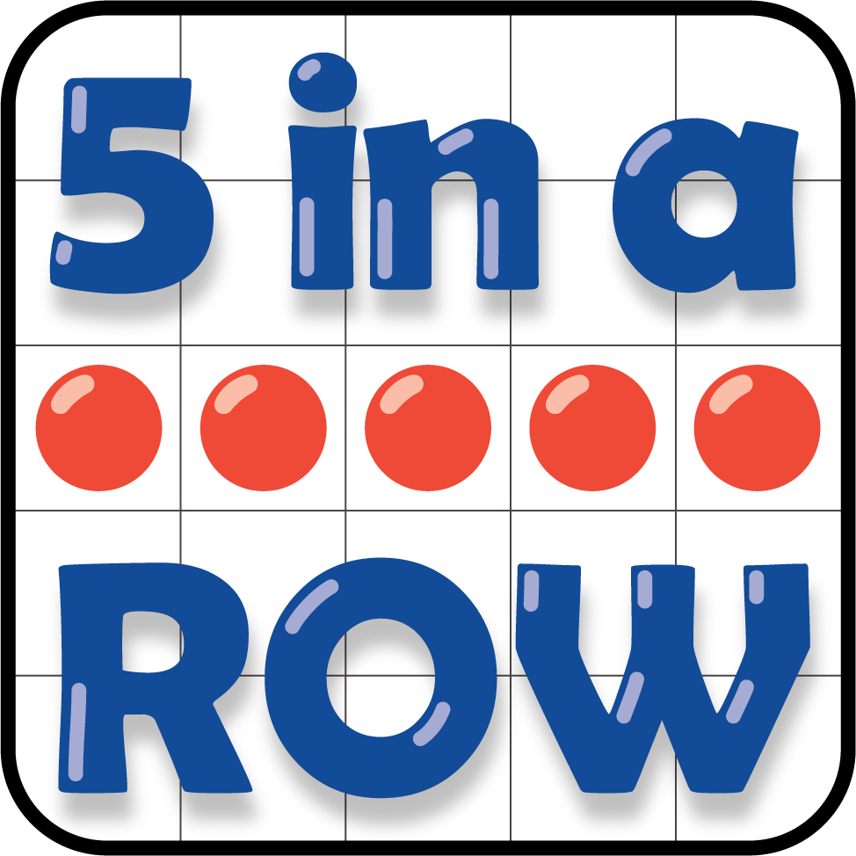

Record your favorite round.

Show your thinking using drawings, numbers, or words.

### 3 Centers: Choice Time

#### Student Task Statement

Choose a center.

Five in a Row



How Close?

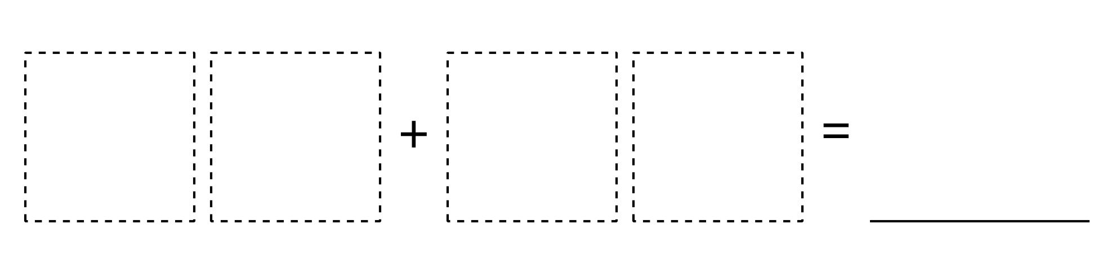

Number Puzzles

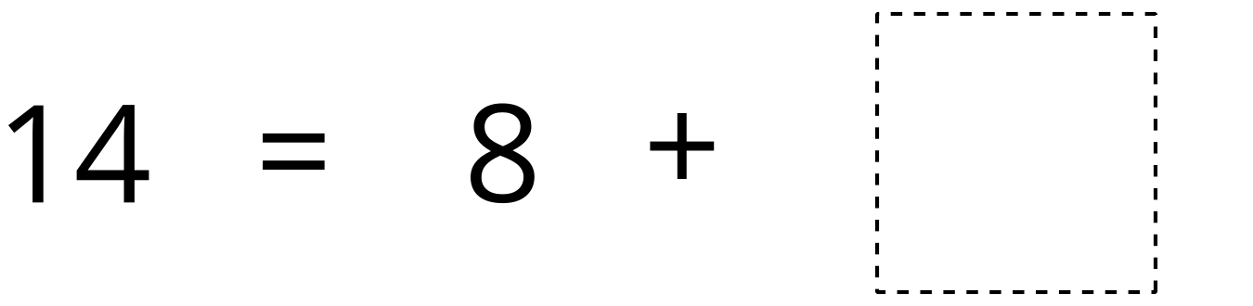



© CC BY 2021 Illustrative Mathematics®