Algebra 1
Unit 8Lesson 23CC BY NC 2024 Illustrative Mathematics®
Unit 8, Lesson 23

Using Quadratic Expressions in Vertex Form to Solve Problems
- Let’s find the maximum or minimum value of a quadratic function.
Algebra 1
Unit 8Lesson 23CC BY NC 2024 Illustrative Mathematics®

23.1Values of a Function
Here are graphs that represent two functions, $f$ and $g$, defined by these equations:
$f\left(x\right)={\left(x−4\right)}^{2}+1$
$g\left(x\right)=\text{-}{\left(x−12\right)}^{2}+7$
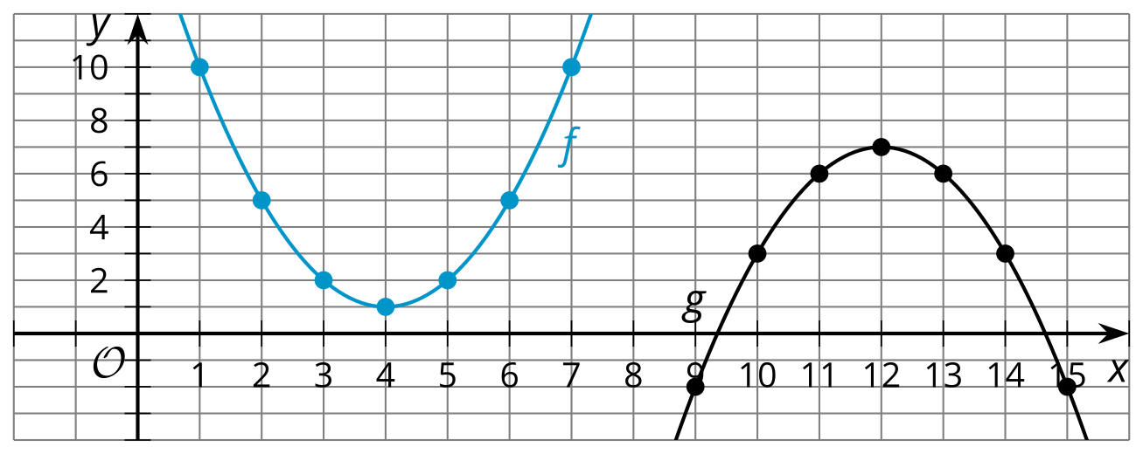
- $f\left(1\right)$ can be expressed in words as “the value of $f$ when $x$ is 1.” Find or compute:
  - the value of $f$ when $x$ is 1
  - $f\left(3\right)$
  - $f\left(10\right)$
- Does $f$ have a maximum, minimum, or neither? If it has a maximum or minimum, what is the greatest or least value $f\left(x\right)$ can have?
- $g\left(9\right)$ can be expressed in words as “the value of $g$ when $x$ is 9.” Find or compute:
  - the value of $g$ when $x$ is 9
  - $g\left(13\right)$
  - $g\left(2\right)$
- Does $g$ have a maximum, minimum, or neither? If it has a maximum or minimum, what is the greatest or least value $g\left(x\right)$ can have?
Algebra 1
Unit 8Lesson 23CC BY NC 2024 Illustrative Mathematics®

23.2Maximums and Minimums
- The graph that represents $p\left(x\right)={\left(x−8\right)}^{2}+1$ has its vertex at $\left(8,1\right)$. Here is one way to show, without graphing, that $\left(8,1\right)$ corresponds to the minimum value of $p$.
  - When $x=8$, the value of ${\left(x−8\right)}^{2}$ is 0, because ${\left(8−8\right)}^{2}=0^{2}=0$.
  - Squaring any nonzero number always results in a positive number, so when $x$ is any value other than 8, $\left(x−8\right)$ will be a number other than 0, and when the expression is squared, ${\left(x−8\right)}^{2}$, it will be positive.
  - Any positive number is greater than 0, so when $x≠8$, the value of ${\left(x−8\right)}^{2}$ will be greater than when $x=8$. In other words, $p$ has the least value when $x=8$.
- Use similar reasoning to explain why the point $\left(4,1\right)$ corresponds to the maximum value of $q$, defined by $q\left(x\right)=\text{-}2{\left(x−4\right)}^{2}+1$.
- Here are some quadratic functions and the coordinates of the vertex of the graph of each. Determine if the vertex corresponds to the maximum or the minimum value of the function. Be prepared to explain how you know.
equation | coordinates of  the vertex | maximum or minimum?
$f\left(x\right)=\text{-}{\left(x−4\right)}^{2}+6$ | $\left(4,6\right)$
$g\left(x\right)={\left(x+7\right)}^{2}−3$ | $\left(\text{-}7,\text{-}3\right)$
$h\left(x\right)=4{\left(x+5\right)}^{2}+7$ | $\left(\text{-}5,7\right)$
$k\left(x\right)=x^{2}−6x−3$ | $\left(3,\text{-}12\right)$
$m\left(x\right)=\text{-}x^{2}+8x$ | $\left(4,16\right)$

Are you ready for more?
Here is a portion of the graph of function $q$, defined by $q\left(x\right)=\text{-}x^{2}+14x−40$.
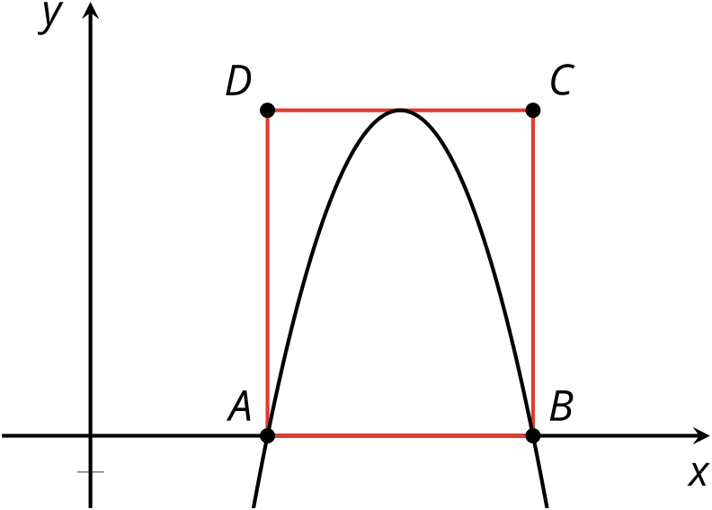
$ABCD$ is a rectangle. Points $A$ and $B$ coincide with the $x$-intercepts of the graph, and segment $CD$ just touches the vertex of the graph.
Find the area of $ABCD$. Show your reasoning.
Algebra 1
Unit 8Lesson 23CC BY NC 2024 Illustrative Mathematics®

23.3All the World’s a Stage
Function $A$, defined by $p\left(600−75p\right)$, describes the revenue collected from the sales of tickets for Performance A, a musical.
The graph represents a function, $B$, that models the revenue collected from the sales of tickets for Performance B, a Shakespearean comedy.
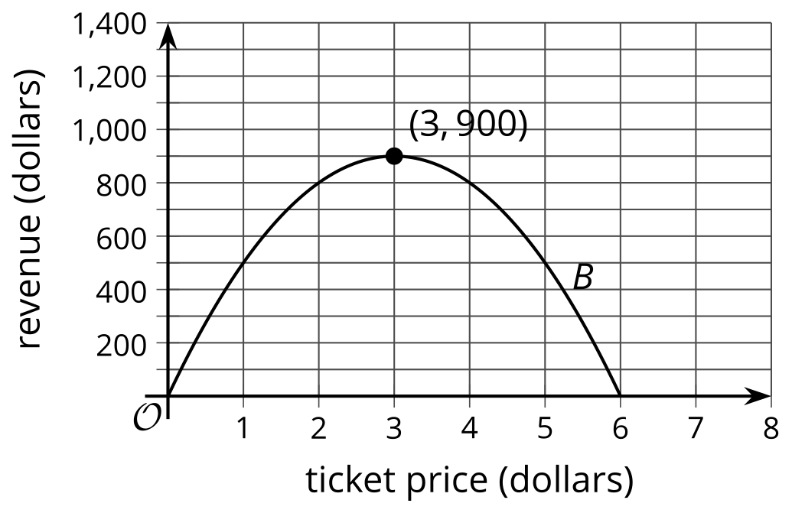
In both functions, $p$ represents the price of one ticket, and both revenues and prices are measured in dollars.
Without creating a graph of $A$, determine which performance gives the greater maximum revenue when tickets are $p$ dollars each. Explain or show your reasoning.

Lesson 23 Summary
Any quadratic function has either a maximum or a minimum value. We can tell whether a quadratic function has a maximum or a minimum by observing the vertex of its graph.
Here are graphs representing functions $f$ and $g$, defined by $f\left(x\right)=\text{-}{\left(x+5\right)}^{2}+4$ and $g\left(x\right)=x^{2}+6x−1$.
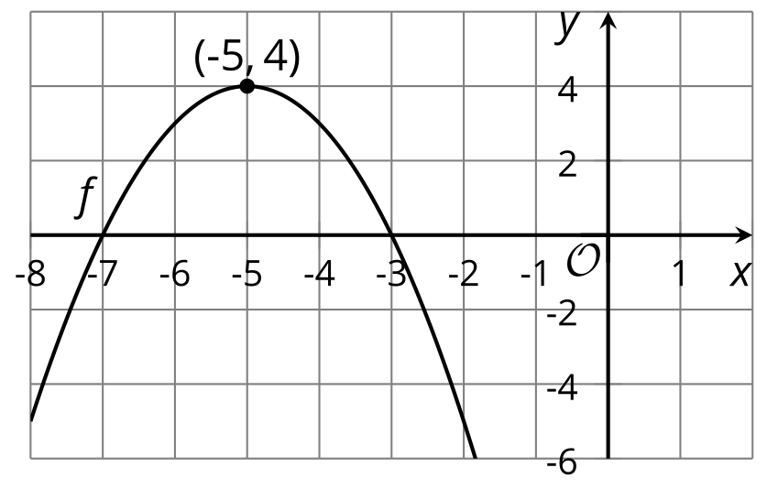
- The vertex of the graph of $f$ is $\left(\text{-}5,4\right)$, and the graph is a parabola that opens downward.
- No other points on the graph of $f$ (no matter how much we zoom out) are higher than $\left(\text{-}5,4\right)$, so we can say that $f$ has a maximum of 4, and that this occurs when $x=\text{-}5$.
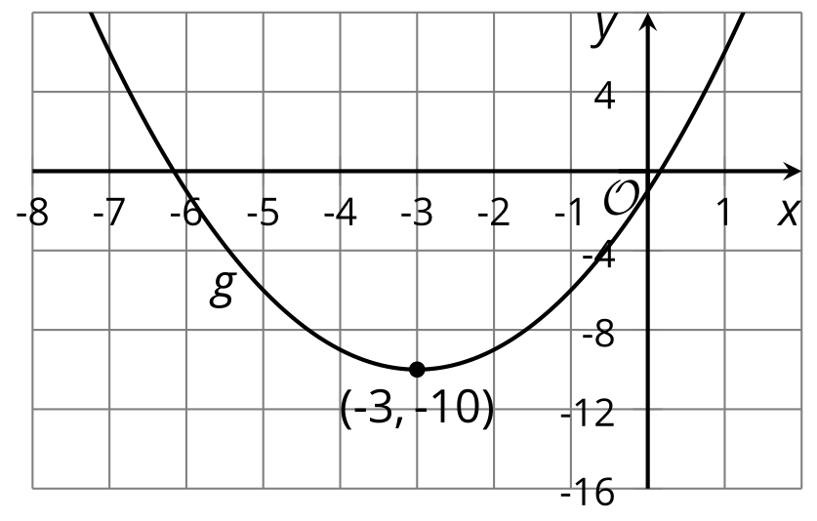
- The vertex of the graph of $g$ is at $\left(\text{-}3,\text{-}10\right)$, and the graph is a parabola that opens upward.
- No other points on the graph (no matter how much we zoom out) are lower than $\left(\text{-}3,\text{-}10\right)$, so we can say that $g$ has a minimum of -10, and that this occurs when $x=\text{-}3$.
We know that a quadratic expression in vertex form can reveal the vertex of the graph, so we don’t actually have to graph the expression. But how do we know, without graphing, if the vertex corresponds to a maximum or a minimum value of a function?
The vertex form can give us that information as well!
To see if $\left(\text{-}3,\text{-}10\right)$ is a minimum or maximum of $g$, we can rewrite $x^{2}+6x−1$ in vertex form, which is ${\left(x+3\right)}^{2}−10$. Let’s look at the squared term in ${\left(x+3\right)}^{2}−10$.
- When $x=\text{-}3$, $\left(x+3\right)$ is 0, so ${\left(x+3\right)}^{2}$ is also 0.
- When $x$ is not -3, the expression $\left(x+3\right)$ is a nonzero number, and ${\left(x+3\right)}^{2}$ is positive.
- Because a squared number cannot have a value less than 0, ${\left(x+3\right)}^{2}$ has the least value when $x=\text{-}3$.
To see if $\left(\text{-}5,4\right)$ is a minimum or maximum of $f$, let’s look at the squared term in $\text{-}{\left(x+5\right)}^{2}+4$.
- When $x=\text{-}5$, $\left(x+5\right)$ is 0, so ${\left(x+5\right)}^{2}$ is also 0.
- When $x$ is not -5, the expression $\left(x+5\right)$ is nonzero, so ${\left(x+5\right)}^{2}$ is positive. The expression $\text{-}{\left(x+5\right)}^{2}$ has a coefficient of -1, however. Multiplying ${\left(x+5\right)}^{2}$ (which is positive when $x≠\text{-}5$) by a negative number results in a negative number.
- Because a negative number is always less than 0, the value of $\text{-}{\left(x+5\right)}^{2}+4$ will always be less when $x≠\text{-}5$ than when $x=\text{-}5$. This means $x=\text{-}5$ gives the greatest value of $f$.

