Grade 2
Unit 7CC BY NC 2024 Illustrative Mathematics®

Unit 7 Family Support Materials

Adding and Subtracting within 1,000
In this unit, students use place-value understanding, the relationship between addition and subtraction, and the properties of operations to add and subtract within 1,000.

Section A: Add and Subtract within 1,000, without Composition or Decomposition
In this section, students add and subtract within 1,000, using strategies that do not involve making or breaking apart a ten or a hundred. The number line helps students recognize that when numbers are relatively close, they can count on or count back to calculate the difference.
For example, students notice that $562−559$ is easier to solve by counting on from 559 to 562 than by using a formal procedure to subtract.
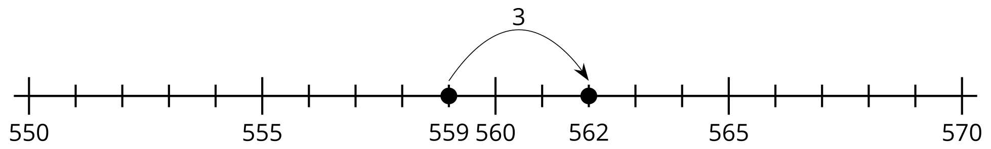
Students then engage in problems that encourage them to use the relationship between addition and subtraction to reason about sums and differences. They analyze and connect methods that use number lines, base-ten diagrams, and equations. They calculate sums and differences, using methods that make sense to them.

Section B: Add within 1,000, Using Place-Value Strategies
This section introduces the idea that when adding three-digit numbers, composing (making) a hundred from 10 tens is sometimes necessary. Students begin the section, with sums that allow them to decide when to compose a ten (for example $414+28$). They then work with greater values in the tens place and determine whether to compose a hundred (for example, $736+91$). As the section progresses, students compose two units to find sums, using place-value strategies, and experience adding two- and three-digit numbers to three-digit numbers (for example, $149+282$). Throughout the section, students use base-ten blocks, base-ten diagrams, expanded form, and other equations to build conceptual understanding and show place-value reasoning.
Priya and Lin were asked to find the value of $358+67$.
What do you notice about their work?
Priya’s Work
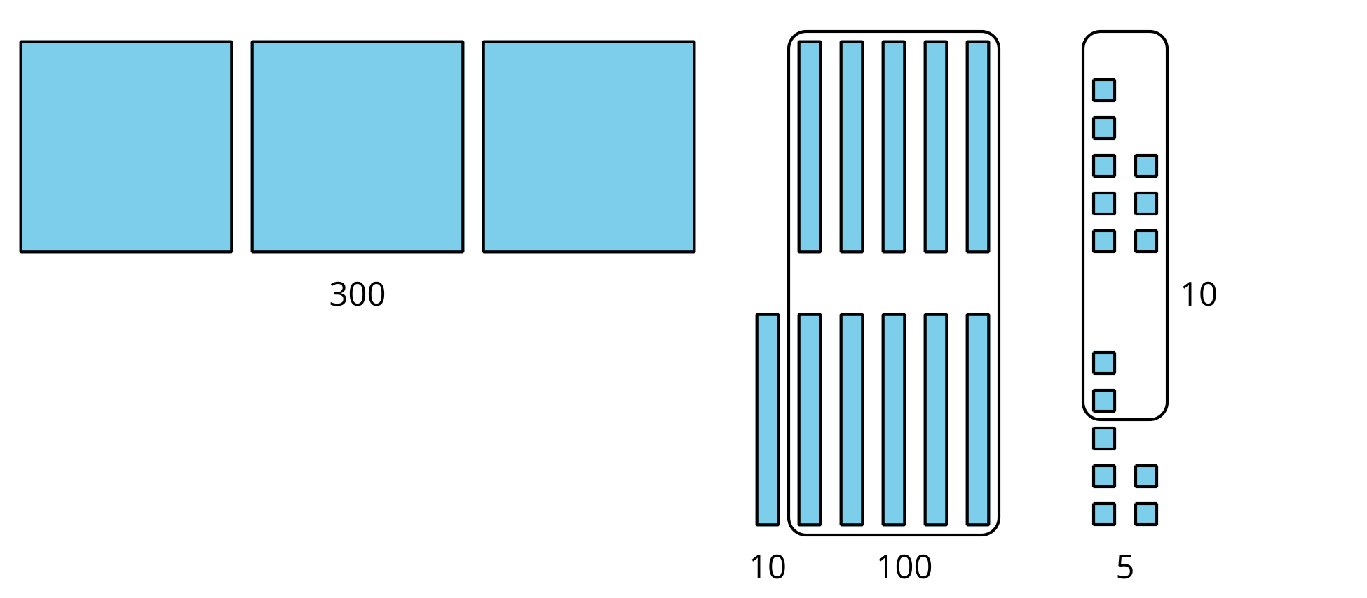
$300+100+10+10+5$
$400+20+5=425$
Lin’s Work
3 hundreds $+$ 11 tens $+$ 15 ones
11 tens $=$ 110
15 ones $=$ 15
$300+110+15=425$

Section C: Subtract within 1,000, Using Place-Value Strategies
Similar to their work in the previous section, students subtract numbers within 1,000, using place-value strategies that involve decomposing (breaking apart) a ten, a hundred, or both. As they subtract by place, hundreds from hundreds, tens from tens, and ones from ones, students exchange a ten for 10 ones or a hundred for 10 tens, as needed.
For example, this is a helpful way to represent 244 if you need to subtract a number with more than 4 ones:
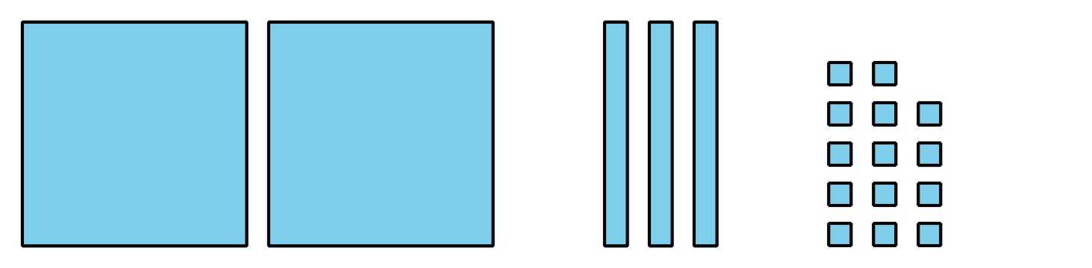
Throughout the section, students compare the steps they use when they decompose, as well as the different ways they can represent and record the units they decompose.

Try it at home!
Near the end of the unit, ask your second grader to do these problems:
- $361+294$
- $421−203$
Questions that may be helpful as they work:
- Do you need to compose (put together) or decompose (break apart) any tens or hundreds?
- Can you show your thinking with a diagram?
- Is there another way to solve this problem?
Solution:
- 655
- 218
Sample response:
- Yes, I needed to compose a hundred when I added 361 and 294. I needed to decompose a ten when I subtracted 203 from 421.
- A number line or a base-ten diagram that represents solving the addition or subtraction expression.
- Yes, I can solve by using place value, by drawing base-ten blocks, or by using a number line.

