Lesson 1: Finding Unknown Inputs
- Let’s find some new equations to solve.

1.1: What Goes Up Must Come Down
A mechanical device is used to launch a potato vertically into the air. The potato is launched from a platform 20 feet above the ground, with an initial vertical velocity of 92 feet per second.
The function $h\left(t\right)=\text{-}16t^{2}+92t+20$ models the height of the potato over the ground, in feet, $t$ seconds after launch.
Here is the graph representing the function.
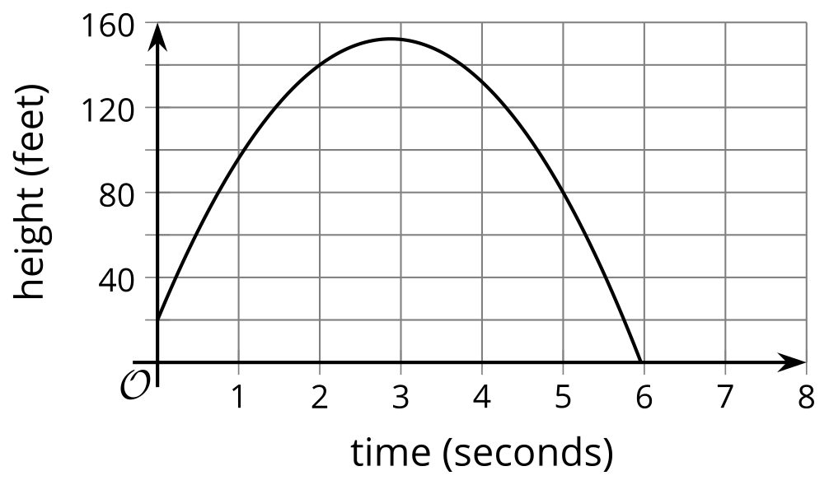
For each question, be prepared to explain your reasoning.
- What is the height of the potato 1 second after launch?
- 8 seconds after launch, will the potato still be in the air?
- Will the potato reach 120 feet? If so, when will it happen?
- When will the potato hit the ground?

1.2: A Trip to the Frame Shop
Your teacher will give you a picture that is 7 inches by 4 inches, a piece of framing material measuring 4 inches by 2.5 inches, and a pair of scissors.
Cut the framing material to create a rectangular frame for the picture. The frame should have the same thickness all the way around and have no overlaps. All of the framing material should be used (with no leftover pieces). Framing material is very expensive!
You get 3 copies of the framing material, in case you make mistakes and need to recut.

Are you ready for more?
Han says, “The perimeter of the picture is 22 inches. If I cut the framing material into 9 pieces, each one being 2.5 inches by $\frac{4}{9}$ inch, I’ll have more than enough material to surround the picture because those pieces would mean 22.5 inches for the frame.”
Do you agree with Han? Explain your reasoning.

1.3: Representing the Framing Problem
Here is a diagram that shows the picture with a frame that is the same thickness all the way around. The picture is 7 inches by 4 inches. The frame is created from 10 square inches of framing material (in the form of a rectangle measuring 4 inches by 2.5 inches).

- Write an equation to represent the relationship between the measurements of the picture and of the frame, and the area of the framed picture. Be prepared to explain what each part of your equation represents.
- What would a solution to this equation mean in this situation?

Lesson 1 Summary
The height of a softball, in feet, $t$ seconds after someone throws it straight up, can be defined by $f\left(t\right)=\text{-}16t^{2}+32t+5$. The input of function $f$ is time, and the output is height.
We can find the output of this function at any given input. For instance:
- At the beginning of the softball's journey, when $t=0$, its height is given by $f\left(0\right)$.
- Two seconds later, when $t=2$, its height is given by $f\left(2\right)$.
The values of $f\left(0\right)$ and $f\left(2\right)$ can be found using a graph or by evaluating the expression $\text{-}16t^{2}+32t+5$ at those values of $t$.
What if we know the output of the function and want to find the inputs? For example:
- When does the softball hit the ground?
- Answering this question means finding the values of $t$ that make $f\left(t\right)=0$, or solving $\text{-}16t^{2}+32t+5=0$.
- How long will it take the ball to reach 8 feet?
- This means finding one or more values of $t$ that make $f\left(t\right)=8$, or solving the equation $\text{-}16t^{2}+32t+5=8$.
The equations $\text{-}16t^{2}+32t+5=0$ and $\text{-}16t^{2}+32t+5=8$ are quadratic equations. One way to solve these equations is by graphing $y=f\left(t\right)$.
- To answer the first question, we can look for the horizontal intercepts of the graph, where the vertical coordinate is 0.
- To answer the second question, we can look for the horizontal coordinates that correspond to a vertical coordinate of 8.
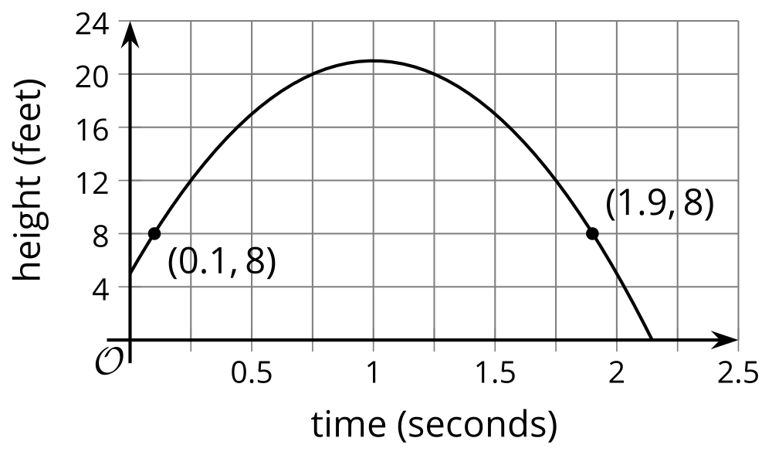
We can see that there are two solutions to the equation $\text{-}16t^{2}+32t+5=8$.
The softball has a height of 8 feet twice, when going up and when coming down, and these occur when $t$ is about 0.1 or 1.9.
Often, when we are modeling a situation mathematically, an approximate solution is good enough. Sometimes, however, we would like to know exact solutions, and it may not be possible to find them using a graph.
In this unit, we will learn more about quadratic equations and how to solve them exactly using algebraic techniques.
© CC BY 2019 by Illustrative Mathematics®

