Lesson 10: Dibujos, situaciones y diagramas, ¡oh, vaya!

Standards Alignments
Addressing | 3.OA.A, 3.OA.A.1
Building Towards | 3.OA.A.1

Teacher-facing Learning Goals
- Interpret a situation involving equal groups and represent it with a diagram.
- Make sense of tape diagrams that represent multiplication.

Student-facing Learning Goals
- Representemos grupos iguales.

Lesson Purpose
The purpose of this lesson is for students to connect situations involving equal groups to tape diagrams.
This lesson introduces tape diagrams as a way to represent equal groups and multiplication, building on students' work with scaled picture graphs and discrete drawings of equal groups. Students deepen their understanding of multiplication as they connect tape diagrams to situations that involve equal groups. They are then introduced to multiplication expressions as a way to represent the quantities and situations encountered in the lesson. This happens at the end to allow students to work with other representations of multiplication before they learn about abstract symbols that represent multiplication.

Access for:

Students with Disabilities
- Engagement (Activity 2)

English Learners
- MLR8 (Activity 1)

Instructional Routines
Card Sort (Activity 2), Notice and Wonder (Warm-up)

Materials to Copy
- Card Sort Equal Groups, Spanish (groups of 2): Activity 2

Lesson Timeline
Warm-up | 10 min
Activity 1 | 15 min
Activity 2 | 20 min
Lesson Synthesis | 10 min
Cool-down | 5 min

Teacher Reflection Question
How did connecting different representations of multiplication during the card sort support students in developing their understanding of multiplication?

Cool-down
(to be completed at the end of the lesson) 5min
Cajas de camisas

Standards Alignments
Addressing | 3.OA.A

Student-facing Task Statement
En la tienda hay 4 cajas. En cada caja hay 10 camisas.
¿Este diagrama corresponde a la situación? Explica tu razonamiento.
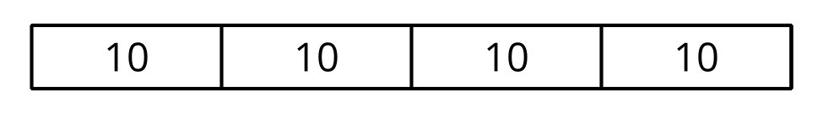

Student Responses
Yes, because the 4 parts represent the 4 boxes and the 10 in each part represents the 10 shirts in each box.

