Unit 1 Lesson 4: The Shape of Distributions

1 Which One Doesn’t Belong: Distribution Shape (Warm up)

Student Task Statement
Which one doesn’t belong?

A.
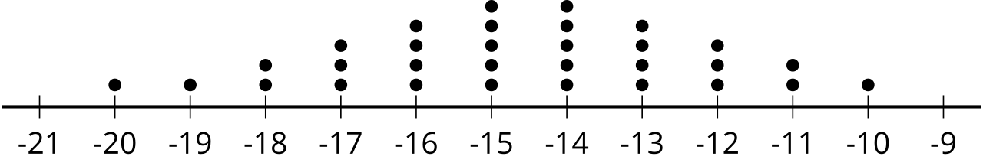

B.
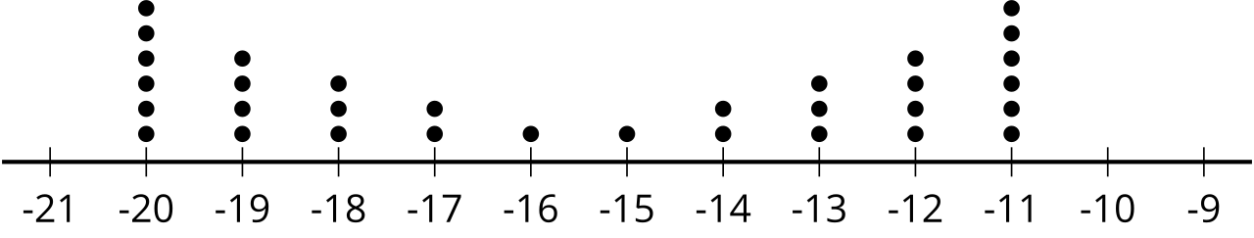

C.
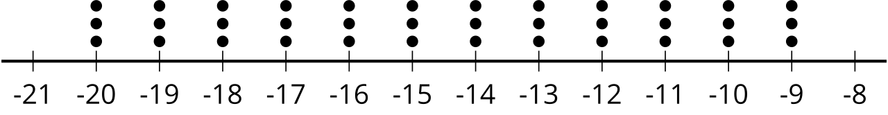

D.
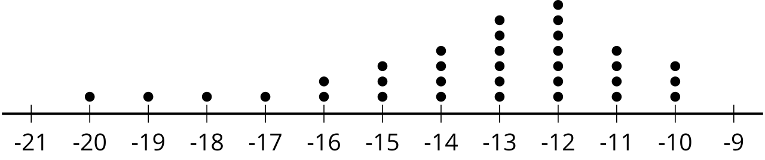

2 Matching Distributions

Images for Launch
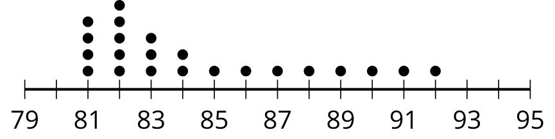
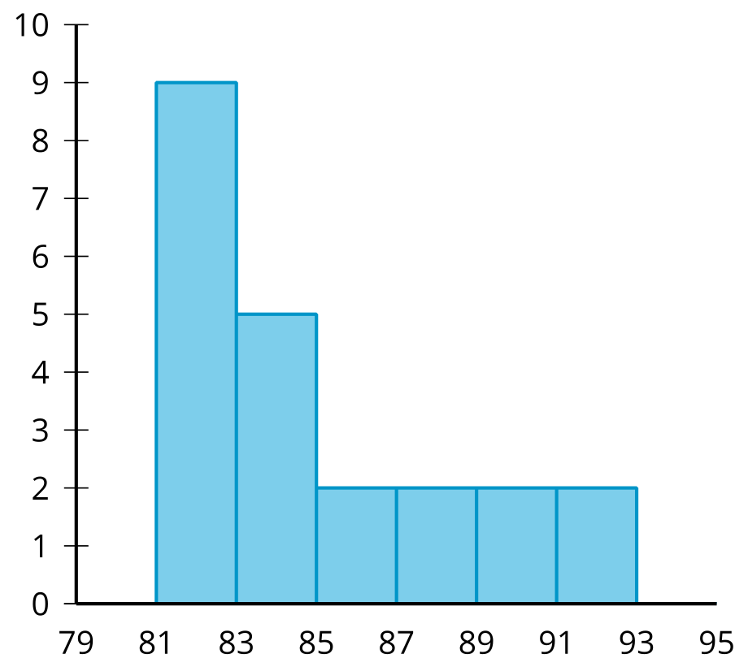

Student Task Statement
Take turns with your partner matching 2 different data displays that represent the distribution of the same set of data.
- For each set that you find, explain to your partner how you know it’s a match.
- For each set that your partner finds, listen carefully to their explanation. If you disagree, discuss your thinking and work to reach an agreement.
- When finished with all ten matches, describe the shape of each distribution.

3 Where Did The Distribution Come From?

Student Task Statement
Your teacher will assign you some of the matched distributions. Using the information provided in the data displays, make an educated guess about the survey question that produced this data. Be prepared to share your reasoning.
© CC BY 2019 by Illustrative Mathematics®

