Unit 6 Lesson 18: Modeling Circular Motion

1 Comparing Bikes (Warm up)

Student Task Statement
Each graph shows the vertical position $v$, in inches, of a point on the outside of a bike wheel, $s$ seconds after the wheel begins to spin.
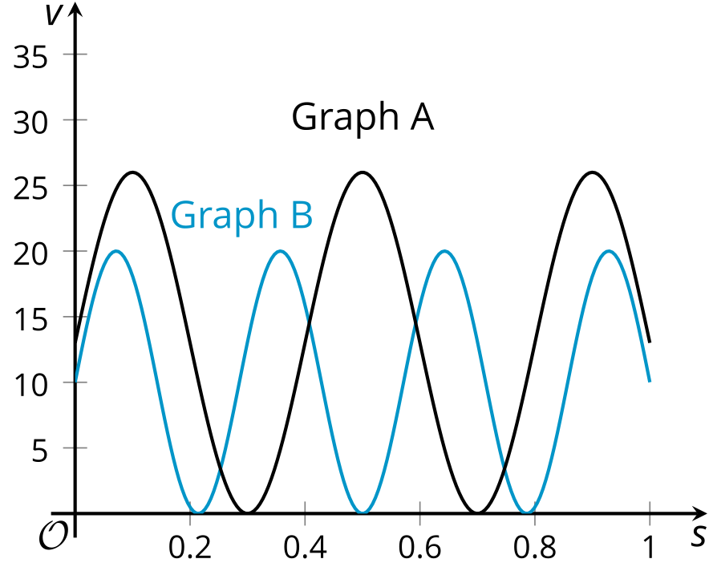
- Which bike has larger wheels? Explain how you know.
- Which bike’s wheels are spinning faster? Explain how you know.

2 Around a Carousel

Student Task Statement

Jada, Noah, and Elena are riding a carousel. Here is a view, from above, of the carousel.
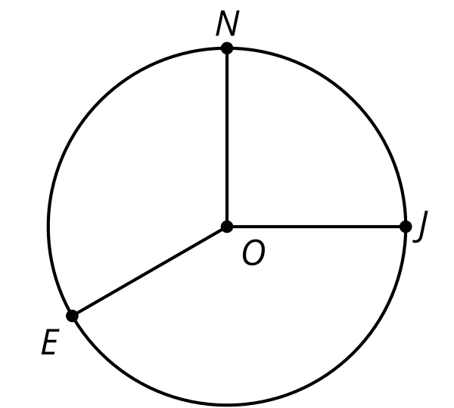
The carousel moves in a counterclockwise direction. When the ride begins, Jada is at position $J$, Noah is at position $N$, and Elena is at position $E$. The measure of angle $JON$ is $\frac{π}{2}$ and the measure of angle $NOE$ is $\frac{2π}{3}$.
- The radius of the carousel is 20 feet. How far does Jada travel to reach Noah’s starting position? What about Elena’s starting position? Explain or show how you know.
- The carousel makes 1 complete rotation every 10 seconds. At which times will Jada be at her starting position? At which times will she be at Noah's starting position? Explain or show how you know.
- The carousel ride lasts for 3.25 minutes. Where will Elena be when the ride ends? How far will she have traveled? Explain or show how you know.

3 Modeling the Carousel Motion

Student Task Statement
Jada begins the carousel ride at point $J$ and Noah begins the ride at point $N$. The radius of the carousel is 20 feet and it rotates in a counterclockwise direction, making one complete rotation every 10 seconds.
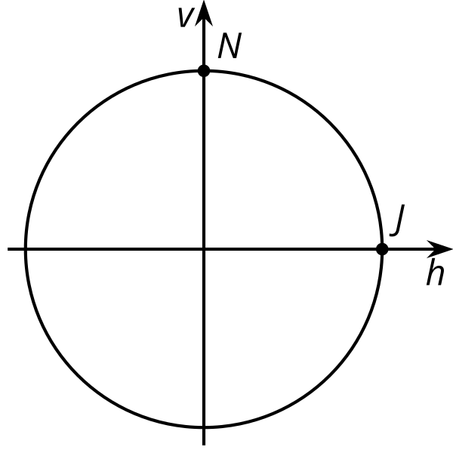

  - Write an equation describing the horizontal coordinate of Jada’s location as a function of time relative to the center of the carousel. Make sure to indicate the units of your variables.
  - Sketch a graph of your function.
  - 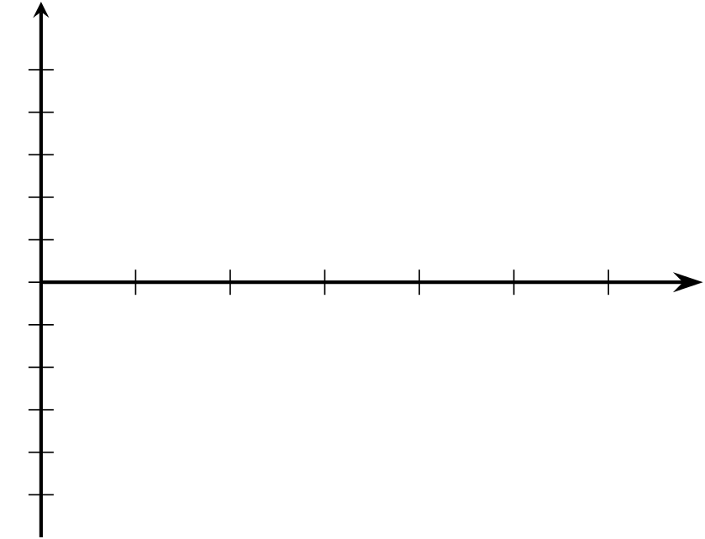
  - What does the graph tell you about Jada’s location during the carousel ride?

  - Write an equation describing the vertical coordinate of Noah’s location as a function of time relative to the center of the carousel. Make sure to indicate the units of your variables.
  - Sketch a graph of your function.
  - What does the graph tell you about Noah’s location during the carousel ride?
© CC BY 2019 by Illustrative Mathematics®

