Unit 5 Lesson 7: Non-unit Fractions on the Number Line

WU Choral Count: One-fourths (Warm up)

Student Task Statement

1 Number Line Scoot

Student Task Statement

2 Fractions on the Number Line

Student Task Statement
- Locate and label $\frac{3}{4}$ and $\frac{6}{4}$.
- Locate and label $\frac{7}{8}$ and $\frac{12}{8}$.
- Locate and label $\frac{2}{3}$ and $\frac{4}{3}$.
- Locate and label $\frac{2}{6}$ and $\frac{7}{6}$.
- How did you partition the number line when you were locating the numbers $\frac{7}{8}$ and $\frac{12}{8}$? Explain your reasoning.
- What patterns did you notice in the fractions you located?

3 What’s the Fraction?

Student Task Statement
- Partition the number line into any number of equal-size parts. Locate and mark, but don’t label, a fraction of your choice.
- Trade number lines with a partner.
  - How did your partner partition their number line?
  - What number did your partner mark on their number line? Explain your reasoning.
If you have time, play the game again.


Images for Activity Synthesis
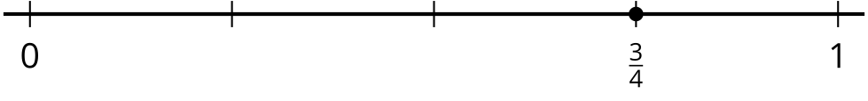
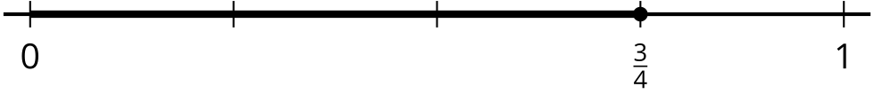
© CC BY 2021 Illustrative Mathematics®

