Grade 2
Unit 9CC BY NC 2024 Illustrative Mathematics®

Unit 9 Family Support Materials

Putting It All Together
Students put together their understanding from throughout the year to cap off the major work and fluency goals of the grade.

Section A: Fluency Within 20
Students develop fluency with addition and subtraction within 20. Requirements of grade 2 include fluency with all sums and differences within 20, and knowing, from memory, all sums of 2 one-digit numbers. When students encounter addition and subtraction expressions that they do not recognize, they use mental-math strategies and other methods that they have learned throughout the year. They may use facts that they know, make equivalent expressions, or compose or decompose a number to make a ten.
Students continue to apply mental-math strategies as they find sums and differences within 20, in a measurement context. They measure lengths, with standard units, and create line plots, and then use the measurements to add and subtract.
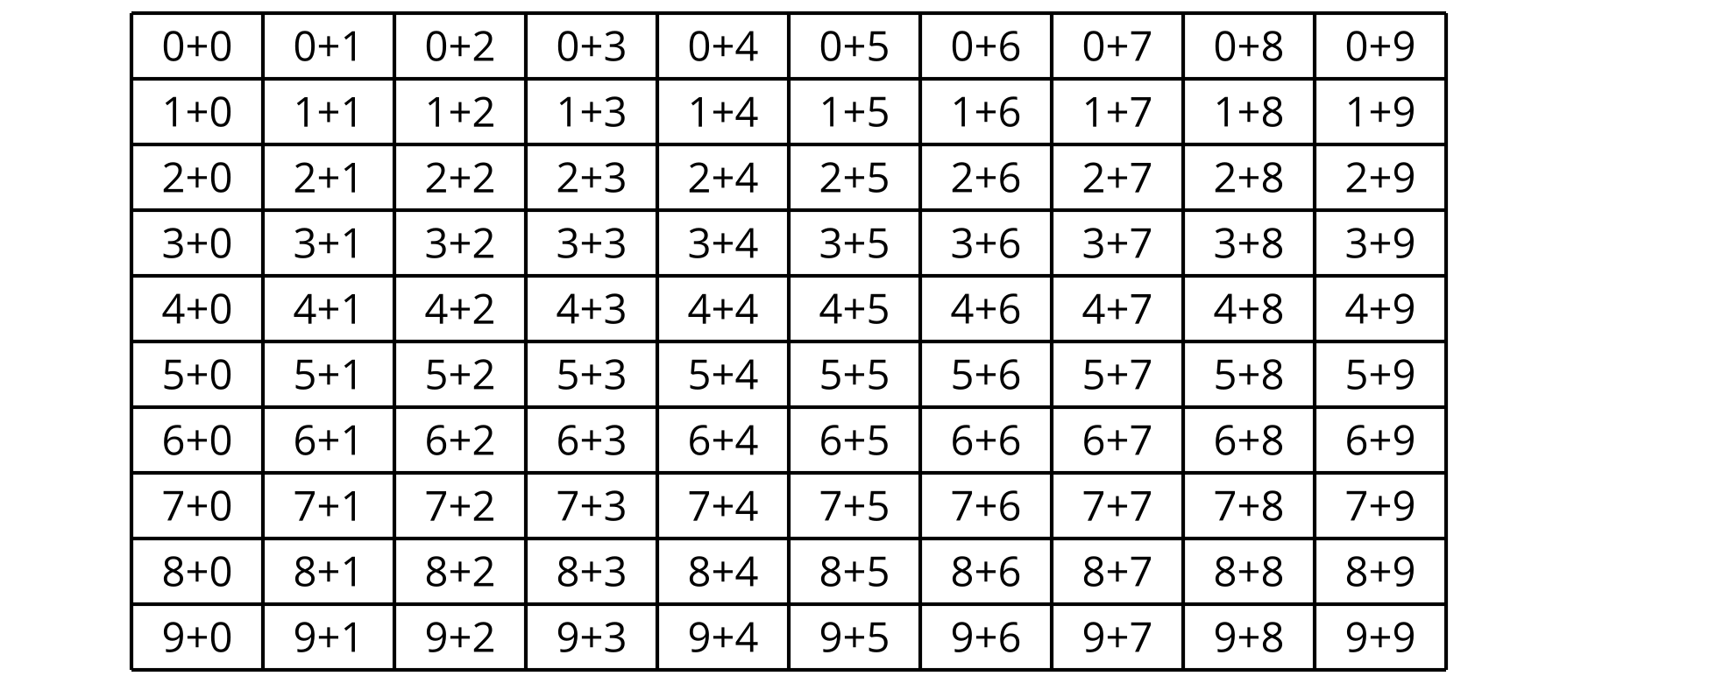

Section B: Numbers to 1,000
Students revisit numbers within 1,000, and focus on developing fluency with addition and subtraction within 100. They develop and show their understanding of place value and operations, with greater numbers that may require composing or decomposing multiple units, before focusing on fluency practice with numbers within 100.
Students practice decomposing and composing three-digit numbers in multiple ways, using base-ten blocks, base-ten diagrams, words, and symbols. They also compose and decompose units as they match and create equivalent expressions for three-digit numbers. Students practice addition and subtraction within 1,000, and reason about which sums and differences are more or less difficult to solve.
263
$2\text{ hundreds}+4\text{ tens}+23\text{ ones}$
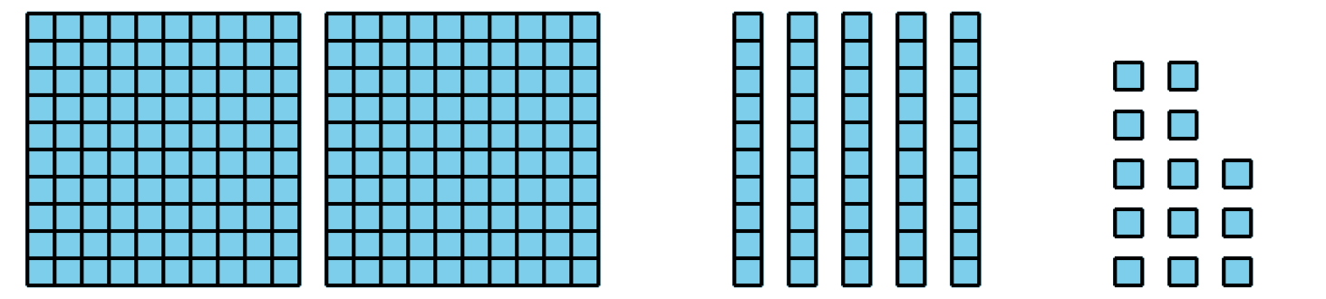

Section C: Create and Solve Story Problems
Students create and solve one- and two-step story problems, with the unknown in all positions, discuss how they made sense of the problem, and share the strategies they used to solve.
At this point in the year, students should be able to solve all types of story problems within 100, using a representation that makes sense to them. They make connections across representations, focusing on tape diagrams and equations. They analyze stories and determine the types of questions that could be asked, based on the provided information, in preparation for writing their own story problems, based on images and their own experiences. The lessons offer space for students to apply their fluency with addition and subtraction within 100, as they engage with the story problems in this section.
How many books in all?
$33+18=?$
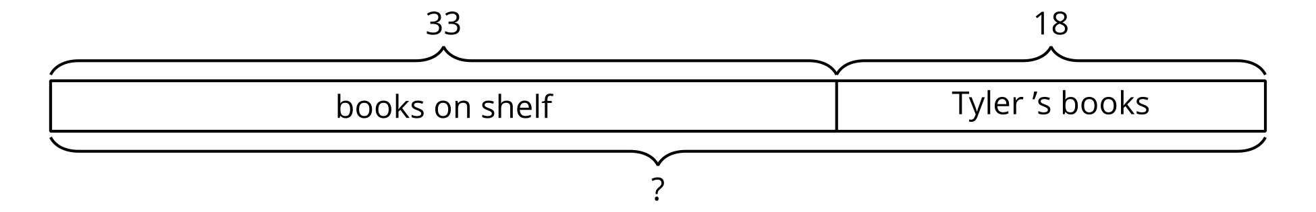

Try it at home!
Near the end of the unit, ask your second grader:
- Using our favorite objects from home, let’s make different types of story problems.
- What kinds of questions can you ask?
Questions that may be helpful as they work:
- What part of the story problem are we trying to find out? How could we solve the problem?
- How could you represent the problem with a diagram?
Solution: Answers may vary.
Sample response:
- We are trying to find the total amount of objects. We can solve the problem by making a diagram and adding.
- I can draw a diagram to represent each group of objects that I am combining. The diagram can help me find the total number of objects.

