Grade 6
Unit 1Lesson 15CC BY NC Illustrative Mathematics, based on IM 6–8 Math, CC BY Open Up Resources.
Unit 1, Lesson 15

More Nets, More Surface Area
Let’s draw nets and find the surface area of polyhedra.
Grade 6
Unit 1Lesson 15CC BY NC Illustrative Mathematics, based on IM 6–8 Math, CC BY Open Up Resources.

15.1Math Talk: Adjusting a Factor
Find the value of each product mentally.
- $6⋅15$
- $12⋅15$
- $6⋅45$
- $13⋅45$
Grade 6
Unit 1Lesson 15CC BY NC Illustrative Mathematics, based on IM 6–8 Math, CC BY Open Up Resources.

15.2Building Prisms and Pyramids
Your teacher will give you a drawing of a polyhedron. You will draw its net and calculate its surface area.
- What polyhedron do you have?
- Study your polyhedron. Then draw its net on graph paper. Use the side length of a grid square as the unit.
- Label each polygon on the net with a name or number.
- Find the surface area of your polyhedron. Show your thinking in an organized manner so that it can be followed by others.
Grade 6
Unit 1Lesson 15CC BY NC Illustrative Mathematics, based on IM 6–8 Math, CC BY Open Up Resources.

15.3Comparing Boxes
Here are the nets of three cardboard boxes that are all rectangular prisms. The boxes will be packed with 1-centimeter cubes. All lengths are in centimeters.
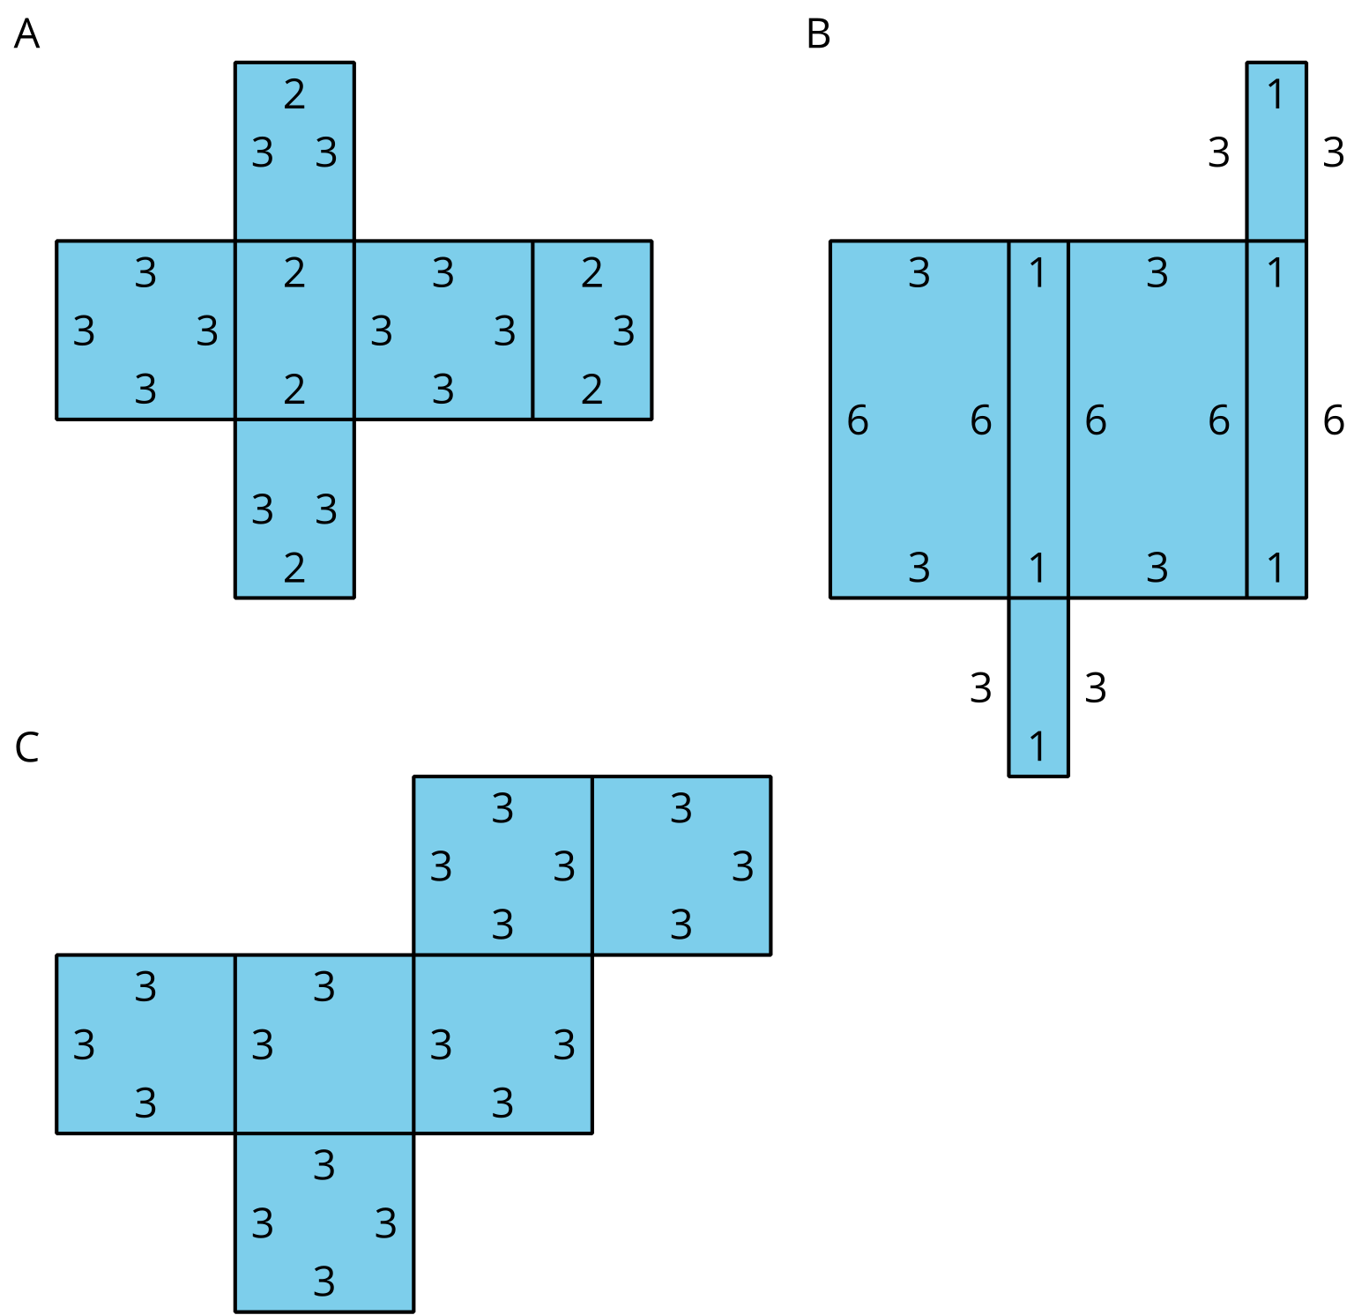
- Compare the surface areas of the boxes. Which box will use the least cardboard? Show your reasoning.
- Now compare the volumes of these boxes in cubic centimeters. Which box will hold the most 1-centimeter cubes? Show your reasoning.

Are you ready for more?
Figure C shows a net of a cube. Draw a different net of a cube. Draw another one. And then another one. How many different nets can be drawn and assembled into a cube?

Lesson 15 Summary
A net can help us find the surface area of a polyhedron that has different polygons for its faces. We can find the areas of all polygons in the net and add them.
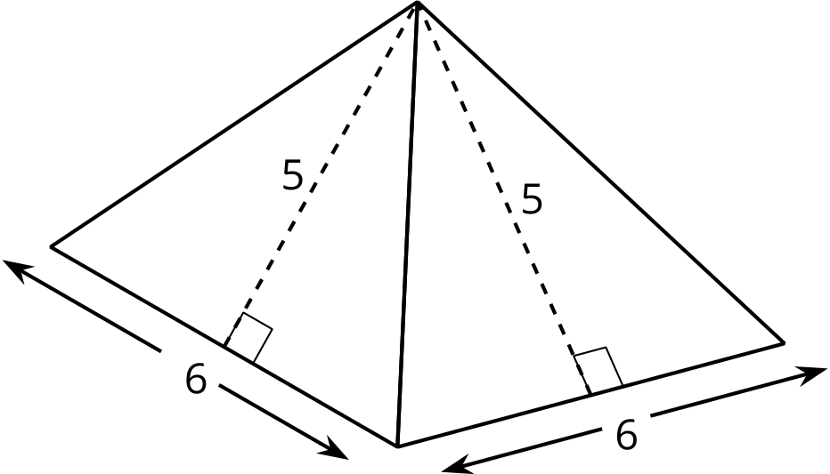
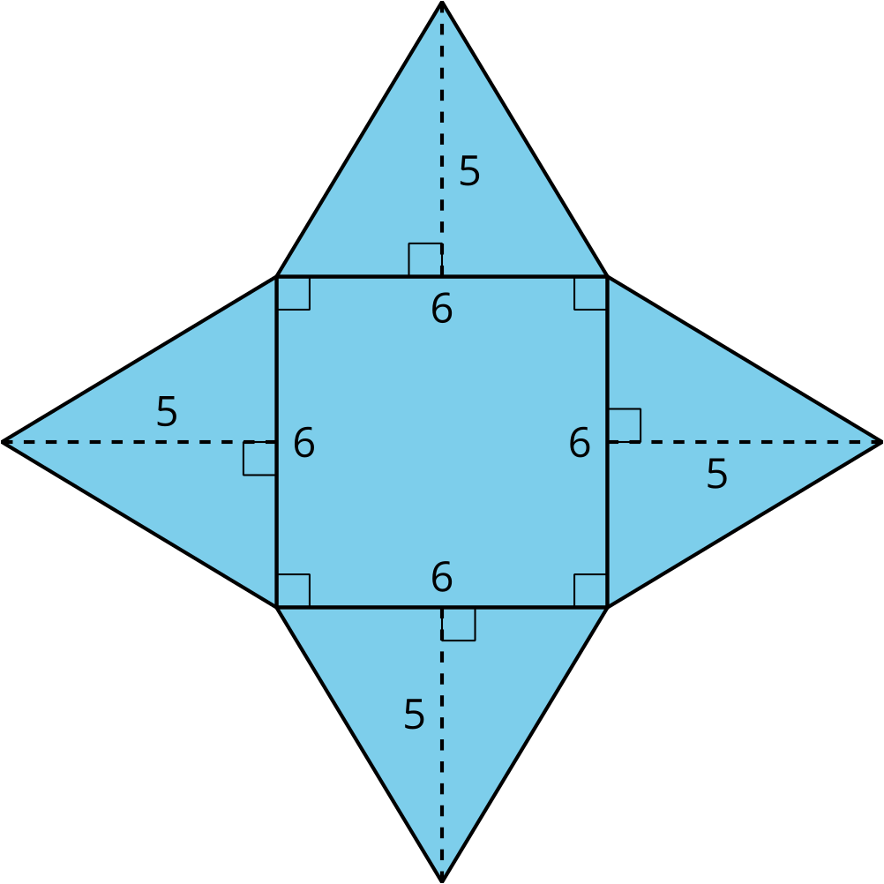
A square pyramid has a square and 4 triangles for its faces. Its surface area is the sum of the areas of the square base and the 4 triangular faces:
$\left(6⋅6\right)+4⋅\left(\frac{1}{2}⋅5⋅6\right)=96$
The surface area of this square pyramid is 96 square units.

