Unit 3 Lesson 7: Fractions as Sums

WU Choral Count: Three-fourths at a Time (Warm up)

Student Task Statement

1 Barley Soup

Student Task Statement
Lin is learning to make barley soup using a family recipe. Here are some ingredients in the recipe:
- $\frac{3}{4}$ cup of barley
- $\frac{5}{4}$ cups of chopped celery
- $\frac{6}{4}$ cups of chopped carrots
- 1 cup of chopped onions
- $2\frac{1}{4}$ cups of vegetable broth
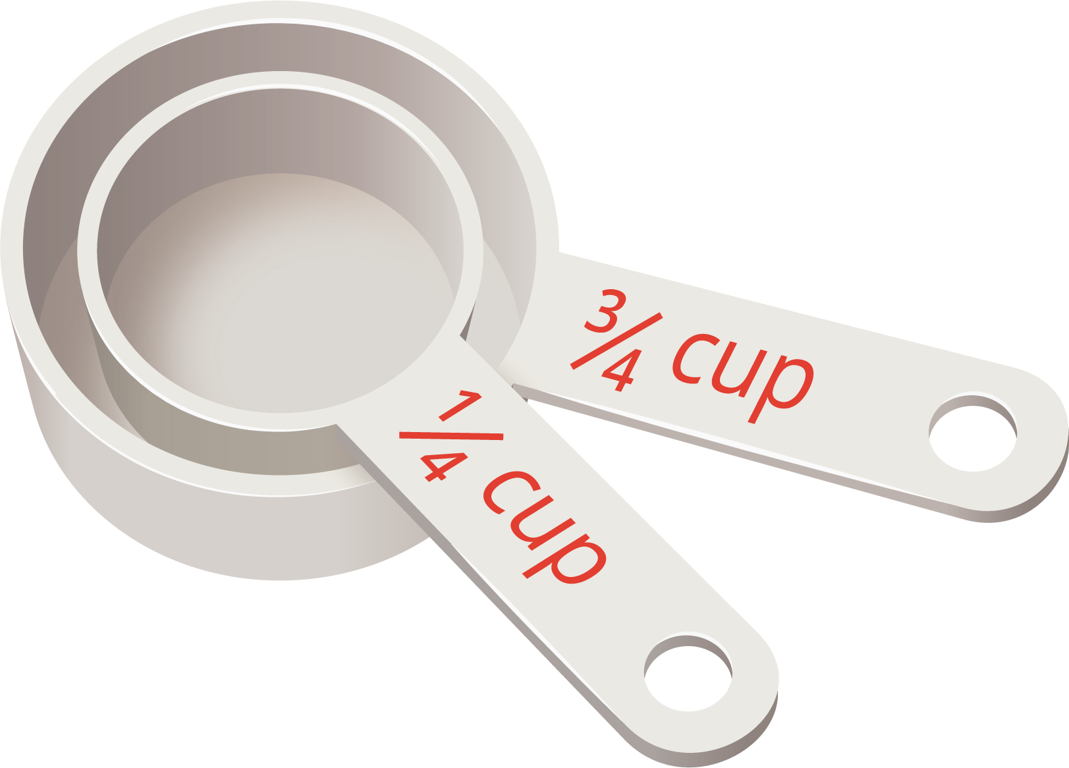
- Lin has only one measuring cup that measures $\frac{1}{4}$ cup. Show how Lin could use the cup to measure the right amount of each ingredient.
  - Barley:
  - Celery:
  - Carrots:
  - Onions:
  - Vegetable broth:
- Lin later found a $\frac{3}{4}$-cup measuring cup. Show how she could use the cups to measure the right amount of each ingredient.
  - Barley:
  - Celery:
  - Carrots:
  - Onions:
  - Vegetable broth:

Activity Synthesis

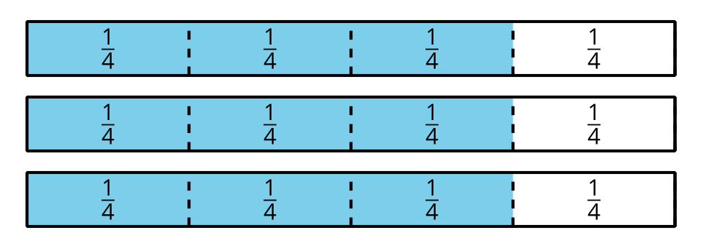

2 Sums in Fifths and Thirds

Student Task Statement
- Use different combinations of fifths to make a sum of $\frac{9}{5}$.
  - $\frac{9}{5}=\underset{_}{​}+\underset{_}{​}+\underset{_}{​}+\underset{_}{​}+\underset{_}{​}$
  - $\frac{9}{5}=\underset{_}{​}+\underset{_}{​}+\underset{_}{​}+\underset{_}{​}$
  - $\frac{9}{5}=\underset{_}{​}+\underset{_}{​}+\underset{_}{​}$
  - $\frac{9}{5}=\underset{_}{​}+\underset{_}{​}$
- Write different ways to use thirds to make a sum of $\frac{4}{3}$. How many can you think of? Write an equation for each combination.
- Is it possible to write any fraction with a denominator of 5 as a sum of other fifths? Explain or show your reasoning.
© CC BY 2021 Illustrative Mathematics®

