Lesson 7: Expressing Transformations of Functions Algebraically
- Let’s express transformed functions algebraically.

7.1: Describing Translations
Let $g\left(x\right)=\sqrt{x}$. Complete the table. Be prepared to explain your reasoning.
words (the graph of $y=g\left(x\right)$ is...) | function notation | expression
translated left 5 units | $g\left(x+5\right)$
translated left 5 units and down 3 units |  | $\sqrt{x+5}−3$
 | $g\left(\text{-}x\right)$ | $\sqrt{\text{-}x}$
translated left 5 units, then down 3 units,
then reflected across the $y$-axis

7.2: Translating Vertex Form
Let $f$ be the function given by $f\left(x\right)=x^{2}$.
- Write an equation for the function $g$ whose graph is the graph of $f$ translated 3 units left and up 5 units.
- What is the vertex of the graph of $g$? Explain how you know.
- Write an equation for a quadratic function $h$ whose graph has a vertex at $\left(1.5,2.6\right)$.
- Write an equation for a quadratic function $k$ whose graph opens downward and has a vertex at $\left(3.2,\text{-}4.7\right)$.

7.3: An Even Better Fit
In an earlier lesson, we looked at the temperature $T$, in degrees Fahrenheit, of a bottle of soda water left outside for $h$ hours. Let’s model this data with a function. This time, we will start with the function $f\left(h\right)=33{\left(0.6\right)}^{h}$. This graph has a shape that fits the data well.
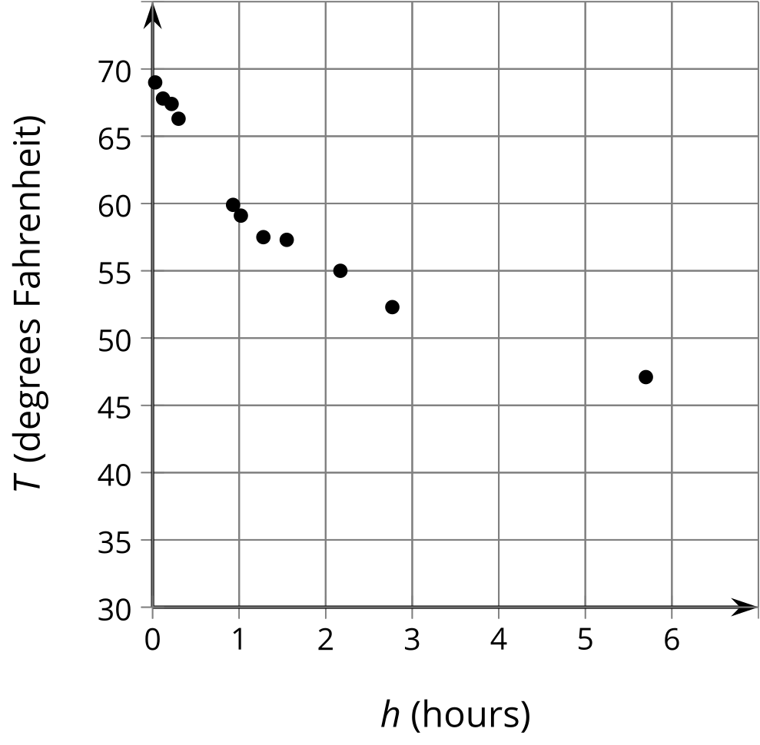
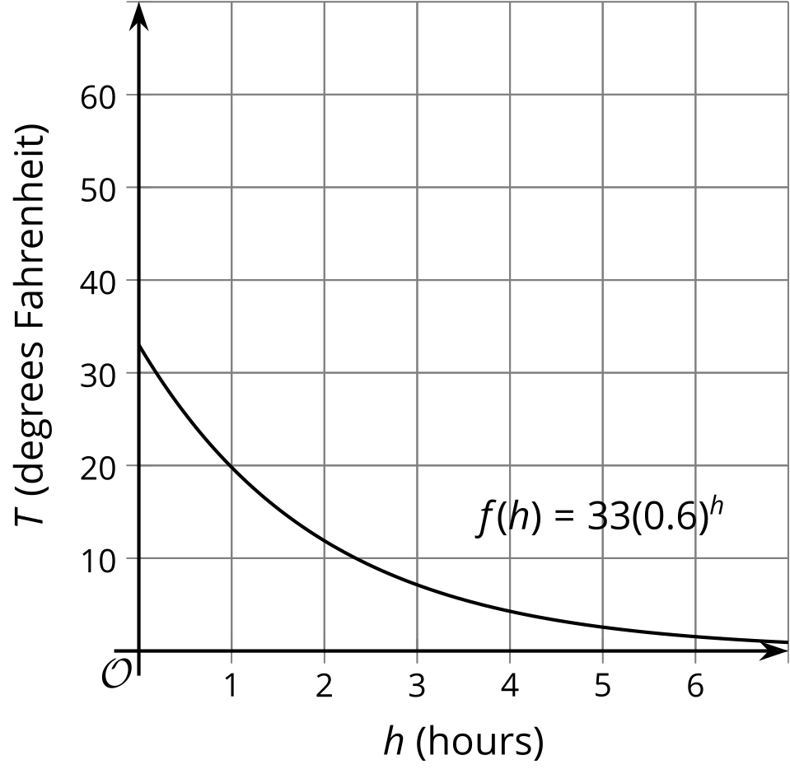
- Describe a translation of this graph that fits the data.
- Write an equation defining a function $g$ that models the data.
- What does your function tell you about the temperature outside?

Are you ready for more?
Han tried the following steps to model the soda water temperature. First he shifts the given graph left by one hour, then he applies a vertical shift.
- What vertical shift does Han need to apply to model the 45 degree Fahrenheit temperature in the refrigerator?
- How does Han’s model compare to yours?

Lesson 7 Summary
You can use the equation of a function to write an equation for its transformation. For example, let $f\left(x\right)=x^{2}$. Take the graph of $f$, reflect it across the $x$-axis, translate it up 10 units, and translate it left 3 units. What is an equation for this new function? The new function $g$ is related to $f$ by $g\left(x\right)=\text{-}f\left(x+3\right)+10$, since
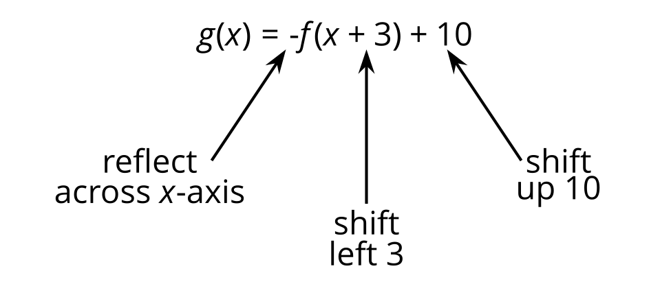
Which means $g\left(x\right)=\text{-}{\left(x+3\right)}^{2}+10$.
Sometimes you can recognize from the expression for a function that it is the transformation of a simpler function. For example, consider:
$H\left(t\right)=10−{\left(1.2\right)}^{t+5}$
One way to obtain the expression for $H$ from ${1.2}^{t}$ is:
- adding 5 to the input to get ${\left(1.2\right)}^{t+5}$
- multiplying the output by -1 to get $\text{-}{\left(1.2\right)}^{t+5}$
- adding 10 to the output to get $10−{\left(1.2\right)}^{t+5}$
So the graph of $H$ is obtained from the graph of $f\left(t\right)={1.2}^{t}$ by translating left 5 units, reflecting across the $x$-axis, and translating up 10 units. Consider the point $\left(0,1\right)$ on the graph of $f$. After translating, reflecting, and translating again, it becomes the point $\left(\text{-}5,9\right)$ on the graph of $H$.
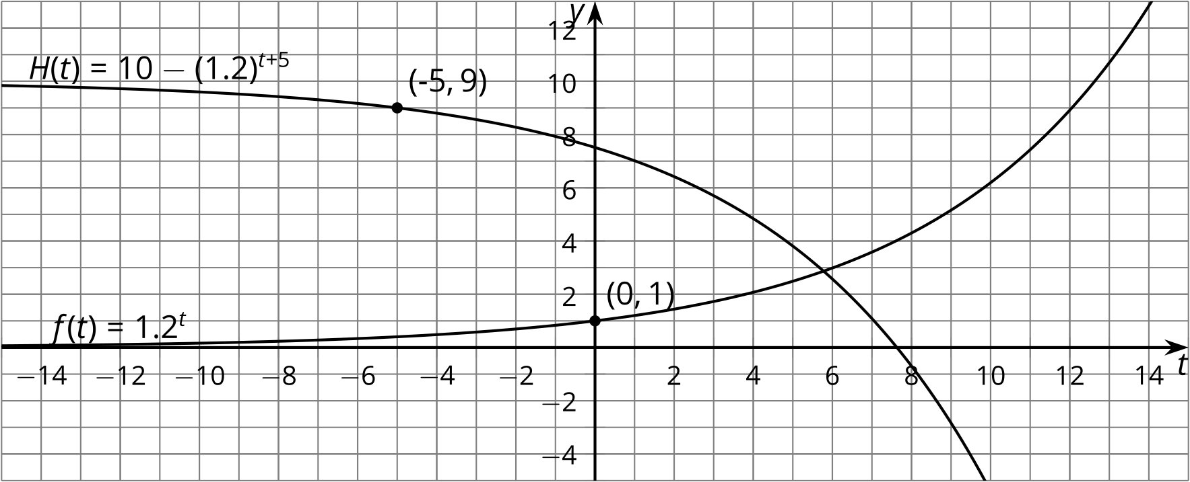
© CC BY 2019 by Illustrative Mathematics®

