Grade 2
Unit 1Lesson 17CC BY NC 2024 Illustrative Mathematics®
Unit 1, Lesson 17

Center Day 3
- Let’s count objects, play addition games, and create graphs.
Grade 2
Unit 1Lesson 17CC BY NC 2024 Illustrative Mathematics®

Warm-upNumber Talk: Add 10 More
Find the value of each sum mentally.
- $27+10$
- $27+10+10$
- $27+30$
- $37+30$
Grade 2
Unit 1Lesson 17CC BY NC 2024 Illustrative Mathematics®

Activity 2Centers: Choice Time
Choose a center.
What’s Behind My Back?
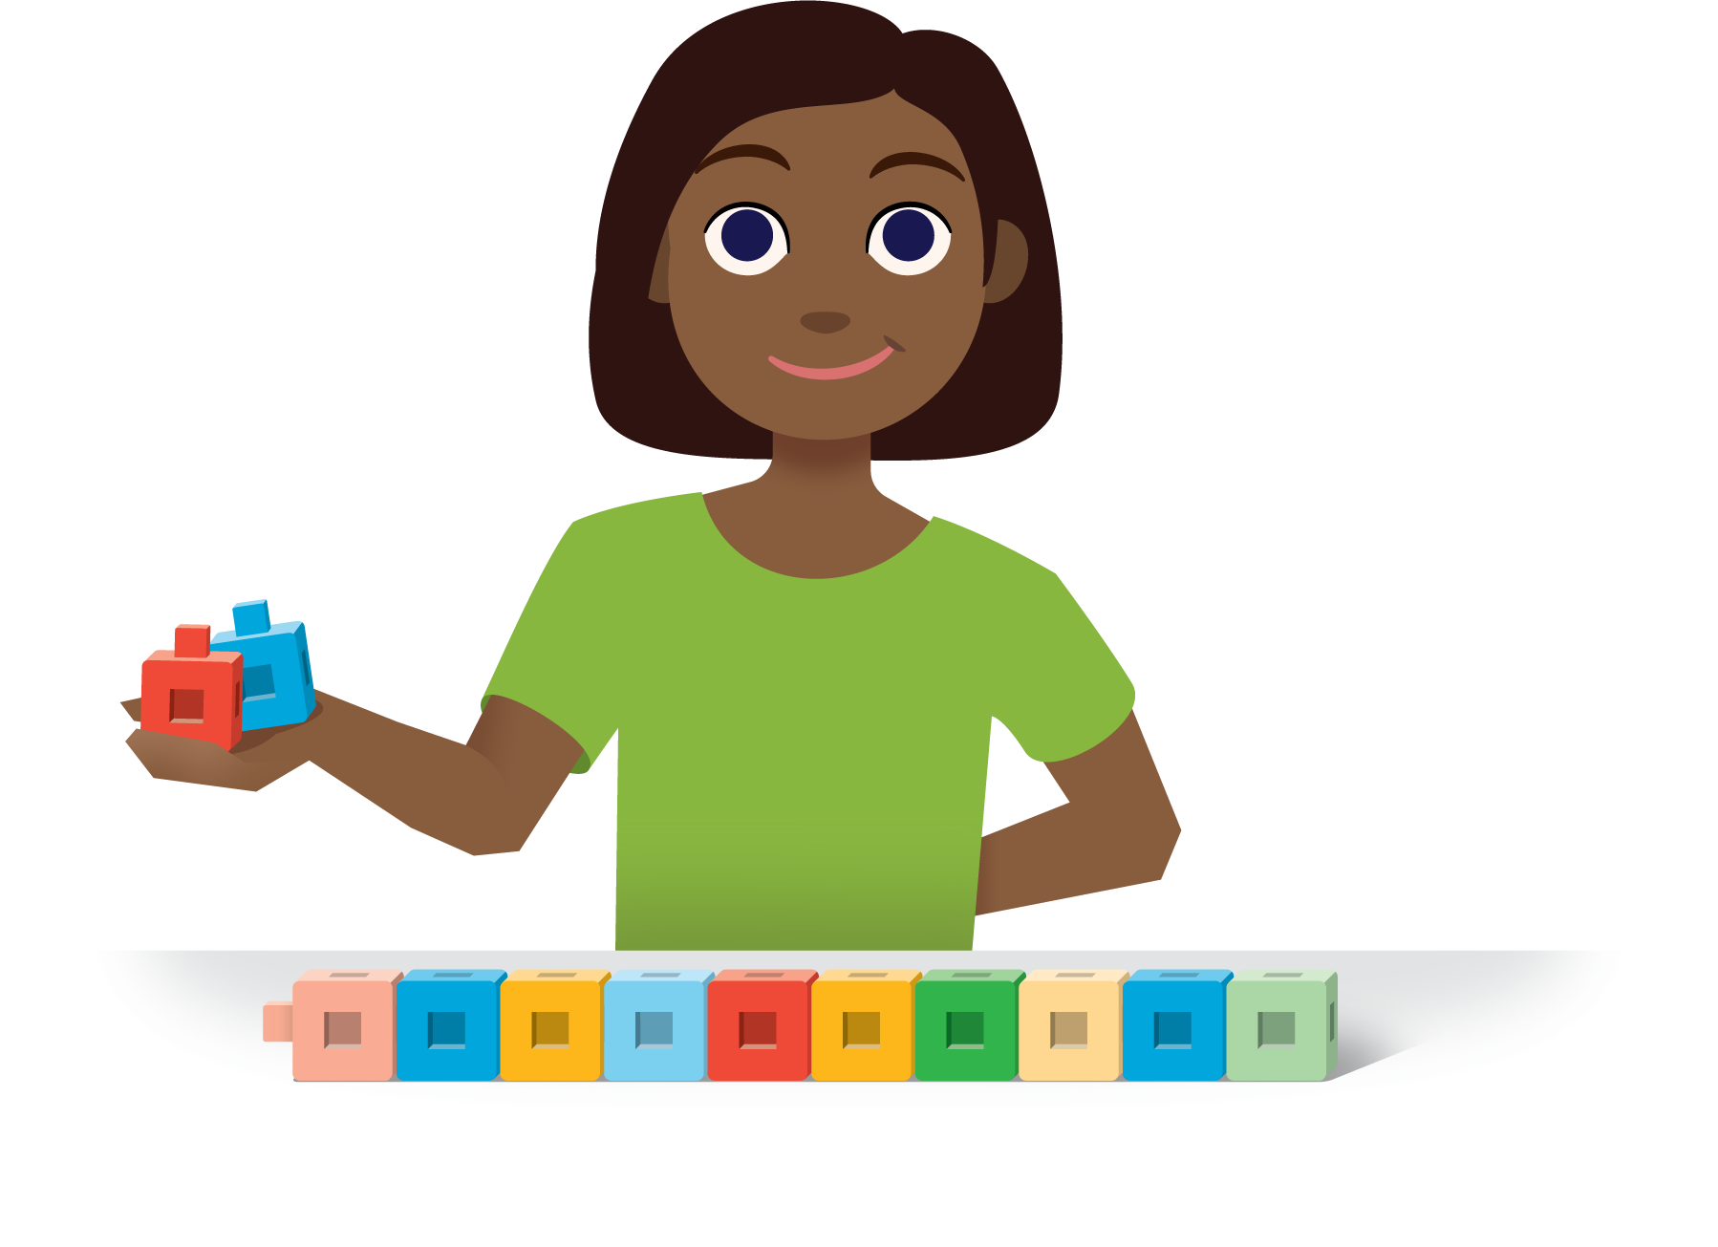
How Close?
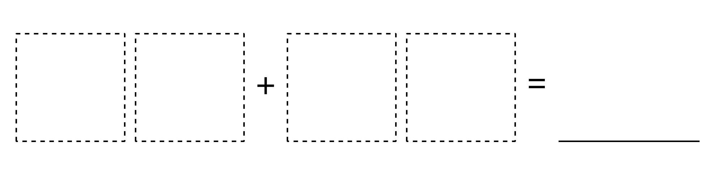
Number Puzzles
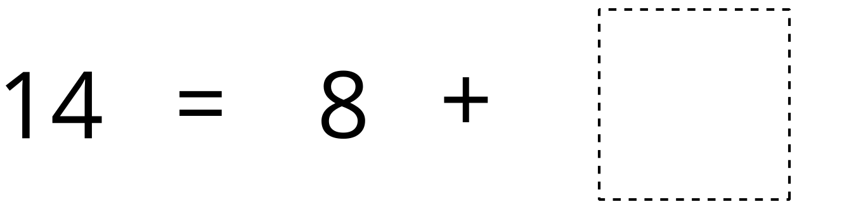
Sort and Display


