Lesson 19 Practice Problems
- Without calculating the solutions, determine whether each equation has real solutions or not.
  - $\text{-}0.5x^{2}+3x=0$
  - $x^{2}−4x+7=0$
  - $2x^{2}−2x−1=0$
  - $\text{-}0.5x^{2}+3x=3$
  - $x^{2}−4x+7=5$
  - $2x^{2}−2x−1=\text{-}4$
- $y=\text{-}0.5x^{2}+3x$
- 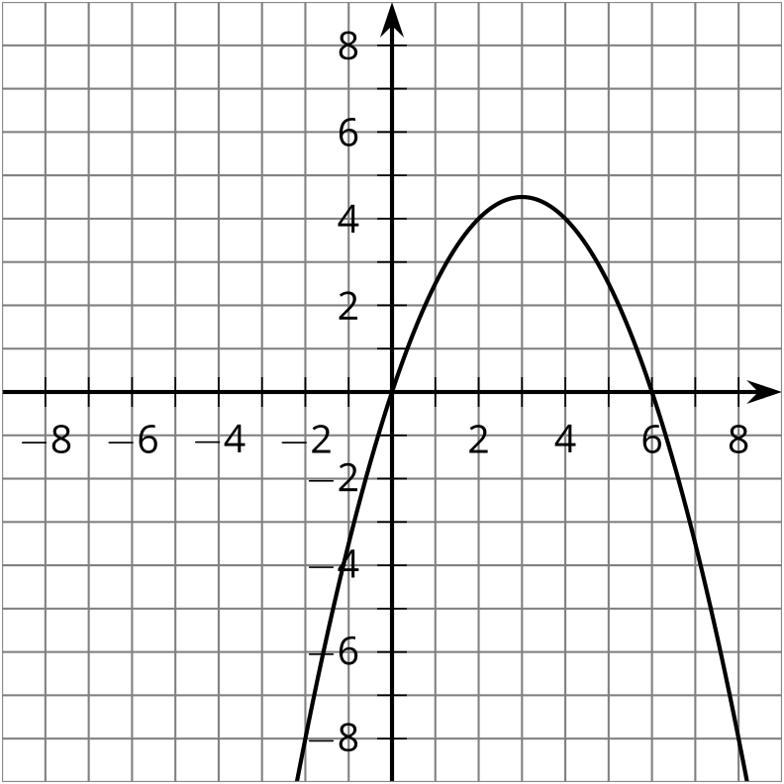
- $y=x^{2}−4x+7$
- 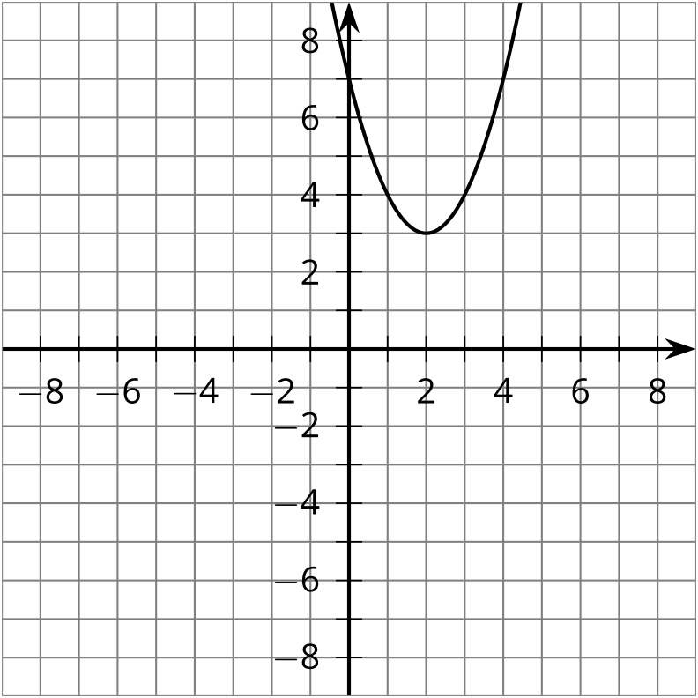
- $y=2x^{2}−2x−1$
- 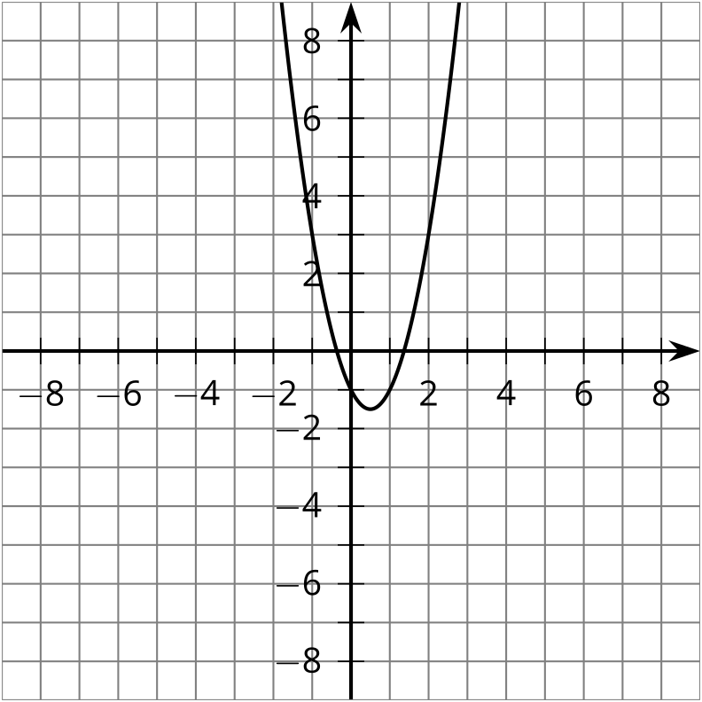
- The graph shows the equation $y=2x^{2}+0.5x−4$.
- 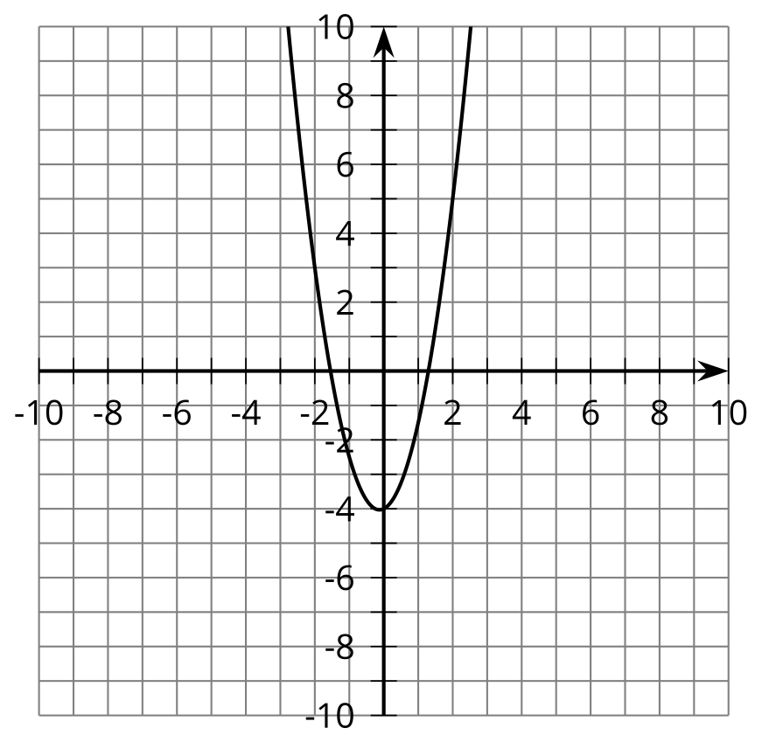
- Based on the graph, what number could you put in the box to create an equation that has no real solutions?
2x2+0.5x−4=30
- The graph shows the equation $y=1.5x^{2}−3x+2$.
- 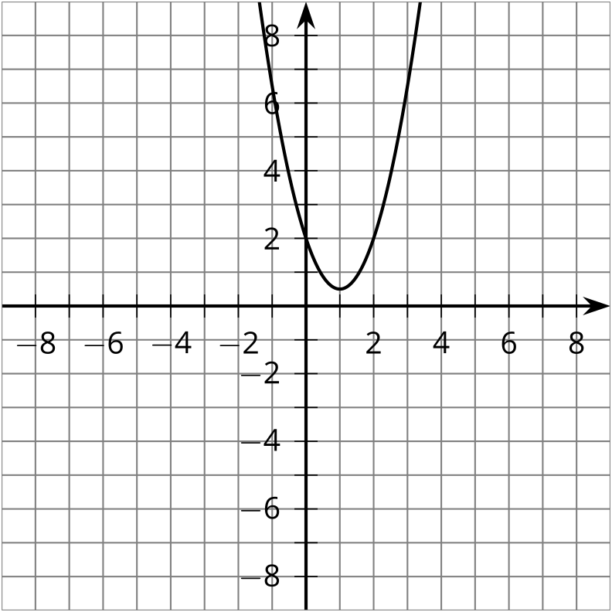
  - Without calculating the solutions, determine whether $1.5x^{2}−3x+2=0$ has real solutions.
  - Show how to solve $1.5x^{2}−3x+2=0$.
- Write a quadratic equation that has two non-real solutions. How did you decide what equation to write?
- Find the solution or solutions to each equation.
  - $\text{-}2x^{2}+2x=2.5$
  - $4.5x^{2}+3x+\frac{1}{2}=0$
  - $\frac{1}{2}x^{2}+5x=\text{-}14$
  - $\text{-}x^{2}−1.5x+5=7$
- Elena and Kiran were solving the equation $2x^{2}−4x+3=0$ and they got different answers. Elena wrote $1±i\sqrt{0.5}$, and Kiran wrote $1±\frac{i\sqrt{8}}{4}$. Are their answers equivalent? Say how you know.
© CC BY 2019 by Illustrative Mathematics®

