Lesson 2: Share More Sandwiches
- Let’s use diagrams and expressions to represent division situations.

Warm-up: Estimation Exploration: Name that Fraction
The large rectangle represents 1. What fraction of the large rectangle is shaded?
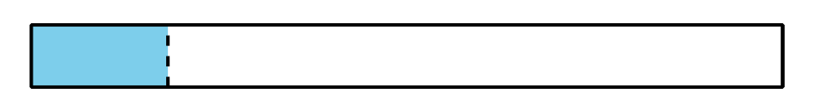
Record an estimate that is:
too low | about right | too high

2.1: One Sandwich
Jada’s family made sandwiches to share at a family celebration. Complete the table to show how much sandwich each person gets.
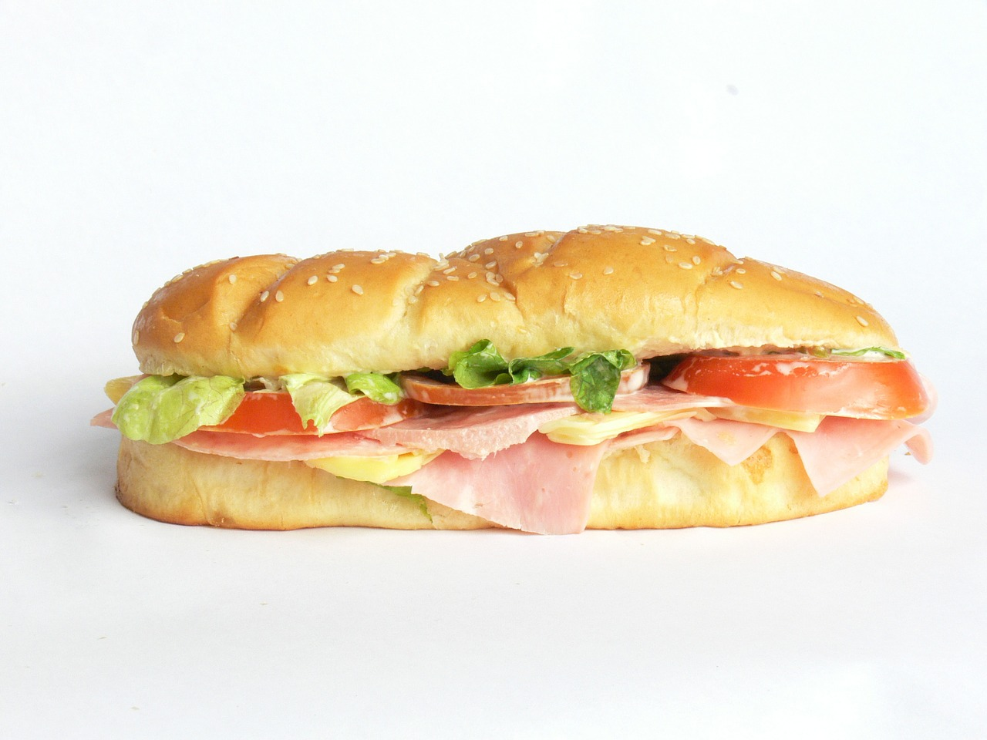
sandwiches being shared | number of people sharing sandwiches | amount of sandwich each person gets | division expression
1 | 2
1 | 3
1 | 4
1 | 5
- Choose one row from the table and represent your thinking with a diagram.
- What patterns do you notice in the table?

2.2: Card Sort: Sandwich Match
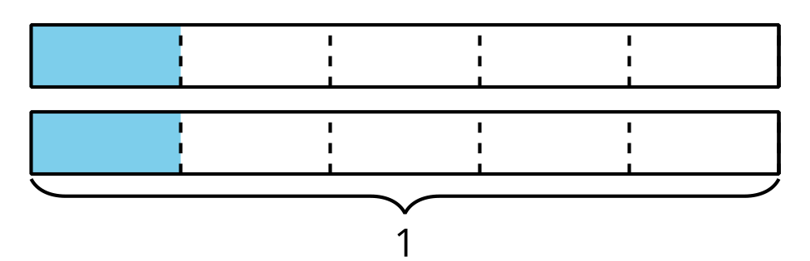
Your teacher will give you a set of cards. Match each representation with a situation and expression. Some situations and expressions will have more than one matching representation.
Choose one set of matched cards.
- Show or explain how the diagram(s) and expression represent the number of sandwiches being shared.
- Show or explain how the diagram(s) and expression represent the number of people sharing the sandwiches.
- How much sandwich does each person get in the situation?
© CC BY 2021 Illustrative Mathematics®

