Unit 3 Lesson 3: Measuring Dilations

1 Dilating Out (Warm up)

Student Task Statement
Dilate triangle $FGH$ using center $C$ and a scale factor of 3.
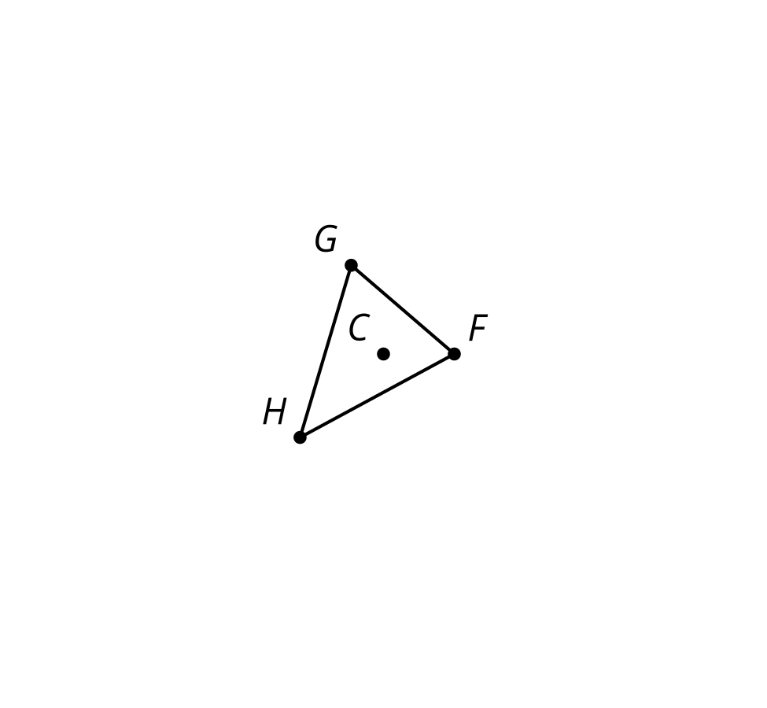

Activity Synthesis
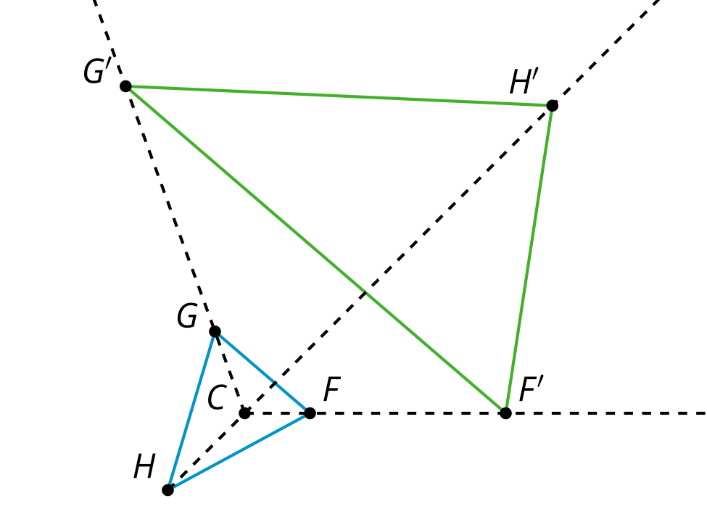

2 All the Scale Factors

Student Task Statement
Here is a center of dilation and a triangle.
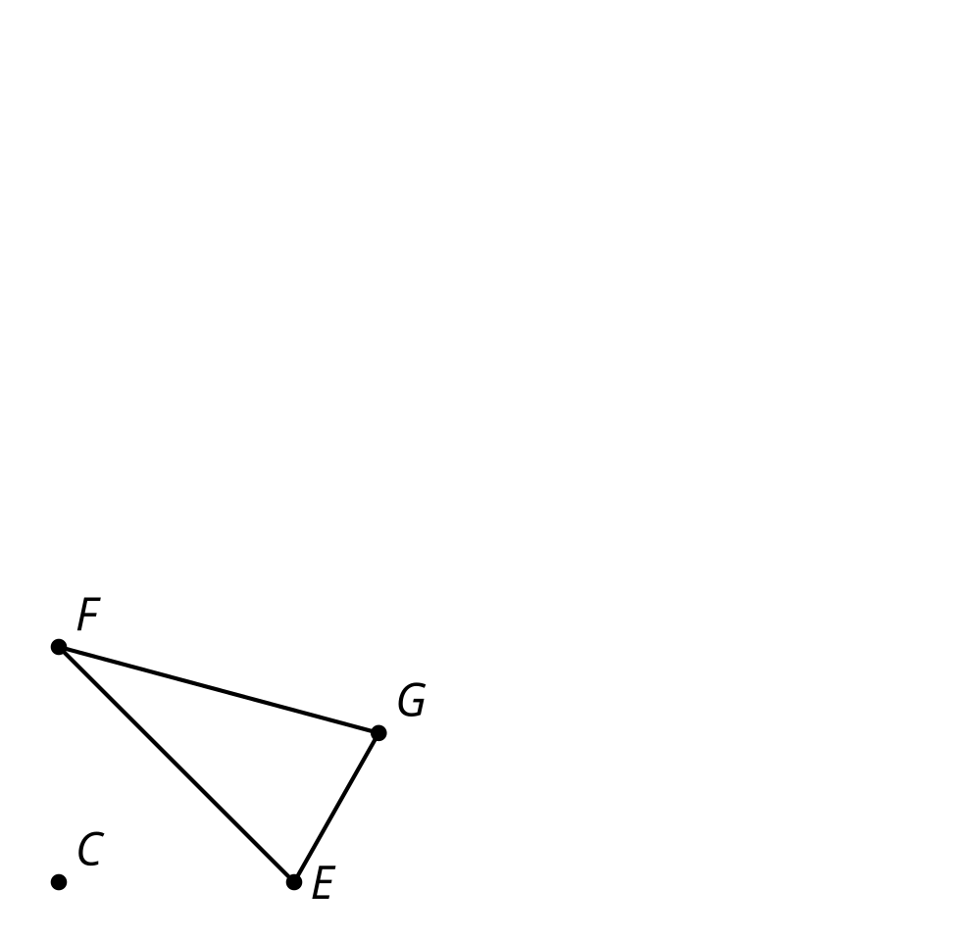
- Measure the sides of triangle $EFG$ (to the nearest mm).
- Your teacher will assign you a scale factor. Predict the relative lengths of the original figure and the image after you dilate by your scale factor.
- Dilate triangle $EFG$ using center $C$ and your scale factor.
- How does your prediction compare to the image you drew?
- Use tracing paper to copy point $C$, triangle $EFG$, and your dilation. Label your tracing paper with your scale factor.
- Align your tracing paper with your partner’s. What do you notice?

3 What Stays the Same?

Student Task Statement
- Dilate quadrilateral $ABCD$ using center $P$ and your scale factor.
- 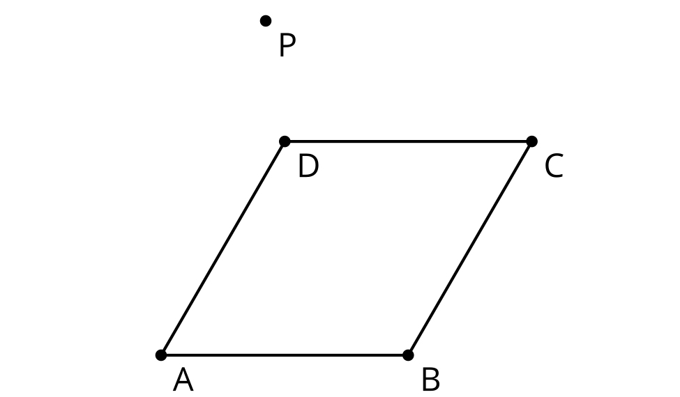
- Complete the table.
- Ratio | - $\frac{PA^{′}}{PA}$ | - $\frac{PB^{′}}{PB}$ | - $\frac{PC^{′}}{PC}$ | - $\frac{PD^{′}}{PD}$
- Value
- What do you notice? Can you prove your conjecture?
- Complete the table.
- Ratio | - $\frac{B^{′}A^{′}}{BA}$ | - $\frac{C^{′}B^{′}}{CB}$ | - $\frac{D^{′}C^{′}}{DC}$ | - $\frac{A^{′}D^{′}}{AD}$
- Value
- What do you notice? Does the same reasoning you just used also prove this conjecture?

Activity Synthesis

$PC:PC^{′}=3:1$, $BC:B^{′}C^{′}=2:\frac{2}{3}$
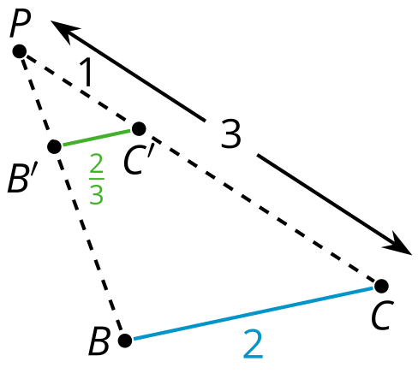

Images for Activity Synthesis
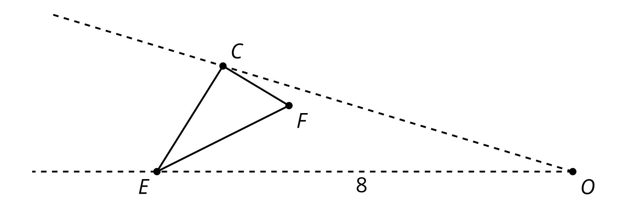
© CC BY 2019 by Illustrative Mathematics®

