Unit 4 Lesson 11: On Both of the Lines

1 Notice and Wonder: Bugs Passing in the Night (Warm up)

Student Task Statement
What do you notice? What do you wonder?
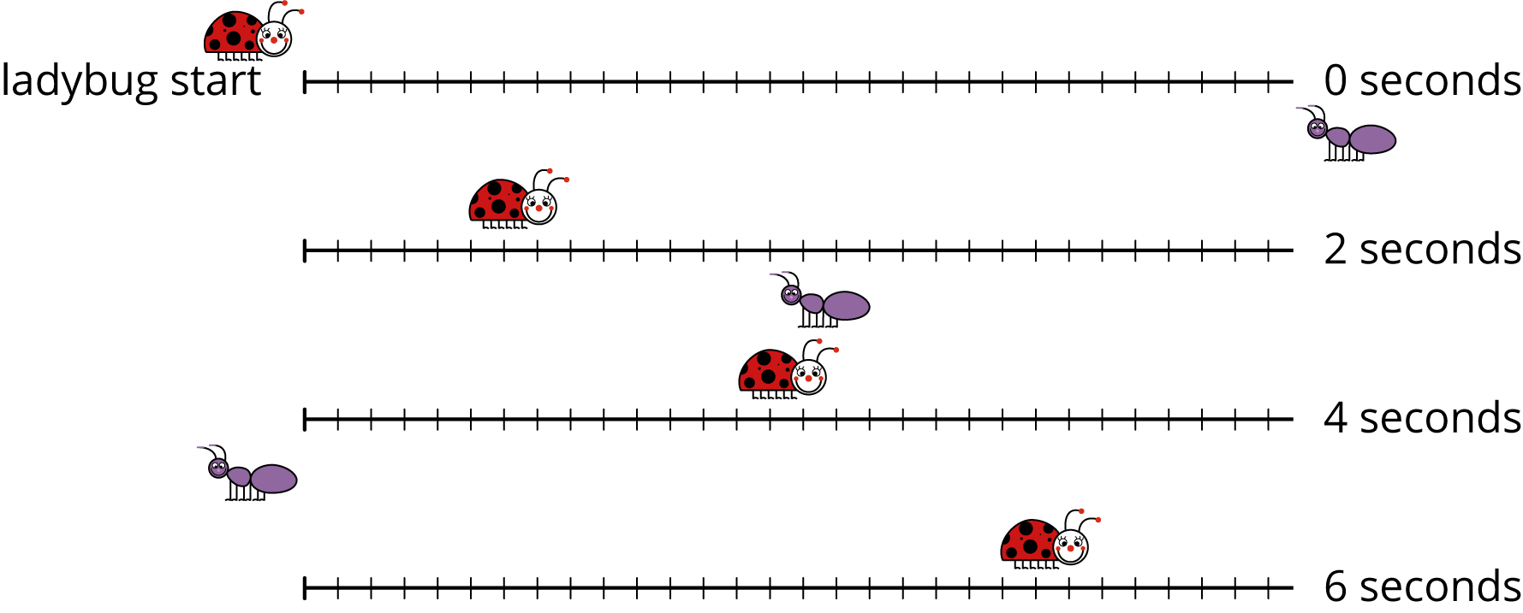

2 Bugs Passing in the Night, Continued

Student Task Statement
A different ant and ladybug are a certain distance apart, and they start walking toward each other. The graph shows the ladybug’s distance from its starting point over time and the labeled point $\left(2.5,10\right)$ indicates when the ant and the ladybug pass each other.
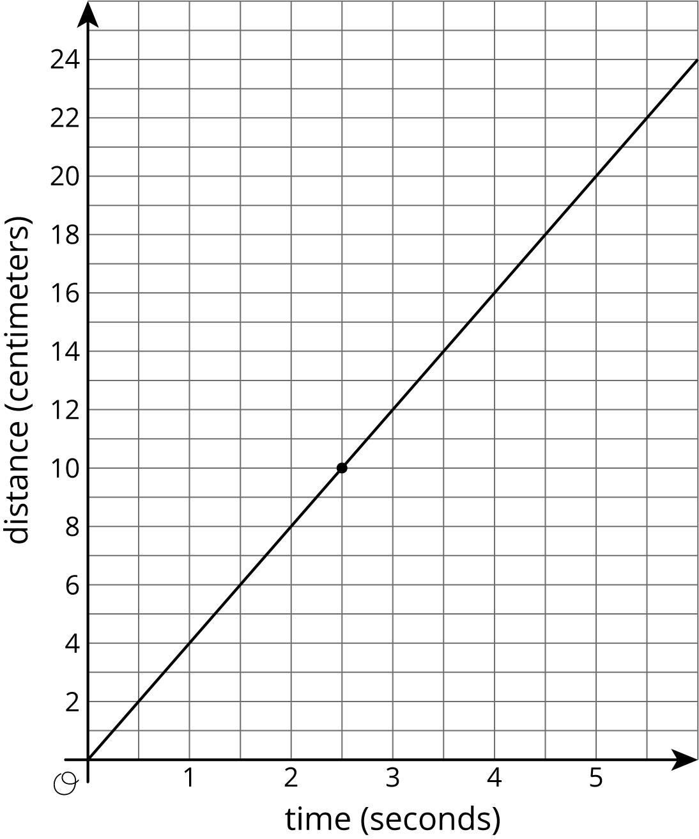
The ant is walking 2 centimeters per second.
- Write an equation representing the relationship between the ant’s distance from the ladybug’s starting point and the amount of time that has passed.
- If you haven’t already, draw the graph of your equation on the same coordinate plane.

3 A Close Race

Student Task Statement
Elena and Jada were racing 100 meters on their bikes. Both racers started at the same time and rode at constant speed. Here is a table that gives information about Jada’s bike race:
time from start (seconds) | distance from start (meters)
6 | 36
9 | 54
- Graph the relationship between distance and time for Jada’s bike race. Make sure to label and scale the axes appropriately.
- 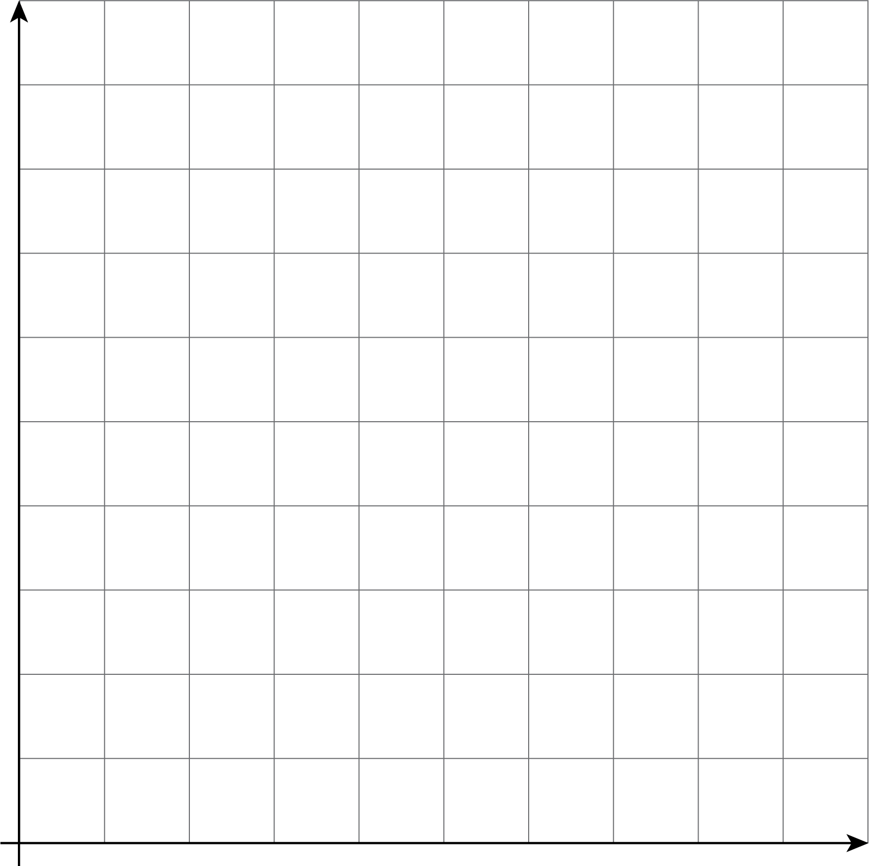

- Elena traveled the entire race at a steady 6 meters per second. On the same set of axes, graph the relationship between distance and time for Elena’s bike race.
- Who won the race?
© CC BY Open Up Resources. Adaptations CC BY IM.

