Grade 2
Unit 6Lesson 17CC BY NC 2024 Illustrative Mathematics®
Unit 6, Lesson 17

Let’s Make a Dollar
- Let’s make a dollar.
Grade 2
Unit 6Lesson 17CC BY NC 2024 Illustrative Mathematics®

Warm-up Number Talk: Add 25
Find the value of each expression mentally.
- $25+10+10+5$
- $25+25$
- $25+25+25$
- $25+25+25+25$
Grade 2
Unit 6Lesson 17CC BY NC 2024 Illustrative Mathematics®

Activity 1 Many Many Cents
- Coin Collection A
- 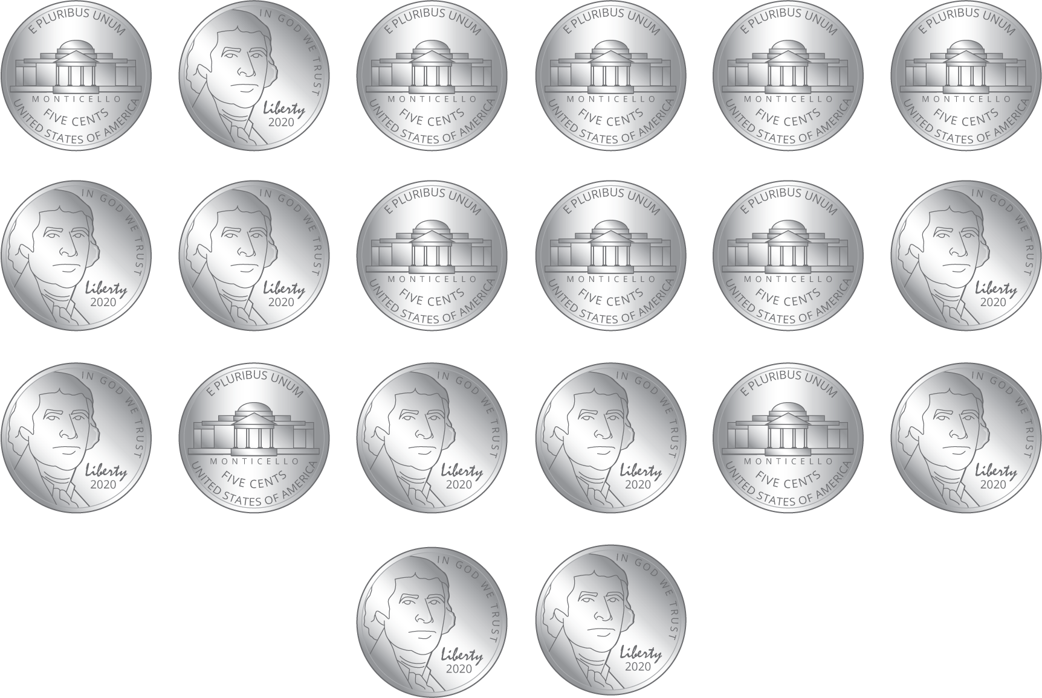
- Circle the coins
in this collection.
- quarters
- dimes
- nickels
- pennies
- How many coins? __________
- What is the value in cents?
Show your thinking, using drawings, numbers, or words.
- Coin Collection B
- 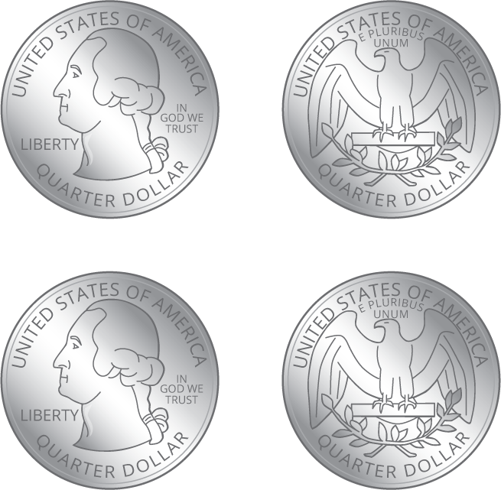
- Circle the coins
in this collection.
- quarters
- dimes
- nickels
- pennies
- How many coins? __________
- What is the value in cents?
Show your thinking, using drawings, numbers, or words.
- Coin Collection C
- Make a collection that has the same value as Collection A. Use only dimes.
- Glue or draw coins here.
- How many coins? __________
- What is the value in cents?
Show your thinking, using drawings, numbers, or words.
Grade 2
Unit 6Lesson 17CC BY NC 2024 Illustrative Mathematics®

Activity 2The Value of a Dollar
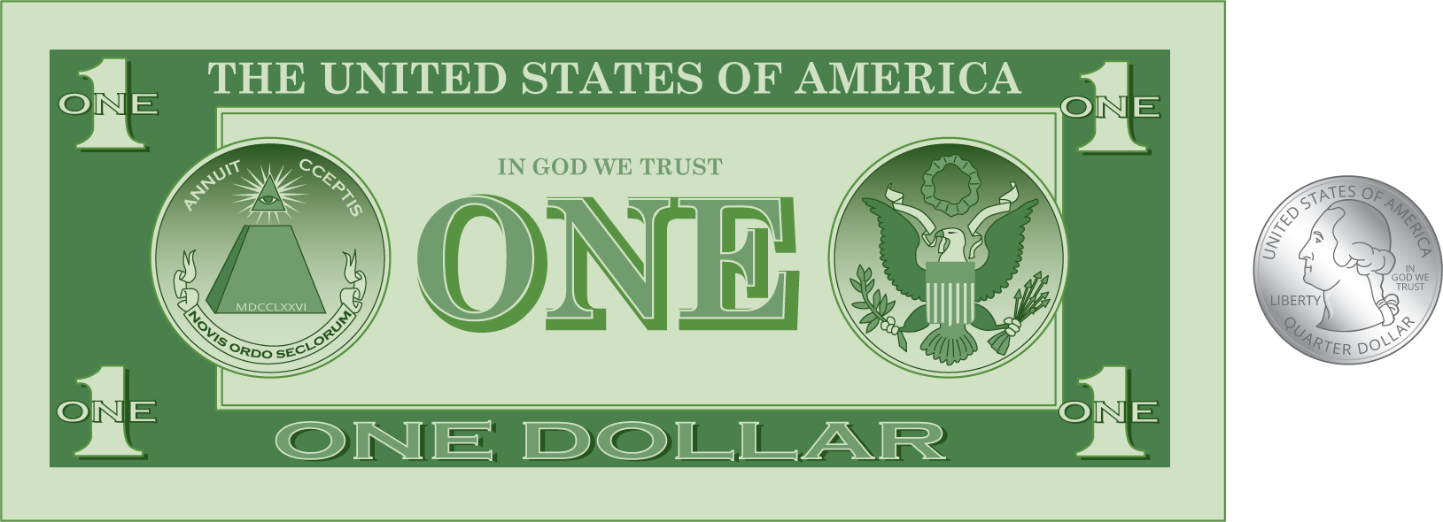
- Andre empties his pockets. He finds these coins.
- 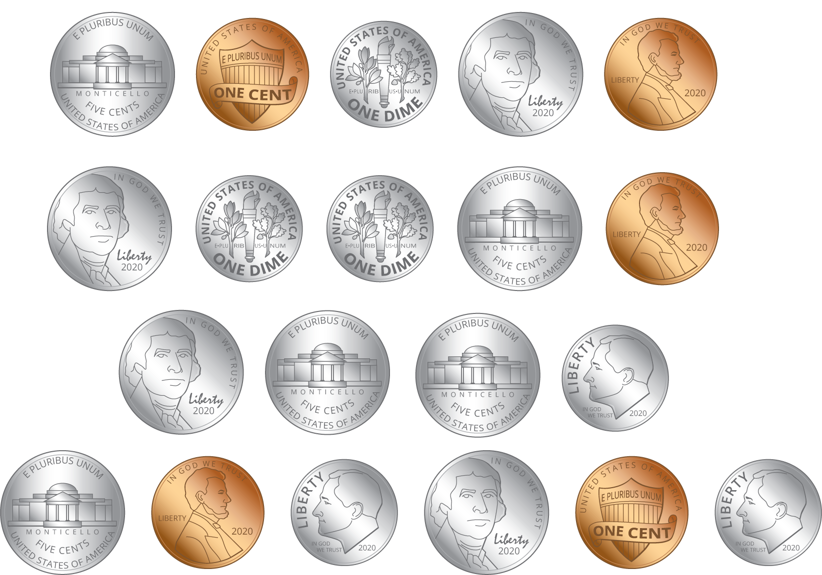
- How much money does he have? Show your thinking, using drawings, numbers, or words.
- Han empties his pockets. He finds these coins.
- 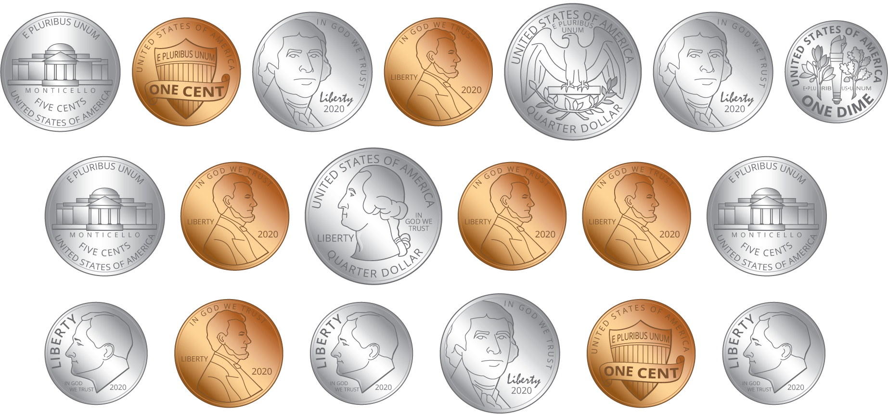
- How much money does he have? Show your thinking, using drawings, numbers, or words.
- Priya has $1 and 18¢ in her pocket.
  - If Priya only had coins in her pocket, what coins could she have?
  - Represent Priya’s coins.
  - If Priya had a dollar bill and some coins, what coins could she have?
  - Represent Priya’s money.

