Lesson 10: Subtraction Algorithms (Part 3)
- Let’s learn another algorithm to subtract.

Warm-up: Notice and Wonder: Digits that Disappear
What do you notice? What do you wonder?
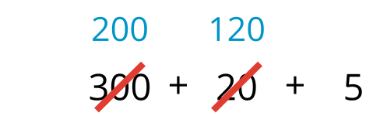


10.1: A New Subtraction Algorithm
Andre and Clare found the value of $528−271$. How they started their work is shown.
Andre's algorithm
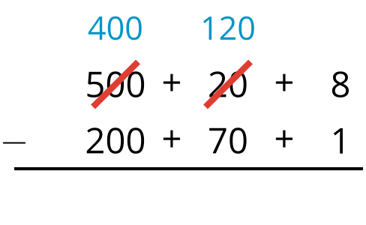
Clare's algorithm
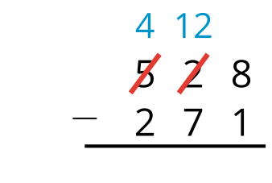
- Complete both algorithms to find the difference.
- Andre and Clare started their subtraction in different ways. How did their way of starting affect the steps needed to find the difference?

10.2: Try Clare’s Algorithm
Clare used an algorithm to find the value of $538−156$.
Try using her algorithm to find the value of each difference.
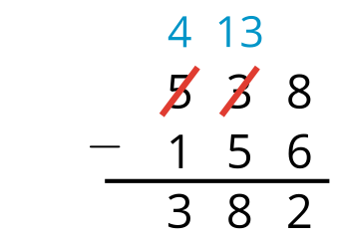
- $691−358$
- $926−584$
- $317−182$
- $492−325$
© CC BY 2021 Illustrative Mathematics®

