Lesson 7 Practice Problems
- Here is a graph of $f\left(x\right)=e^{x}$ and a graph of $g$, which is a transformation of $f$. Write an equation for the function $g$.
- 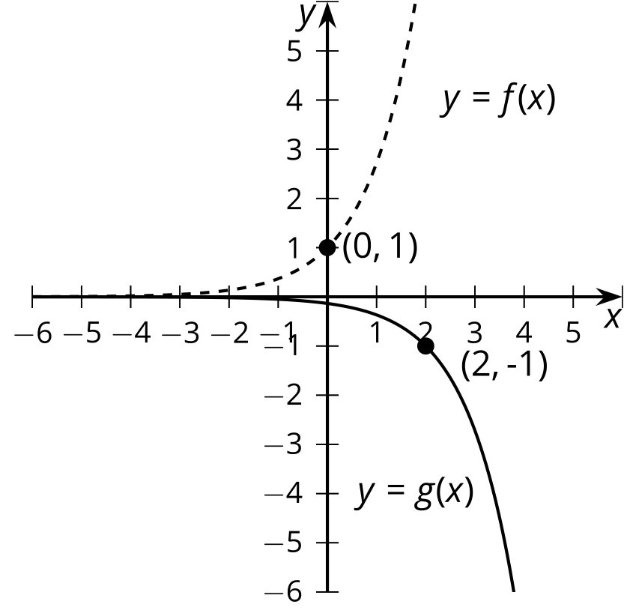
- Describe the transformation that takes the graph of function $f$ to the graph of function $g$.
  - $f\left(x\right)=e^{x}$ and $g\left(x\right)=\text{-}e^{x}+2.7$
  - $f\left(x\right)=x^{5}$ and $g\left(x\right)={\left(\text{-}x+3.1\right)}^{5}+1$
  - $f\left(x\right)=\left|x\right|$ and $g\left(x\right)=\left|x\right|−26$
  - $f\left(x\right)=\sqrt{x}$ and $g\left(x\right)=\text{-}\sqrt{x−0.004}$

  - Write an equation whose graph is a parabola with vertex at $\left(1,4\right)$ and which opens upward.
  - Write an equation whose graph is a parabola with vertex at $\left(2,\text{-}3\right)$ and which opens downward.
- Describe how to move the graph so that it better matches the data.
- 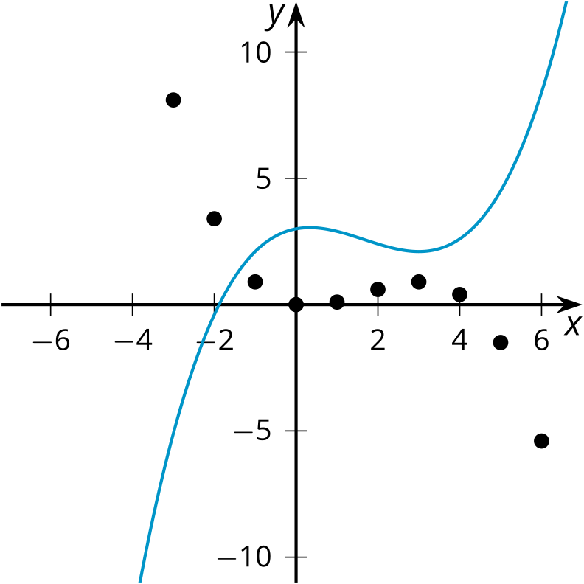
- (From Unit 5, Lesson 1.)
- Here is a graph of $y=f\left(x\right)$ for $\text{-}10≤x≤0$. Sketch $f$ for $0≤x≤10$ if:
  - $f$ is even
  - $f$ is odd
  - $f$ is neither even nor odd
- 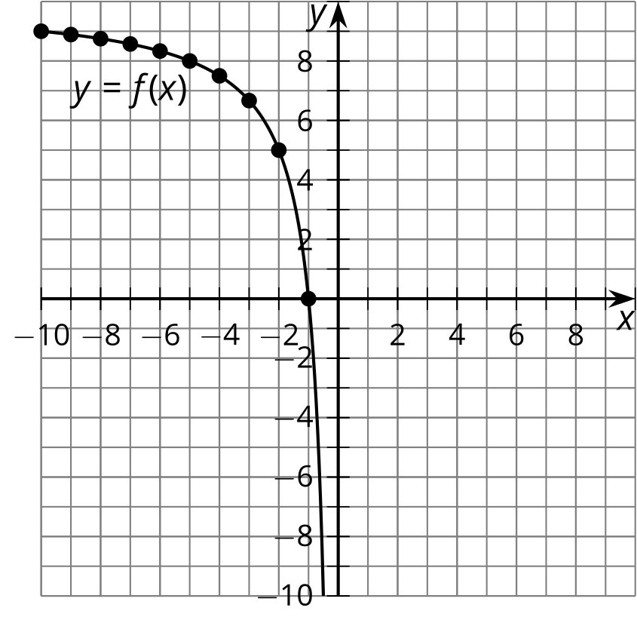
- (From Unit 5, Lesson 6.)
- Here are graphs of functions $f$ and $g$.
- Which sequences of transformations take the graph of $f$ to the graph of $g$? Select all that apply.
- 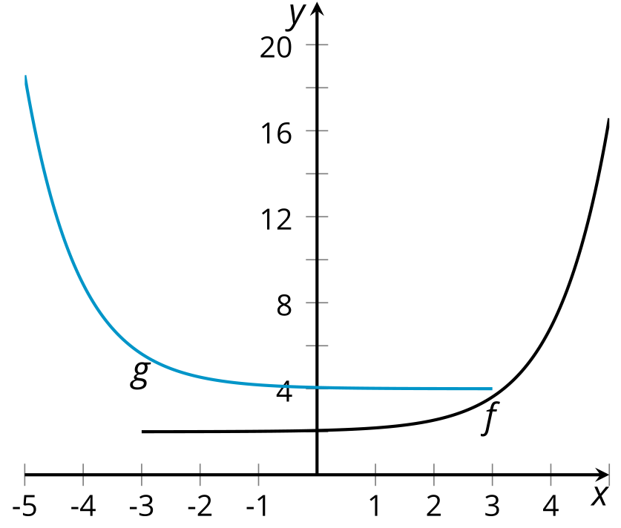
  - reflection over the $y$-axis, then translation up by 2
  - reflection over the $x$-axis, then translation up by 2
  - translation up 2, then reflection over the $y$-axis
  - translation up 2, then reflection over the $x$-axis
  - translation up 2, and then translation left by 5
- (From Unit 5, Lesson 4.)
© CC BY 2019 by Illustrative Mathematics®

