Grade 2
Unit 4Lesson 1CC BY NC 2024 Illustrative Mathematics®
Unit 4, Lesson 1

Whole Numbers on the Number Line
- Let’s represent numbers on a number line.
Grade 2
Unit 4Lesson 1CC BY NC 2024 Illustrative Mathematics®

Warm-up Notice and Wonder: Rulers and Number Lines
What do you notice? What do you wonder?
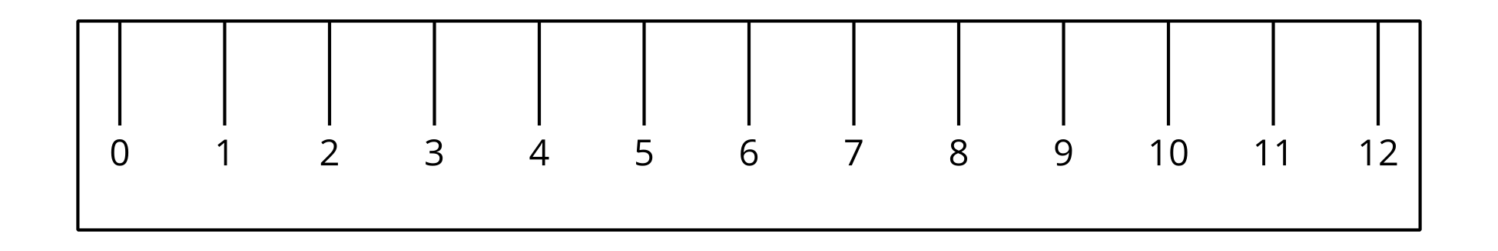
Grade 2
Unit 4Lesson 1CC BY NC 2024 Illustrative Mathematics®

Activity 1 What Is a Number Line?
- Label each tick mark with the number it represents.
- Locate 6. Mark it with a point.
- Locate a number that is greater than 6. Mark it with a point.
- Label each tick mark with the number it represents.
- Locate 9. Mark it with a point.
- Locate a number that is less than 9. Mark it with a point.
Grade 2
Unit 4Lesson 1CC BY NC 2024 Illustrative Mathematics®

Activity 2 Make Your Own Number Line
- Make a number line that goes from 0 to 20.
- Locate 13. Mark it with a point.
- Locate 3. Mark it with a point.
- Compare number lines with your partner.

