Lesson 18 Practice Problems
- Jada is riding on a Ferris wheel. Her height, in feet, is modeled by the function $h\left(m\right)=100sin\left(\text{-}\frac{π}{2}+\frac{2πm}{10}\right)+110$, where $m$ is the number of minutes since she got on the ride.
  - How many minutes does it take the Ferris wheel to make one full revolution? Explain how you know.
  - What is the radius of the Ferris wheel? Explain how you know.
  - Sketch a graph of $h$.
- 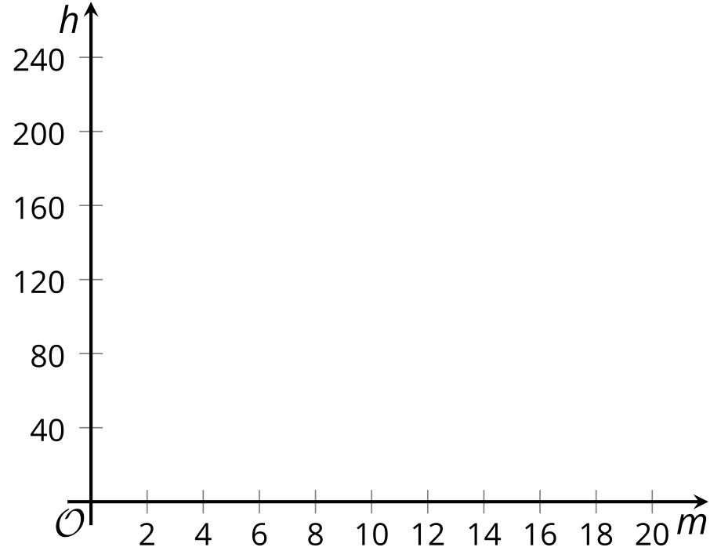
- The vertical position, in feet, of the point $P$ on a windmill is represented by $y=5sin\left(\frac{2πt}{3}\right)+20$, where $t$ is the number of seconds after the windmill started turning at a constant speed. Select all the true statements.
  - The windmill blades are 5 feet long.
  - The windmill blades make 5 revolutions per second.
  - The midline for the graph of the equation is 20.
  - The windmill makes one revolution every 3 seconds.
  - The windmill makes 3 revolutions per second.
- A seat on a Ferris wheel travels $250π$ feet in one full revolution. How many feet is the carriage from the center of the Ferris wheel?
  - $\frac{125}{π}$
  - $\frac{250}{π}$
  - 125
  - 250
- A carousel has a radius of 20 feet. The carousel makes 8 complete revolutions.
  - How many feet does a person on the carousel travel during these 8 revolutions?
  - What angle does the carousel travel through?
  - What is the relationship between the angle of rotation and the distance traveled on this carousel? Explain your reasoning.

  - For which angle measures between 0 and $2π$ is the cosine negative and the sine positive?
  - For which angle measures between 0 and $2π$ is the cosine negative and the sine negative?
- (From Unit 6, Lesson 6.)
- A $\frac{π}{2}$ radian rotation takes a point $D$ on the unit circle to a point $E$. Which other radian rotation also takes point $D$ to point $E$?
  - $\frac{3π}{2}$
  - $\frac{4π}{2}$
  - $\frac{5π}{2}$
  - $\frac{7π}{2}$
- (From Unit 6, Lesson 10.)
- A windmill blade spins in a counterclockwise direction, making one full revolution every 5 seconds.
- Which statements are true? Select all that apply.
- 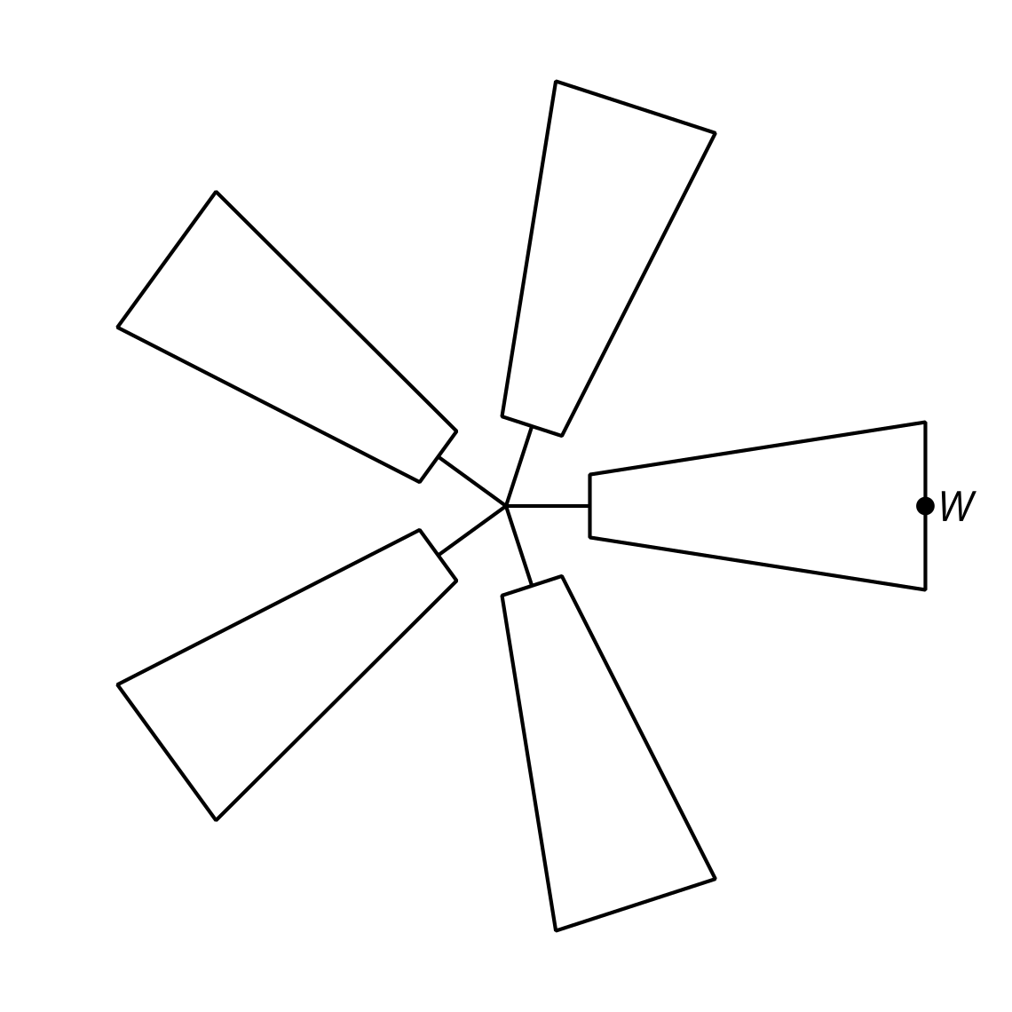
  - After 15 seconds, the point $W$ will be in its starting position.
  - After $\frac{1}{5}$ of a second, the point $W$ will be in its starting position.
  - In 1 second, the point $W$ travels through an angle of $\frac{π}{5}$.
  - The position of $W$ repeats every 5 seconds.
  - The position of $W$ repeats every 10 seconds.
- (From Unit 6, Lesson 16.)
- Here is the graph of a trigonometric function.
- Which equation has this graph?
- 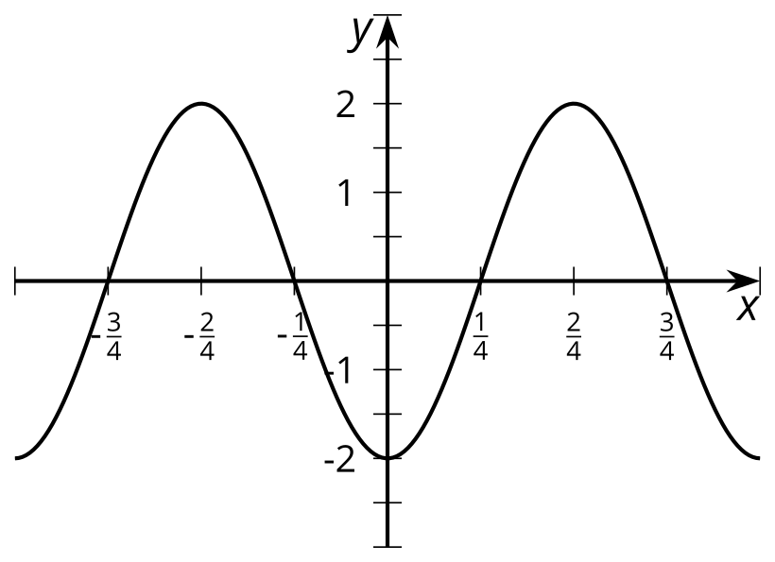
  - $y=\text{-}2sin\left(2x\right)$
  - $y=2sin\left(2π\left(x+\frac{1}{4}\right)\right)$
  - $y=2sin\left(2π\left(x−\frac{1}{4}\right)\right)$
  - $y=2sin\left(2π\left(x−\frac{π}{4}\right)\right)$
- (From Unit 6, Lesson 17.)
© CC BY 2019 by Illustrative Mathematics®

