Grade 2
Unit 4Lesson 14CC BY NC 2024 Illustrative Mathematics®
Unit 4, Lesson 14

Center Day 2
- Let’s practice adding and subtracting using the number line.
Grade 2
Unit 4Lesson 14CC BY NC 2024 Illustrative Mathematics®

Warm-up True or False: Is This 50?
Decide if each statement is true or false. Be prepared to explain your reasoning.
- $28+2+20=50$
- $16+3+30=50$
- $36+4+20=50$
Grade 2
Unit 4Lesson 14CC BY NC 2024 Illustrative Mathematics®

Activity 2 Centers: Choice Time
Choose a center.
Jump the Line
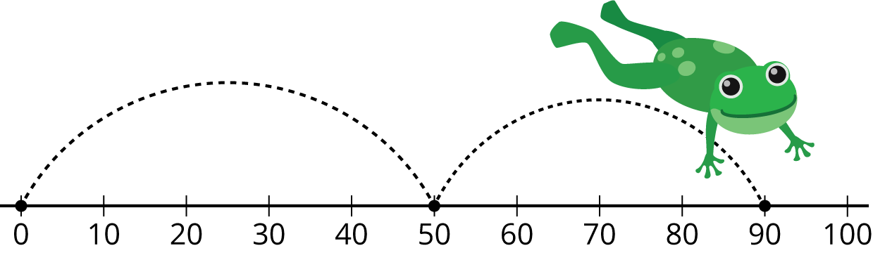
Number Line Scoot
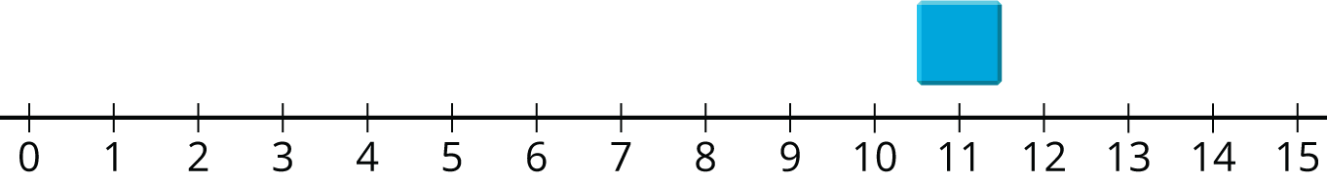
How Close?
Unable to process <img src="/tikz_files/237760.svg">Failed: rsvg-convert --format png --dpi-x 300 --dpi-y 300 /app/tmp/svgtopng-1786380956.6394427.svg --output /app/tmp/svgtopng-1786380956.6394427.png Backtrace: /app/app/services/script/runner.rb:34:in `block in run_cmd' <internal:kernel>:90:in `tap' /app/app/services/script/runner.rb:32:in `run_cmd' /app/app/services/script/svg_to_png.rb:27:in `convert_svg_to_png' /app/app/services/script/svg_to_png.rb:17:in `to_png' /app/vendor/bundle/ruby/3.3.0/gems/embeddable_content-1.1.0/app/services/embeddable_content/images/image_downloader.rb:37:in `png_rendered_from_svg' /app/vendor/bundle/ruby/3.3.0/gems/embeddable_content-1.1.0/app/services/embeddable_content/images/image_downloader.rb:33:in `raw_image_data' /app/vendor/bundle/ruby/3.3.0/gems/embeddable_content-1.1.0/app/services/embeddable_content/images/image_downloader.rb:13:in `block in save' <internal:kernel>:90:in `tap' /app/vendor/bundle/ruby/3.3.0/gems/embeddable_content-1.1.0/app/services/embeddable_content/images/image_downloader.rb:13:in `save'

