Unit 1 Lesson 16: Compare & Contrast

1 Math Talk: Measuring Up (Warm up)

Student Task Statement
What is the distance between the markings?
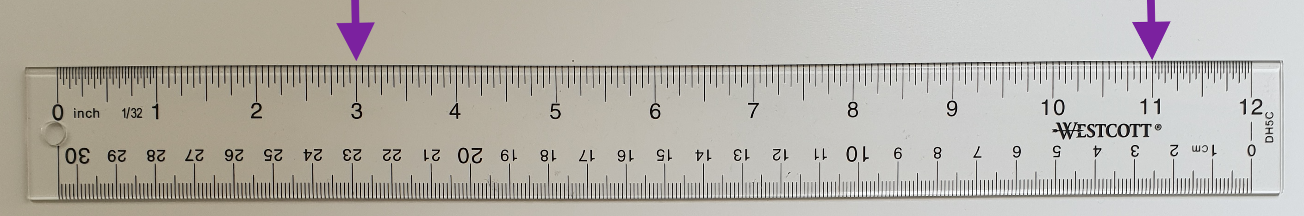
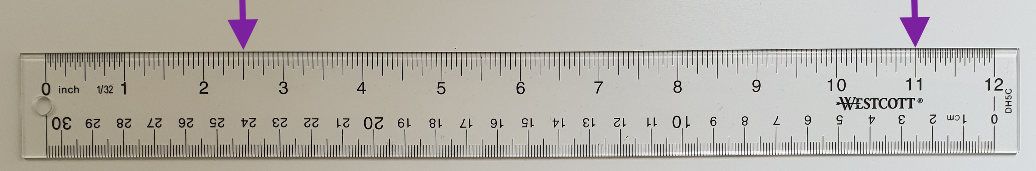
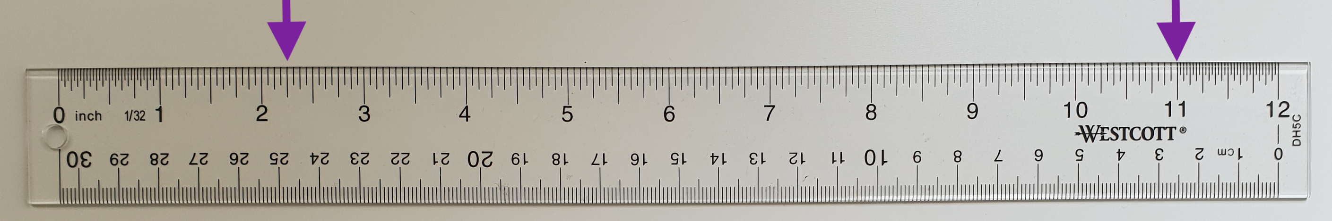
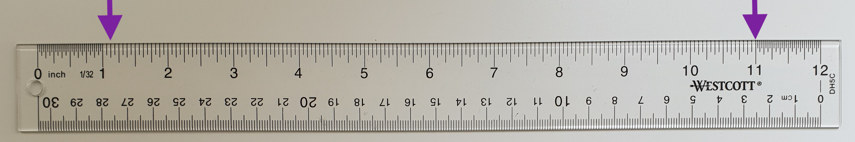

2 Compare & Contrast

Student Task Statement
Here are the shoe sizes from two cohorts in the military.
Cohort A:
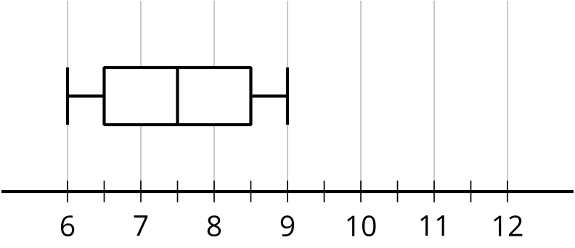
​​​​​
Cohort B:
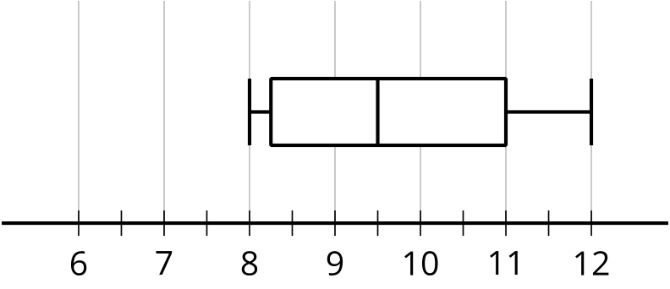
- Is there any overlap between the two data sets? Explain your reasoning.
- Which cohort has more variability?
- Does at least one person from cohort A have a bigger shoe size than someone from cohort B? Explain your reasoning.
- Compare the measures of center.

3 Compare & Contrast Continued

Student Task Statement
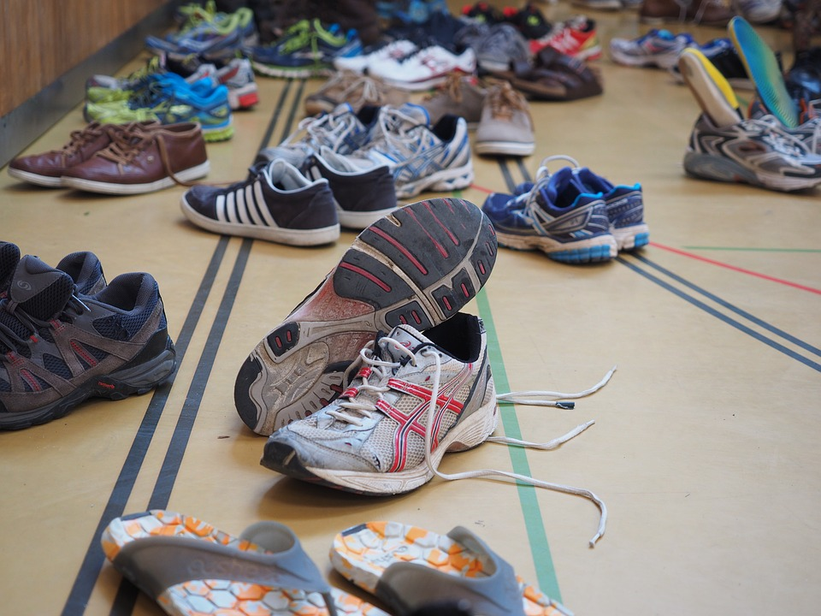
Here are the shoes sizes of some grade 9 and grade 12 students.
Grade 9 shoe sizes:
6 | 8 | 6.5 | 7.5 | 7 | 6.5 | 9 | 6
8.5 | 7.5 | 8 | 10 | 11 | 8 | 9

Grade 12 shoe sizes:
10 | 9 | 10.5 | 8.5 | 10 | 9 | 9.5 | 8
8 | 11 | 9 | 9.5 | 11 | 10.5 | 8.5

- Create a box plot, dot plot, or histogram to represent both sets of data.
- Describe the distribution shapes.
- Complete the table.
 | - mean | - median | - IQR | - standard deviation
- grade 9
shoe sizes
- grade 12
shoe sizes
- Does one grade’s shoe sizes have more variation than the other? Explain how you know.
- Compare the measures of center for the two sets of shoe sizes.
- Do the distributions overlap? Use the data display you created to explain how you know.
© CC BY 2019 by Illustrative Mathematics®

