Lesson 2: Using Diagrams to Represent Addition and Subtraction
Let’s represent addition and subtraction of decimals.

2.1: Changing Values
- Here is a rectangle.
- 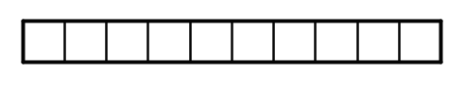
- What number does the rectangle represent if each small square represents:
  - 1
  - 0.1
  - 0.01
  - 0.001
- Here is a square.
- 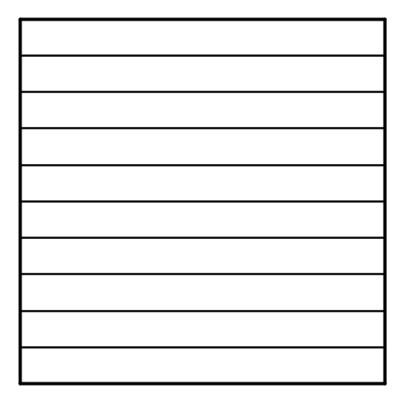
- What number does the square represent if each small rectangle represents:
  - 10
  - 0.1
  - 0.00001

2.2: Squares and Rectangles
You may be familiar with base-ten blocks that represent ones, tens, and hundreds. Here are some diagrams that we will use to represent base-ten units.
- A large square represents 1 one.
- A medium rectangle represents 1 tenth.
- A medium square represents 1 hundredth.
- A small rectangle represents 1 thousandth.
- A small square represents 1 ten-thousandth.
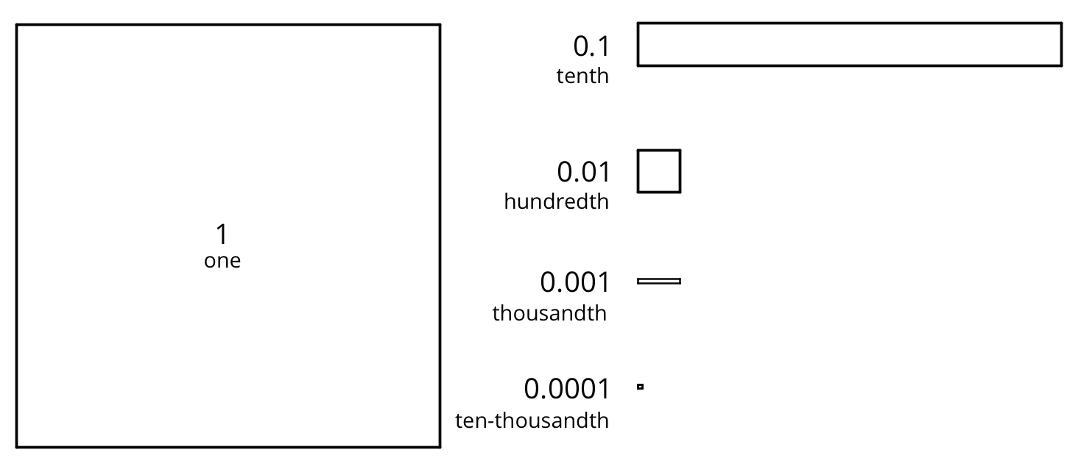
- Here is the diagram that Priya drew to represent 0.13. Draw a different diagram that represents 0.13. Explain why both diagrams represent the same number.
- 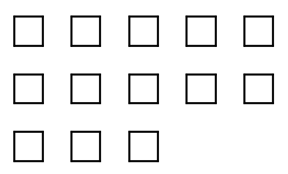

- Here is the diagram that Han drew to represent 0.025. Draw a different diagram that represents 0.025. Explain why both diagrams represent the same number.
- 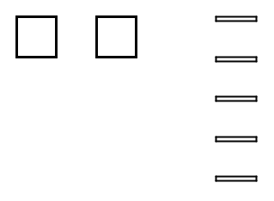

- For each number, draw or describe two different diagrams that represent it.
  - 0.1
  - 0.02
  - 0.004
- Use diagrams of base-ten units to represent each sum. Think about how you could use as few units as possible to represent each number.
  - $0.03+0.05$
  - $0.006+0.007$
  - $0.4+0.7$

2.3: Finding Sums in Different Ways
- Here are two ways to calculate the value of $0.26+0.07$. In the diagram, each rectangle represents 0.1 and each square represents 0.01.
- 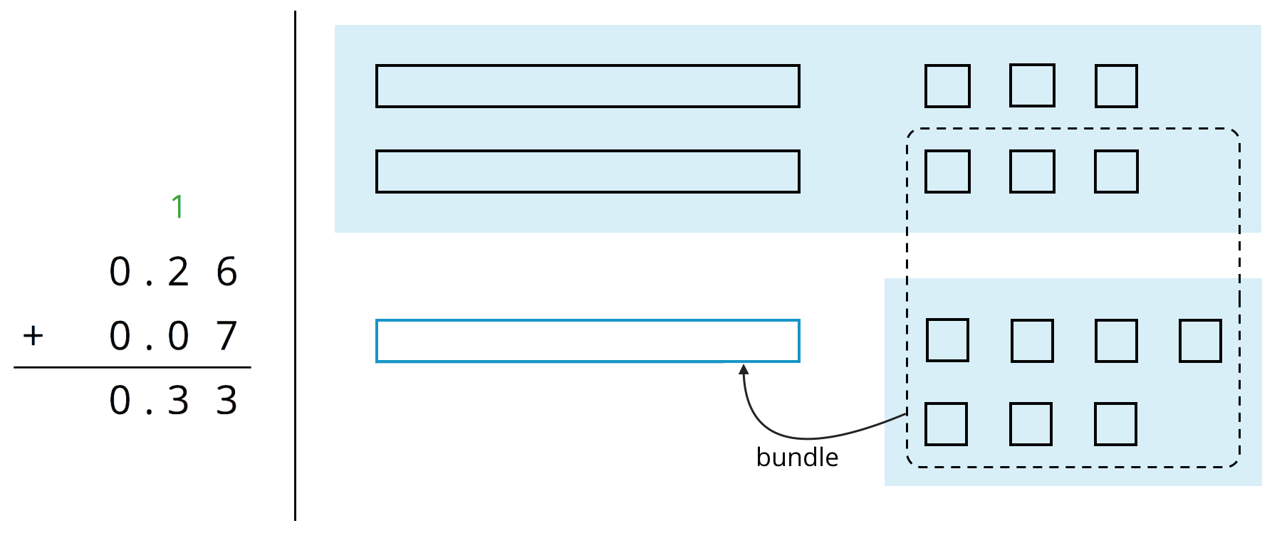
- Use what you know about base-ten units and addition to explain:
  - Why ten squares can be “bundled” into a rectangle.
  - How this “bundling” is represented in the vertical calculation.
- Find the value of $0.38+0.69$ by drawing a diagram. Can you find the sum without bundling? Would it be useful to bundle some pieces? Explain your reasoning.
- Calculate $0.38+0.69$. Check your calculation against your diagram in the previous question.
- Find each sum. The larger square represents 1.

  - 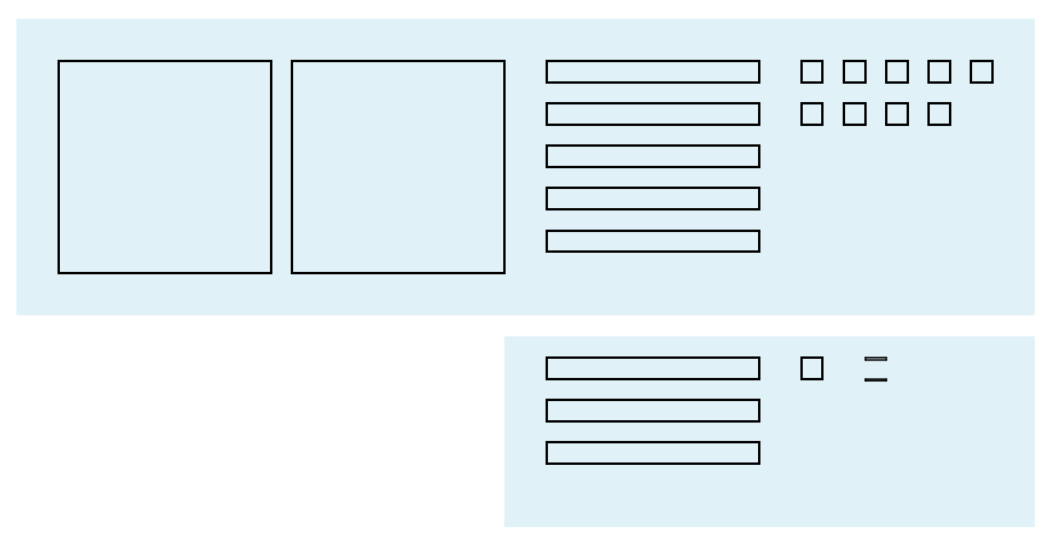

  - 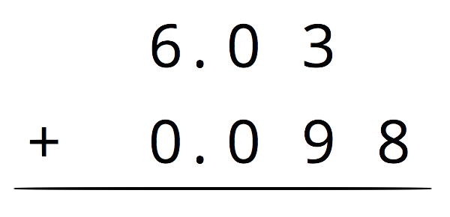

Are you ready for more?
A distant, magical land uses jewels for their bartering system. The jewels are valued and ranked in order of their rarity. Each jewel is worth 3 times the jewel immediately below it in the ranking. The ranking is red, orange, yellow, green, blue, indigo, and violet. So a red jewel is worth 3 orange jewels, a green jewel is worth 3 blue jewels, and so on.
- If you had 500 violet jewels and wanted to trade so that you carried as few jewels as possible, which jewels would you have?
- Suppose you have 1 orange jewel, 2 yellow jewels, and 1 indigo jewel. If you’re given 2 green jewels and 1 yellow jewels, what is the fewest number of jewels that could represent the value of the jewels you have?

2.4: Representing Subtraction
- Here are diagrams that represent differences. Removed pieces are marked with Xs. The larger rectangle represents 1 tenth. For each diagram, write a numerical subtraction expression and determine the value of the expression.
- 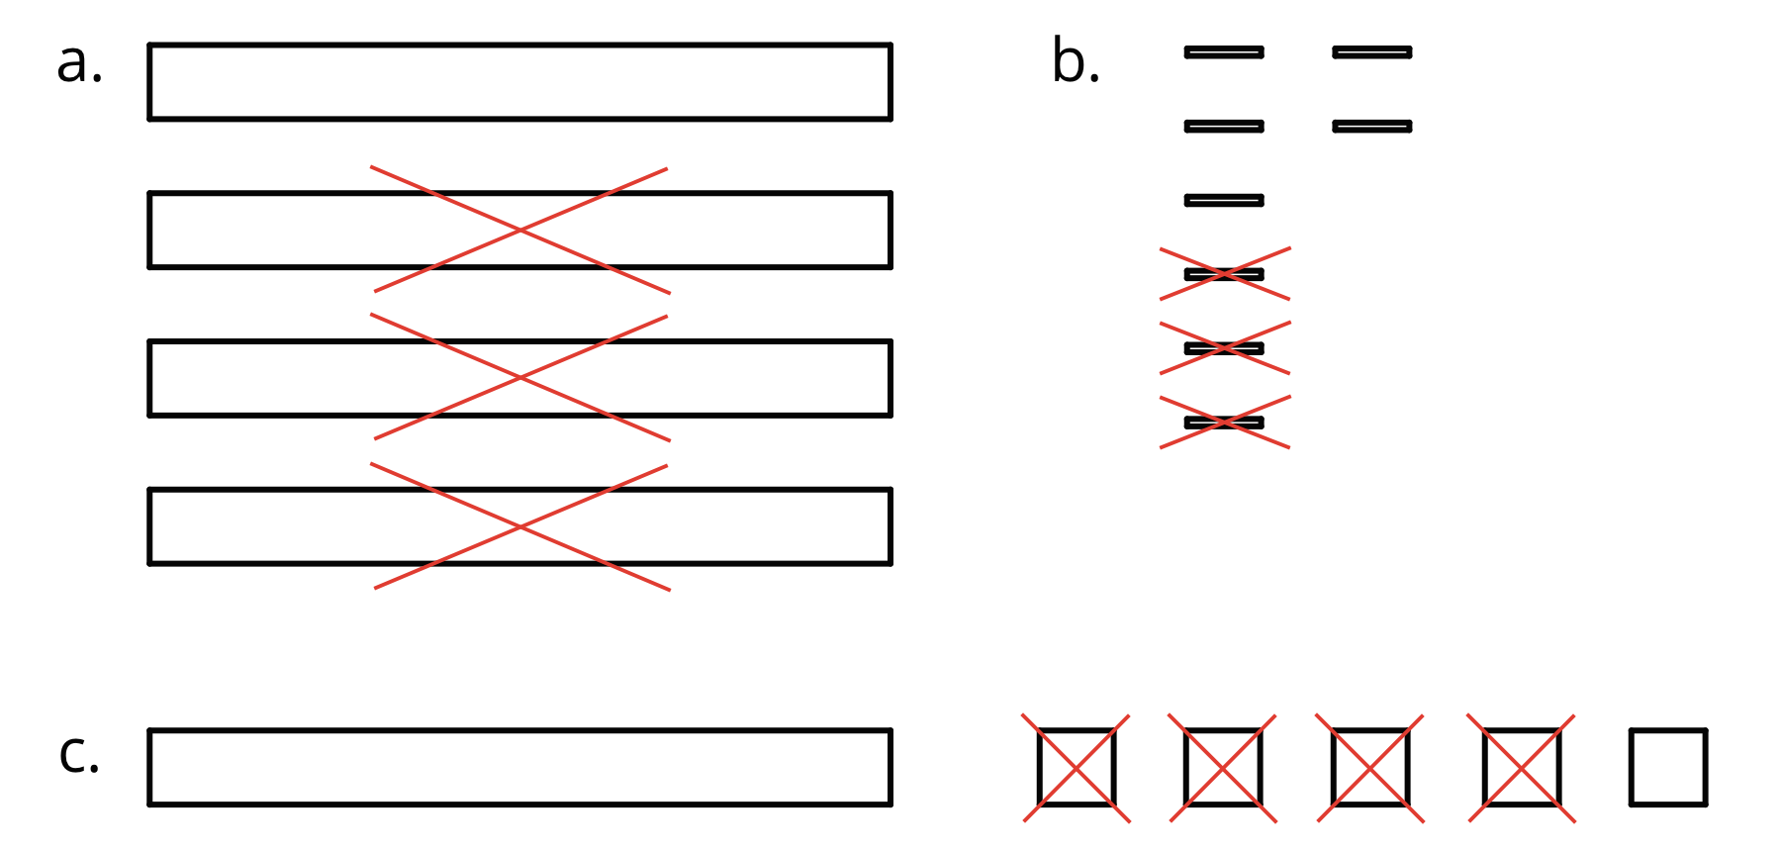
- Express each subtraction in words.
  - $0.05−0.02$
  - $0.024−0.003$
  - $1.26−0.14$
- Find each difference by drawing a diagram and by calculating with numbers. Make sure the answers from both methods match. If not, check your diagram and your numerical calculation.
  - $0.05−0.02$
  - $0.024−0.003$
  - $1.26−0.14$

Lesson 2 Summary
Base-ten diagrams represent collections of base-ten units—tens, ones, tenths, hundredths, etc. We can use them to help us understand sums of decimals.
Suppose we are finding $0.08+0.13$. Here is a diagram where a square represents 0.01 and a rectangle (made up of ten squares) represents 0.1.
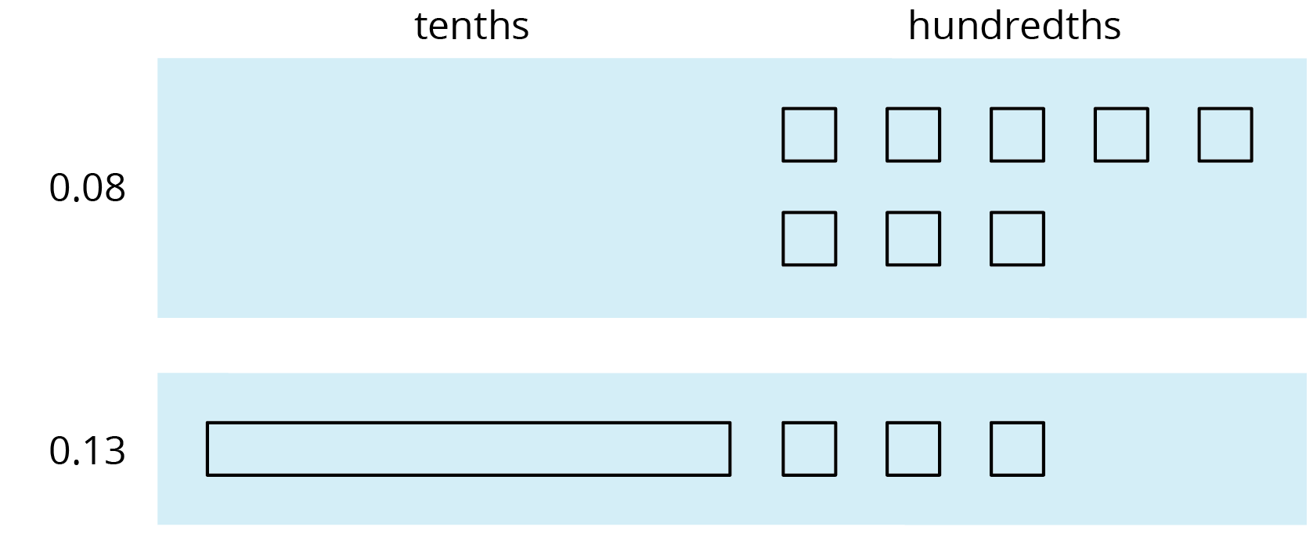
To find the sum, we can “bundle” (or compose) 10 hundredths as 1 tenth.
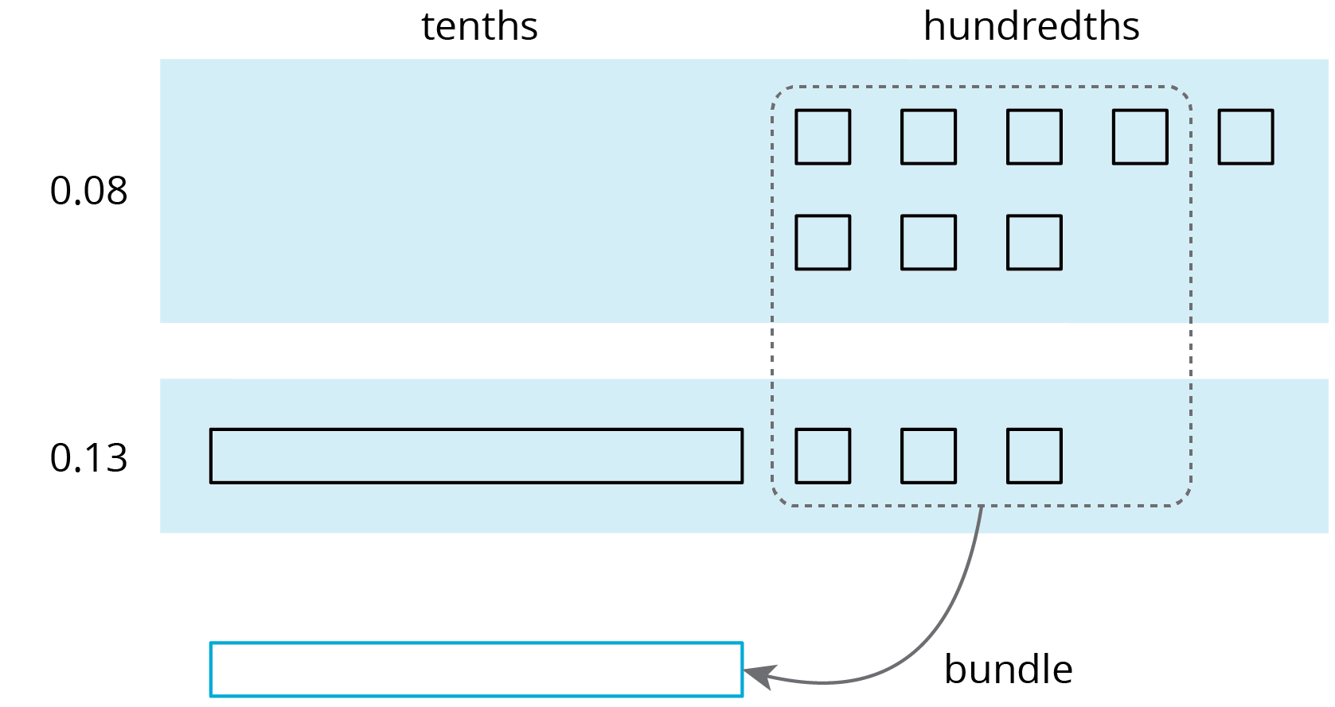
We now have 2 tenths and 1 hundredth, so $0.08+0.13=0.21$.
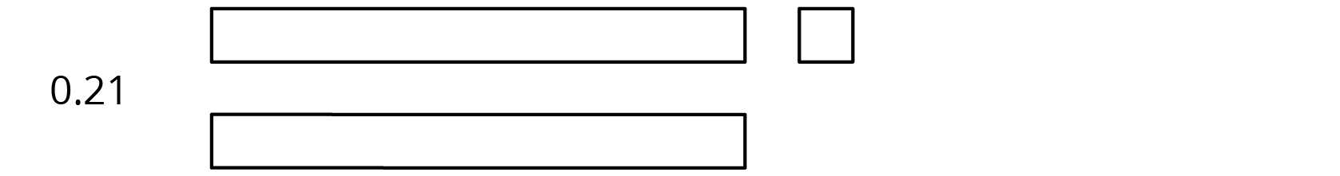
We can also use vertical calculation to find $0.08+0.13$.
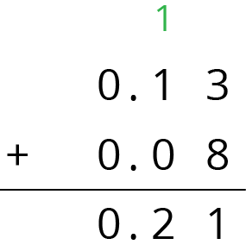
Notice how this representation also shows 10 hundredths are bundled (or composed) as 1 tenth.
This works for any decimal place. Suppose we are finding $0.008+0.013$. Here is a diagram where a small rectangle represents 0.001.
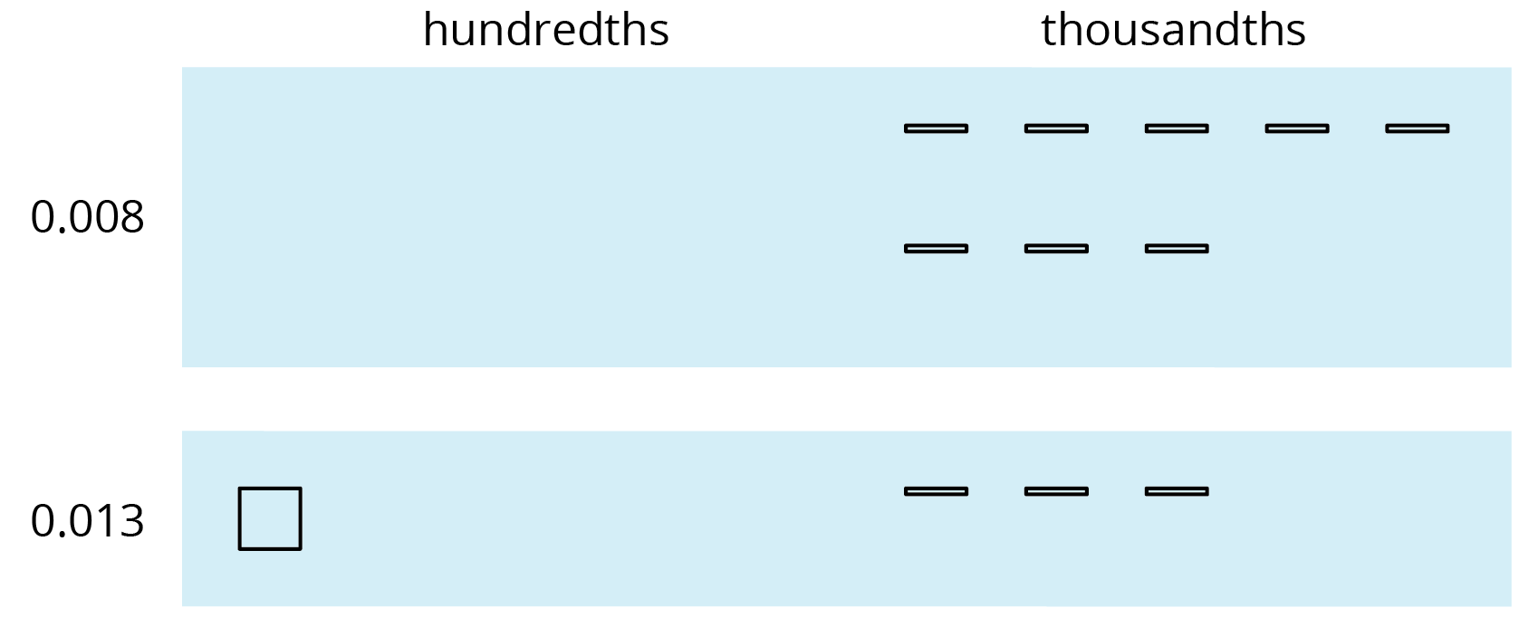
We can “bundle” (or compose) 10 thousandths as 1 hundredth.
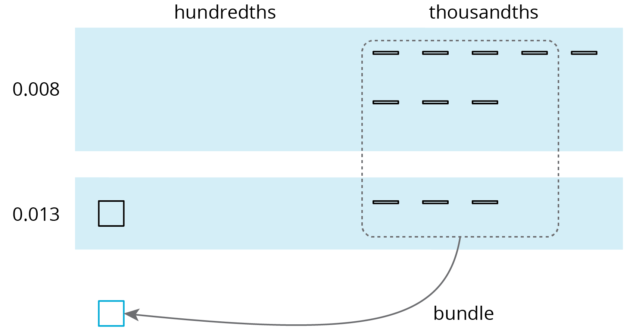
The sum is 2 hundredths and 1 thousandth.
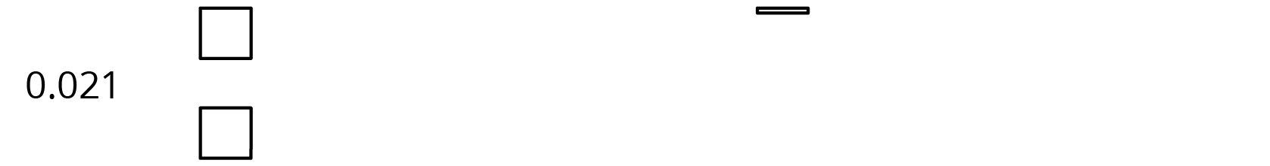
Here is a vertical calculation of $0.008+0.013$.
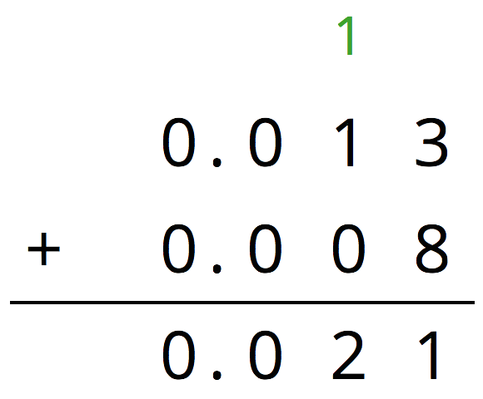
© CC BY Open Up Resources. Adaptations CC BY IM.

