Unit 6 Lesson 17: Changing the Vertex

1 Graphs of Two Functions (Warm up)

Student Task Statement
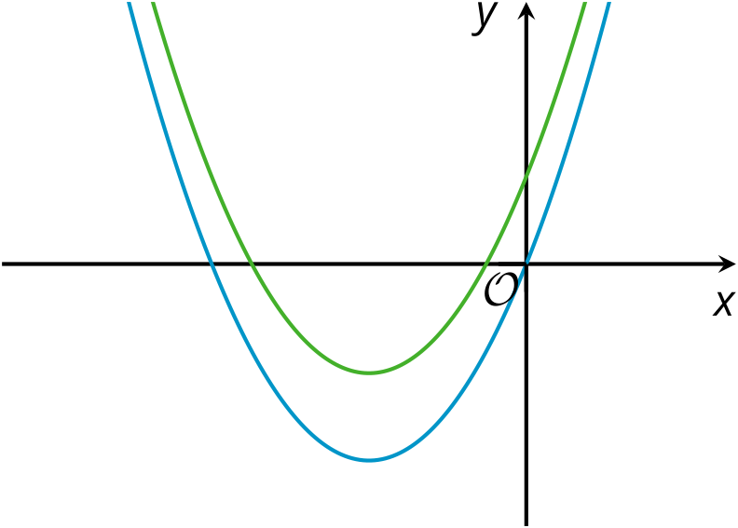
Here are graphs representing the functions $f$ and $g$, given by $f\left(x\right)=x\left(x+6\right)$ and $g\left(x\right)=x\left(x+6\right)+4$.
- Which graph represents each function? Explain how you know.
- Where does the graph of $f$ meet the $x$-axis? Explain how you know.

2 Shifting the Graph

Student Task Statement
- How would you change the equation $y=x^{2}$ so that the vertex of the graph of the new equation is located at the following coordinates and the graph opens as described?
  - $\left(0,11\right)$, opens up
  - $\left(7,11\right)$, opens up
  - $\left(7,\text{-}3\right)$, opens down
- Use graphing technology to verify your predictions. Adjust your equations if necessary.
- Kiran graphed the equation $y=x^{2}+1$ and noticed that the vertex is at $\left(0,1\right)$. He changed the equation to $y={\left(x−3\right)}^{2}+1$ and saw that the graph shifted 3 units to the right and the vertex is now at $\left(3,1\right)$.
- Next, he graphed the equation $y=x^{2}+2x+1$, observed that the vertex is at $\left(\text{-}1,0\right)$. Kiran thought, “If I change the squared term $x^{2}$ to ${\left(x−5\right)}^{2}$, the graph will move 5 units to the right and the vertex will be at $\left(4,0\right)$.”
- Do you agree with Kiran? Explain or show your reasoning.

3 A Peanut Jumping over a Wall

Images for Launch
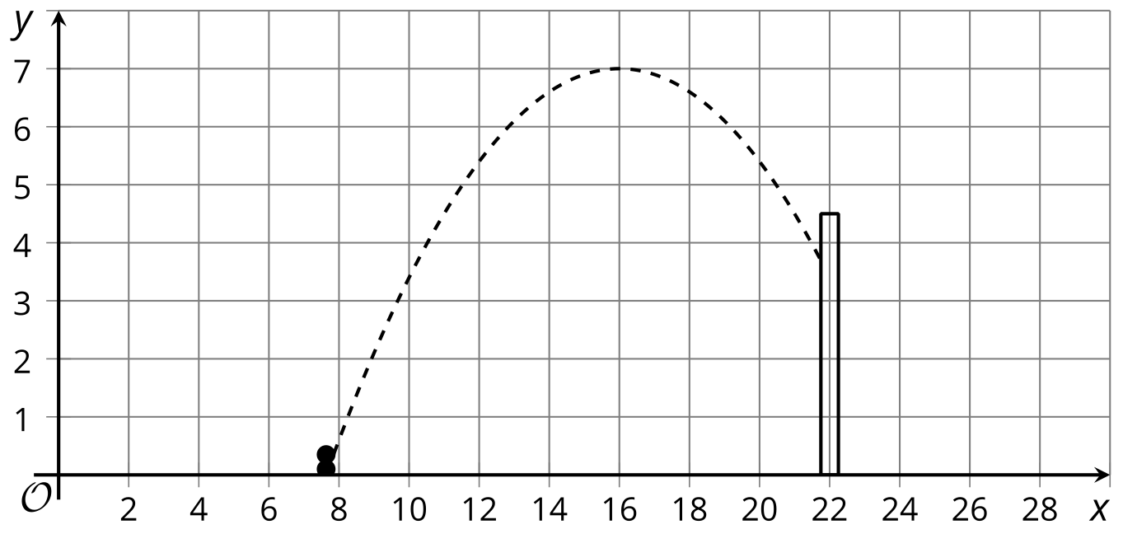

Student Task Statement
Mai is learning to create computer animation by programming. In one part of her animation, she uses a quadratic function to model the path of the main character, an animated peanut, jumping over a wall.
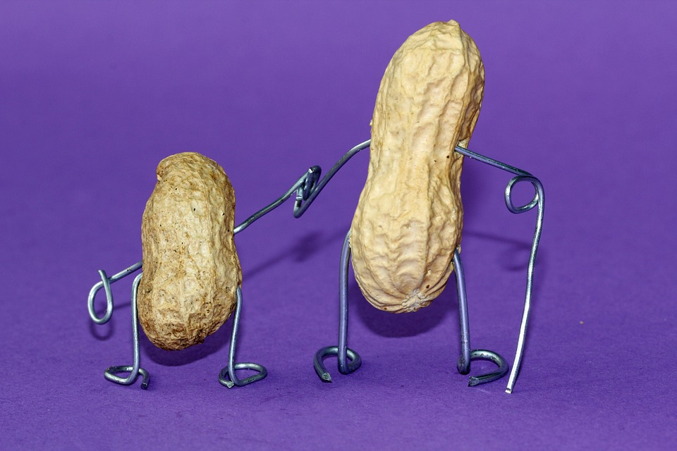
Mai uses the equation $y=\text{-}0.1{\left(x−h\right)}^{2}+k$ to represent the path of the jump. $y$ represents the height of the peanut as a function of the horizontal distance it travels, $x$.
On the screen, the base of the wall is located at $\left(22,0\right)$, with the top of the wall at $\left(22,4.5\right)$. The dashed curve in the picture shows the graph of 1 equation Mai tried, where the peanut fails to make it over the wall.
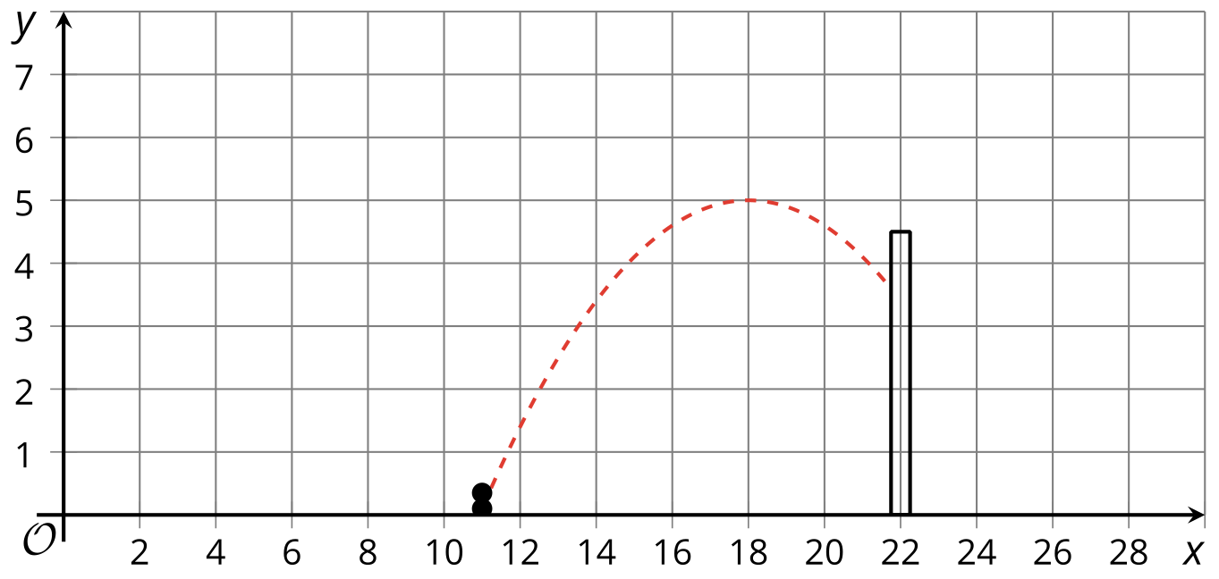
- What are the values of $h$ and $k$ in this equation?
- Starting with Mai’s equation, choose values for $h$ and $k$ that will guarantee the peanut stays on the screen but also makes it over the wall. Be prepared to explain your reasoning.

4 Smiley Face (Optional)

Student Task Statement
Do you see 2 “eyes” and a smiling “mouth” on the graph? The 3 arcs on the graph all represent quadratic functions that were initially defined by $y=x^{2}$, but whose equations were later modified.
- Write equations to represent each curve in the smiley face.
- What domain is used for each function to create this graph?
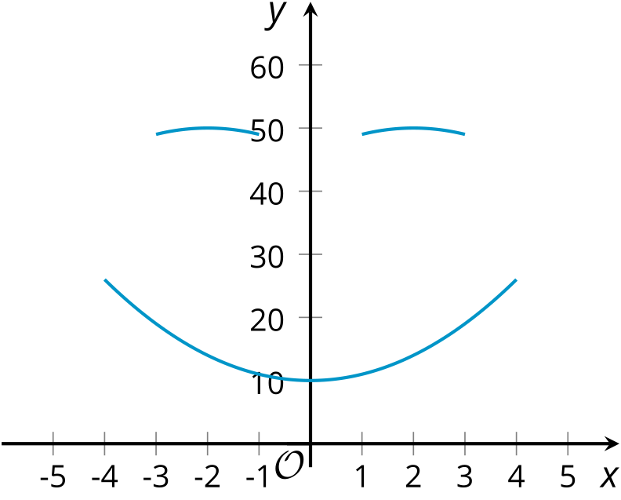

© CC BY 2019 by Illustrative Mathematics®

