Lesson 4: Interpret Division Expressions
- Let’s make sense of division expressions.

Warm-up: Number Talk: More or Less?
Find the value of each expression mentally.
- $500−475$
- $504−475$
- $512−475$
- $512−449$

4.1: Spinning Tops
Spinning tops are popular around the world. Here are spinning tops from a few different cultures.
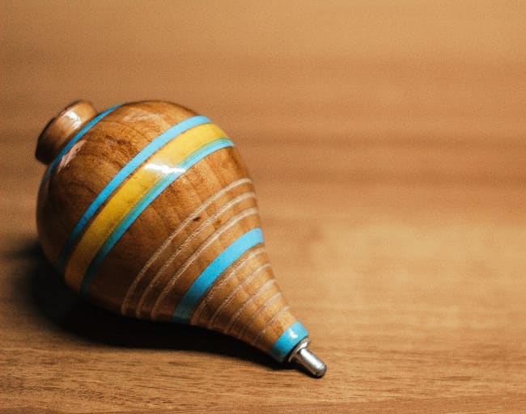
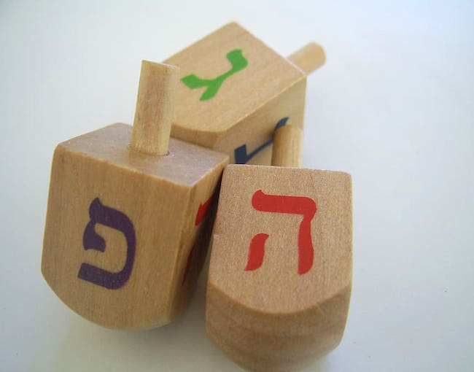
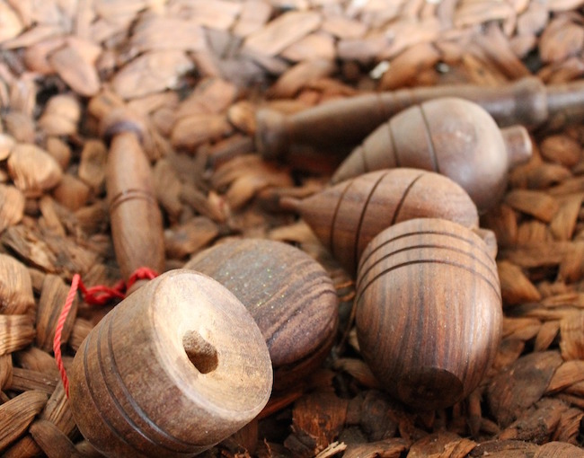
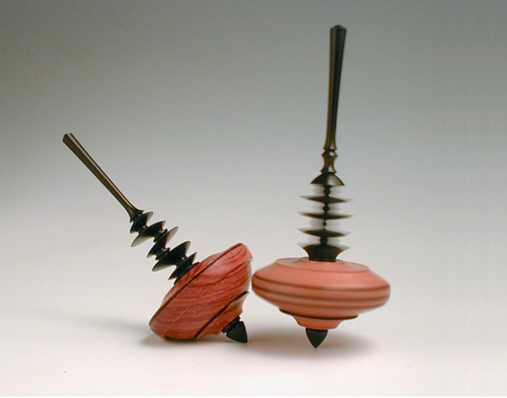
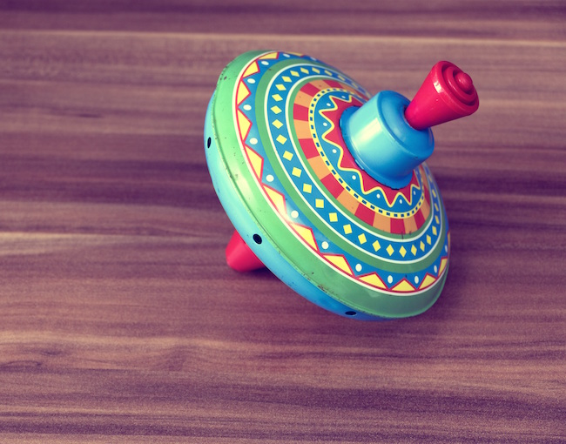
Match each situation about spinning tops with an expression that can represent it.
1. Clare has a collection of 24 spinning tops in four colors. She has the same number of tops in black, white, red, and green. How many tops of each color does she have?
A. $24÷2$
2. Priya and her friend are decorating 24 wooden tops with paint. If each person is painting the same number of tops, how many tops is each person painting?
B. $12÷2$
3. A store has 24 tops from around the world displayed in 6 boxes. Each box contains the same number of tops. How many tops are in each box?
C. $24÷4$
4. Diego has 12 trompos that he wants to give as gifts. If he gives each friend 2 trompos, how many friends can get them as gifts?
D. $12÷6$
5. Six friends are playing with 12 dreidels. If everyone is playing with the same number of dreidels, how many dreidels does each person have?
E. $24÷6$

4.2: Cars in Boxes
Consider these two situations.
A. Han has 21 toy cars. He puts the same number of cars in each of 3 boxes. How many cars will be in each box?
B. Han has 21 toy cars. He wants to put 3 cars in each box. How many boxes will he need?
Which situation does the expression $21÷3$ represent? Explain your reasoning.
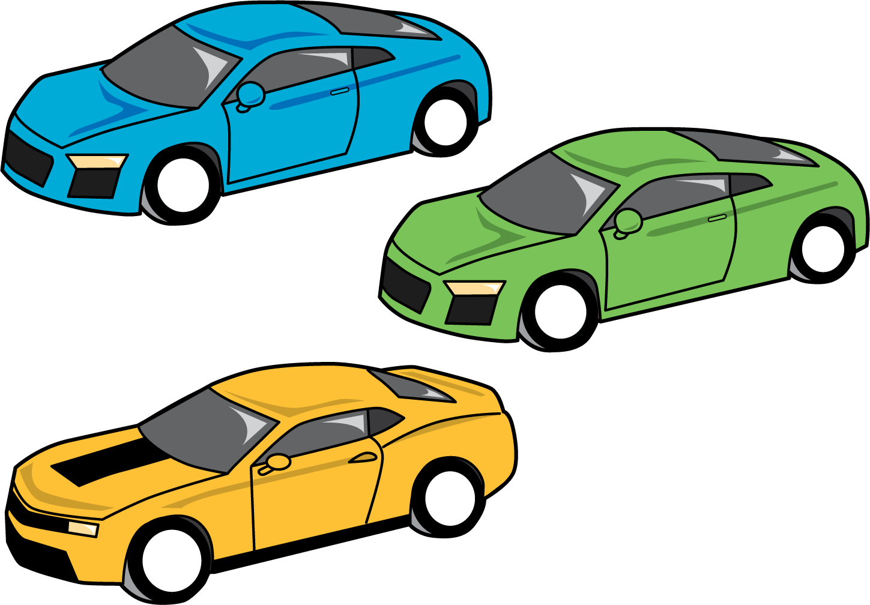

4.3: Stacks of Blocks
Match each situation to a drawing and an expression that represent the situation. Be prepared to explain your reasoning.
- Kiran uses 6 blocks to make stacks. Each stack has 2 blocks. How many stacks are there?
- Han uses 6 blocks to make two equal stacks. How many blocks are in each stack?
- Jada uses 6 blocks to build stacks with 3 blocks each. How many stacks are there?
- Mai uses 6 blocks to make 3 equal stacks. How many blocks are in each stack?
drawings
A
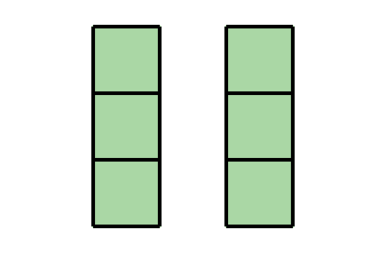
B
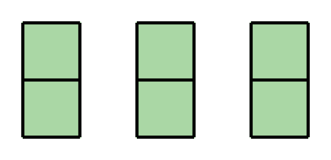
expressions
C
$6÷2$
D
$6÷3$
© CC BY 2021 Illustrative Mathematics®

