Grade 6
Unit 5Lesson 14CC BY NC Illustrative Mathematics, based on IM 6–8 Math, CC BY Open Up Resources.
Unit 5, Lesson 14

Solving Problems Involving Decimals
Let’s solve some problems using decimals.
Grade 6
Unit 5Lesson 14CC BY NC Illustrative Mathematics, based on IM 6–8 Math, CC BY Open Up Resources.

14.1Math Talk: Close Estimates
Decide mentally which value is the best estimate for each expression.
- $124.3÷2$
  - 6
  - 60
  - 600
- $124.3÷24$
  - 0.5
  - 5
  - 50
- $12.43÷80$
  - 0.15
  - 1.5
  - 15
- $1.243÷1.6$
  - 0.075
  - 0.75
  - 7.5
Grade 6
Unit 5Lesson 14CC BY NC Illustrative Mathematics, based on IM 6–8 Math, CC BY Open Up Resources.

14.2Information Gap: Two Ropes and a Traveling Tortoise
Your teacher will give you either a problem card or a data card. Do not show or read your card to your partner.
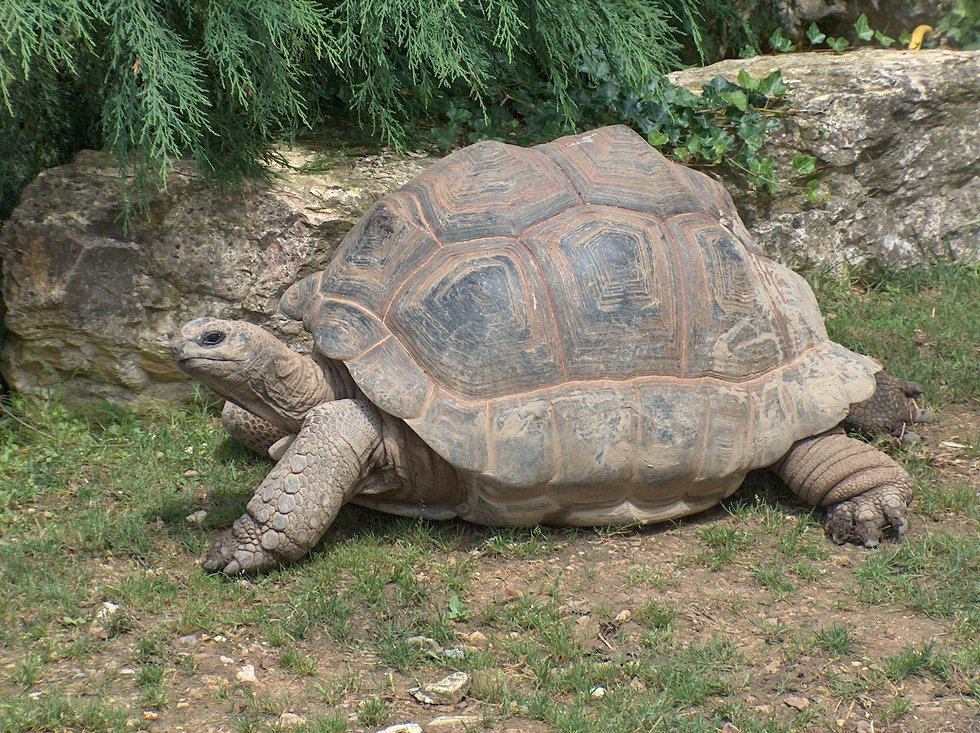
If your teacher gives you the problem card:
- Silently read your card, and think about what information you need to answer the question.
- Ask your partner for the specific information that you need. “Can you tell me $\underset{_}{​}$?”
- Explain to your partner how you are using the information to solve the problem. “I need to know $\underset{_}{​}$ because . . . .”
- Continue to ask questions until you have enough information to solve the problem.
- Once you have enough information, share the problem card with your partner, and solve the problem independently.
- Read the data card, and discuss your reasoning.
If your teacher gives you the data card:
- Silently read your card. Wait for your partner to ask for information.
- Before telling your partner any information, ask, “Why do you need to know $\underset{_}{​}$?”
- Listen to your partner’s reasoning, and ask clarifying questions. Give only information that is on your card. Do not figure out anything for your partner!
- These steps may be repeated.
- Once your partner says there is enough information to solve the problem, read the problem card, and solve the problem independently.
- Share the data card, and discuss your reasoning.
Grade 6
Unit 5Lesson 14CC BY NC Illustrative Mathematics, based on IM 6–8 Math, CC BY Open Up Resources.

14.3Distance between Hurdles
Here is some information about a race track:
- There are 10 equally-spaced hurdles on the track.
- The first hurdle is 13.72 meters from the start line.
- The final hurdle is 14.02 meters from the finish line.
- The race track is 110 meters long.
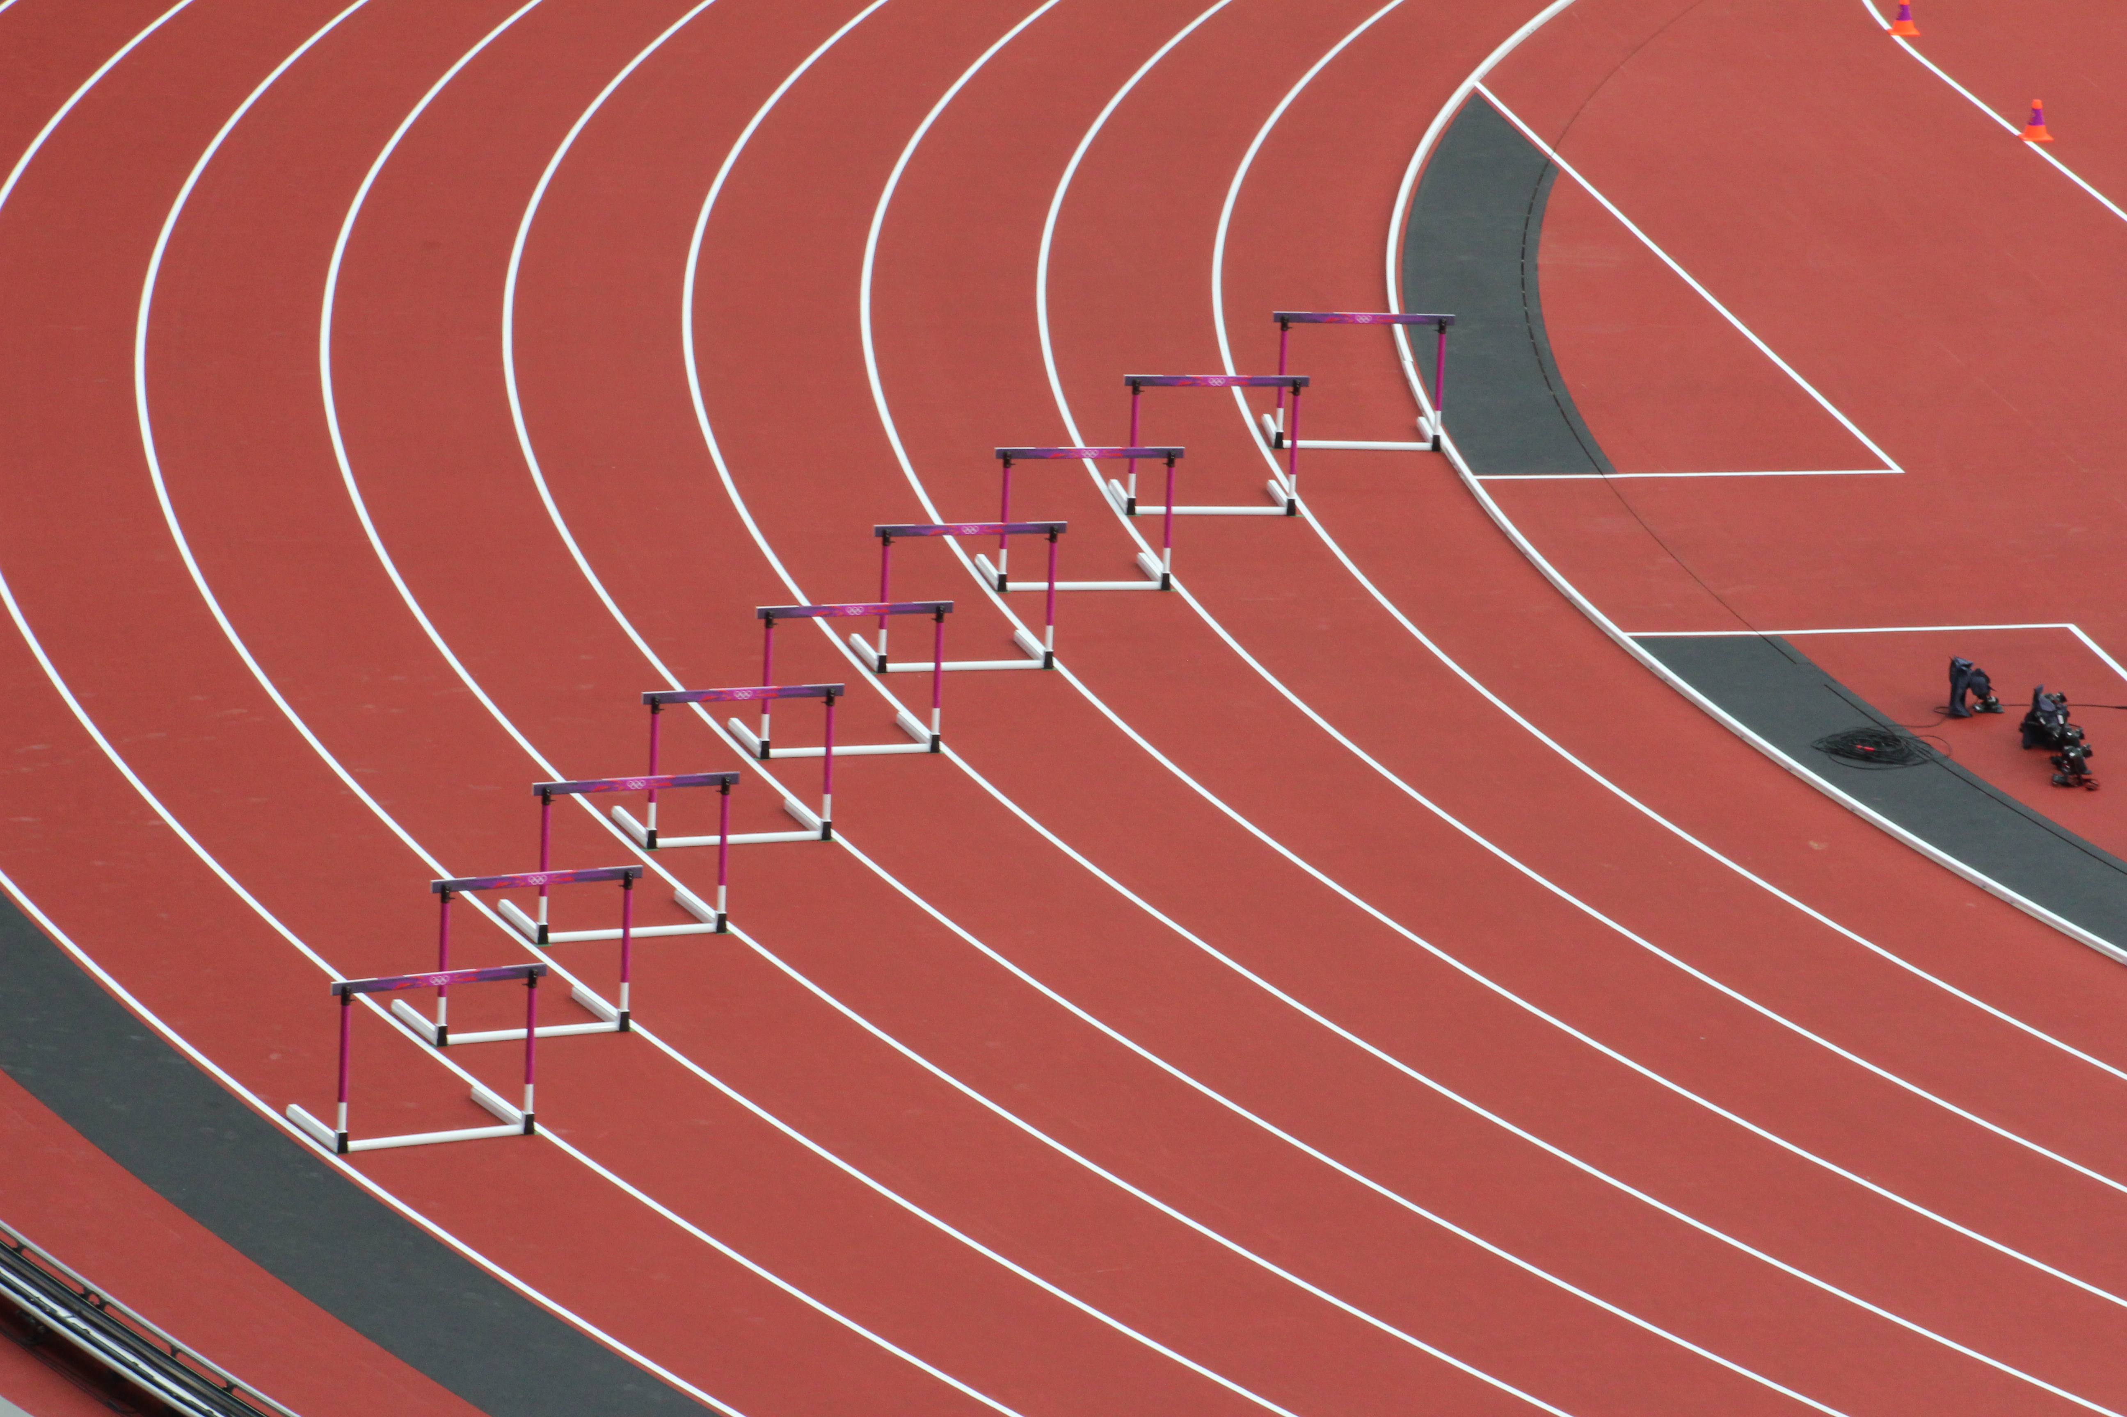
- Draw a diagram that shows the hurdles on the race track. Label all known measurements.
- How far are the hurdles from one another? Explain or show your reasoning.
- A professional runner takes 3 strides between each pair of hurdles. The runner leaves the ground 2.2 meters before the hurdle and returns to the ground 1 meter after the hurdle.
- About how long are each of the runner’s strides between the hurdles? Show your reasoning.
Grade 6
Unit 5Lesson 14CC BY NC Illustrative Mathematics, based on IM 6–8 Math, CC BY Open Up Resources.

14.4Examining a Tennis Court
Here is a diagram of a tennis court.
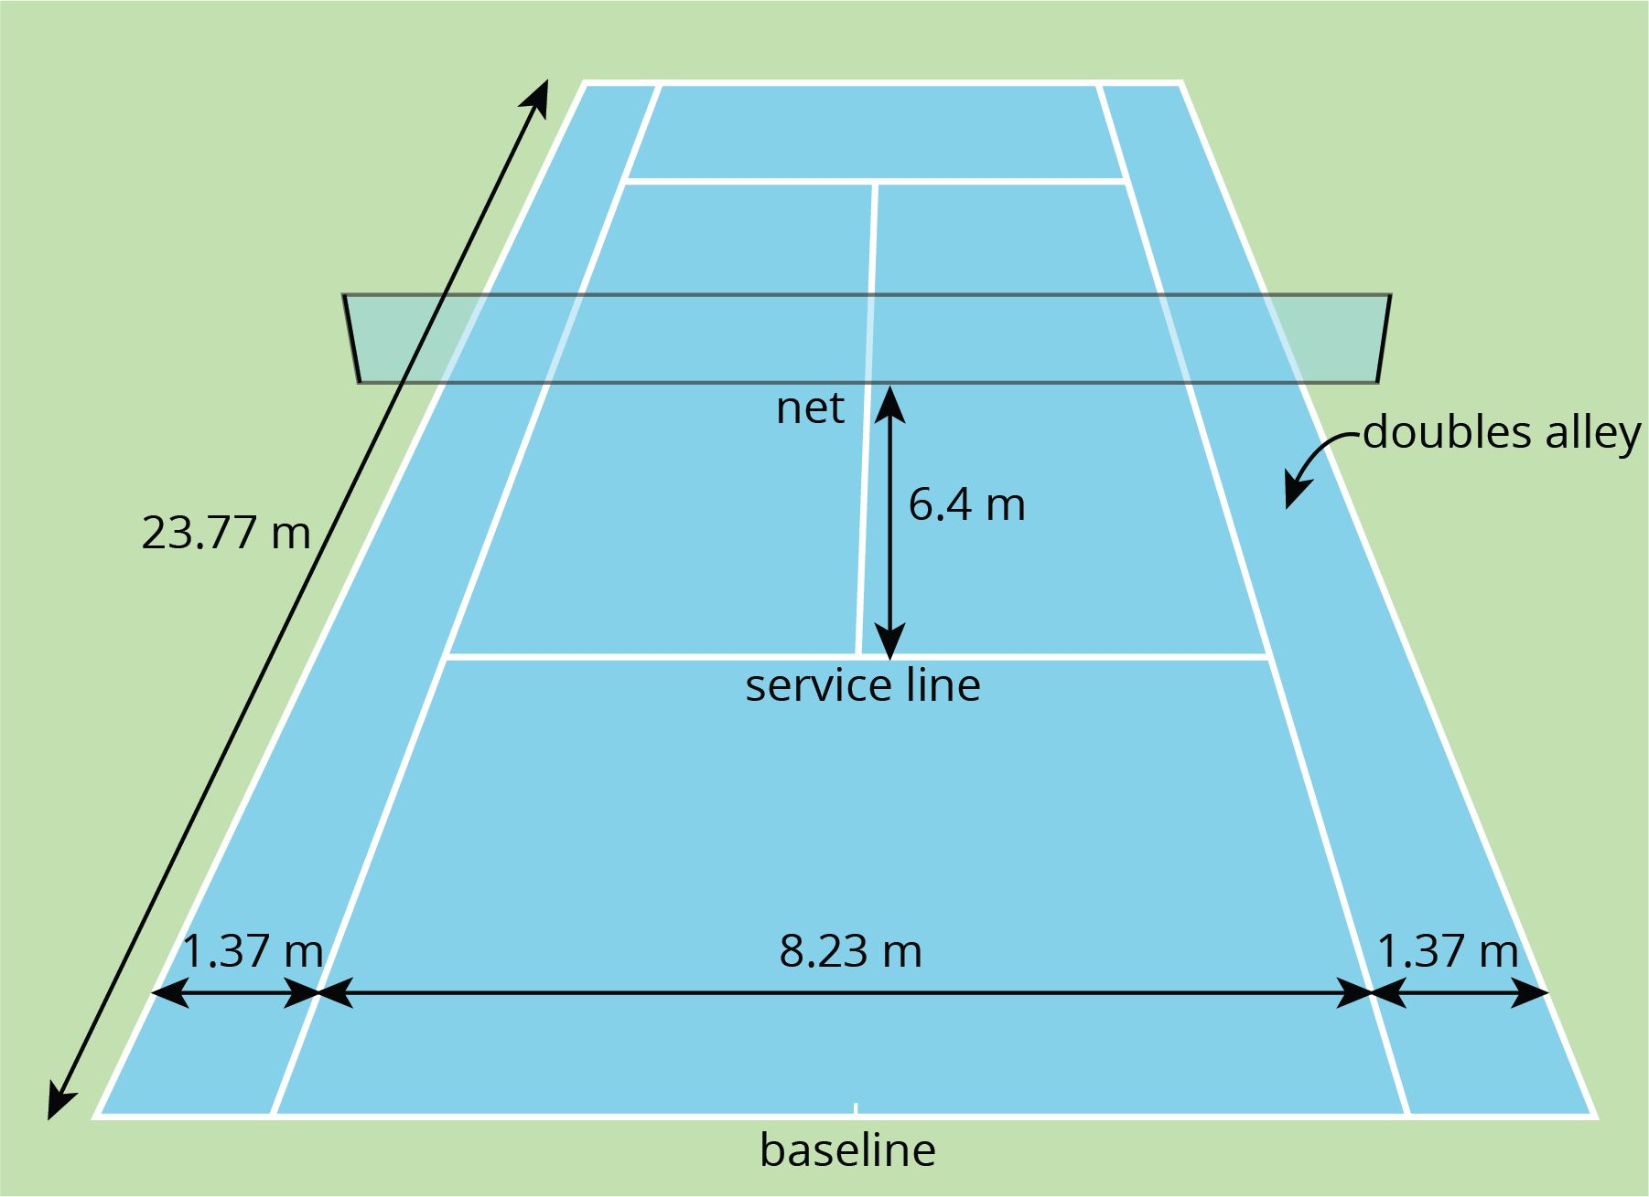
The full tennis court, used for doubles, is a rectangle. All of the angles made by the line segments in the diagram are right angles.
For each question, explain or show your reasoning.
- The net partitions the tennis court into two halves. Is each half a square?
- Is the service line halfway between the net and the baseline?
- Lines painted on a tennis court are 5 cm wide. A painter made markings to show the length and width of the court, then painted the lines to the outside of the markings.
  - Did the painter’s mistake increase or decrease the overall size of the tennis court?
  - By how many square meters did the court’s size change?

Lesson 14 Summary
Many quantities we encounter in everyday situations involve decimals, so solving real-world problems often means adding, subtracting, multiplying, or dividing decimals.
Making sense of the quantities in a situation and how they are related is key to problem solving. Drawing a diagram can help us visualize what is happening in a problem.
Here’s an example: Suppose 10 road signs need to be placed along a 1.35-km stretch of a new road. If there is one sign at each end of the road and the signs must be spaced evenly, what is the distance between the signs?
A diagram can help us set up the problem and see that there are only nine spaces between the signs, which means we need to find $1.35÷9$ to answer the question.
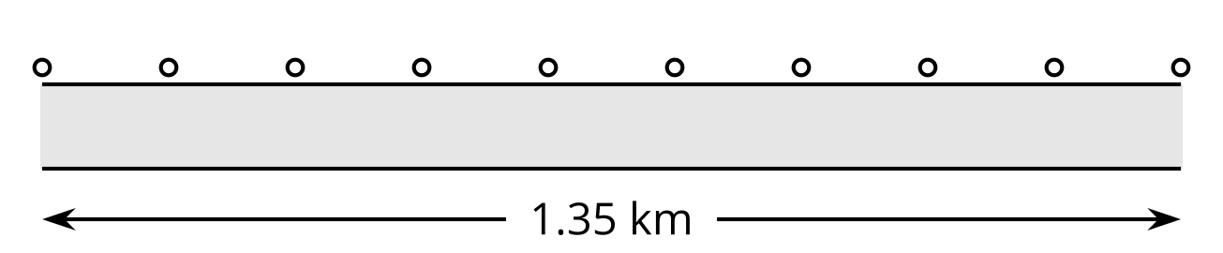
To communicate information clearly and solve problems correctly, it is also important to be precise in our measurements and calculations, especially when they involve decimals.
In tennis, for example, the length of the court is 23.77 m. Because the boundary lines on a tennis court are at least 5 cm wide, we would want to know whether this measurement is taken between the inside of the lines, the center of the lines, or the outside of the lines. Diagrams can help us pay attention to this detail, as shown here.
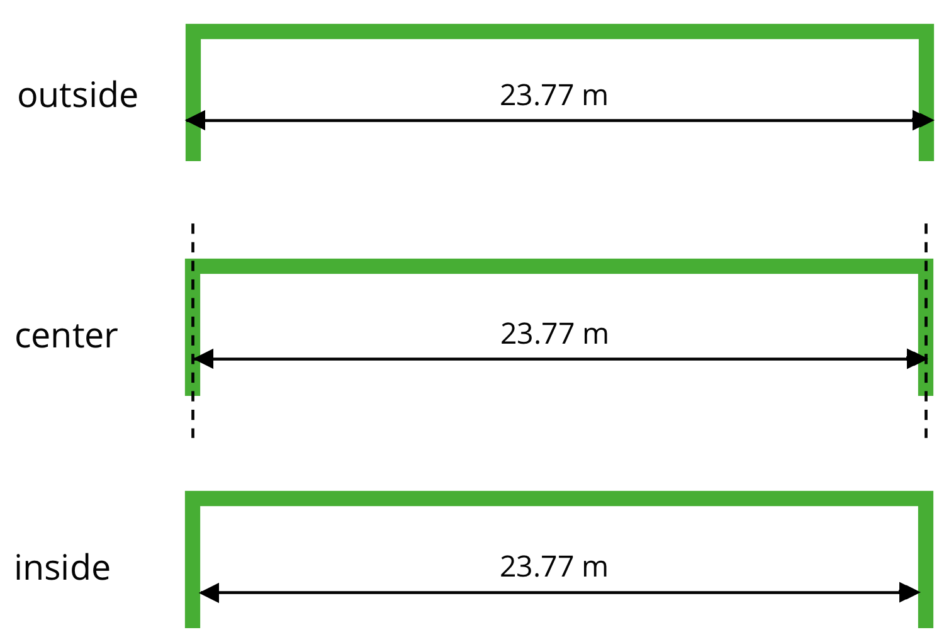
To the tennis players who use the court, it matters that this measurement is accurate, because their shots need to be on or within certain lines. If the court on which they play is not precisely measured, their shots may not land as intended.

