Unit 2 Lesson 3: Writing Equations to Model Relationships (Part 2)

1 Finding a Relationship (Warm up)

Student Task Statement
Here is a table of values. The two quantities, $x$ and $y$, are related.
$x$ | $y$
1 | 0
3 | 8
5 | 24
7 | 48
What are some strategies you could use to find a relationship between $x$ and $y$? Brainstorm as many ways as possible.

Activity Synthesis
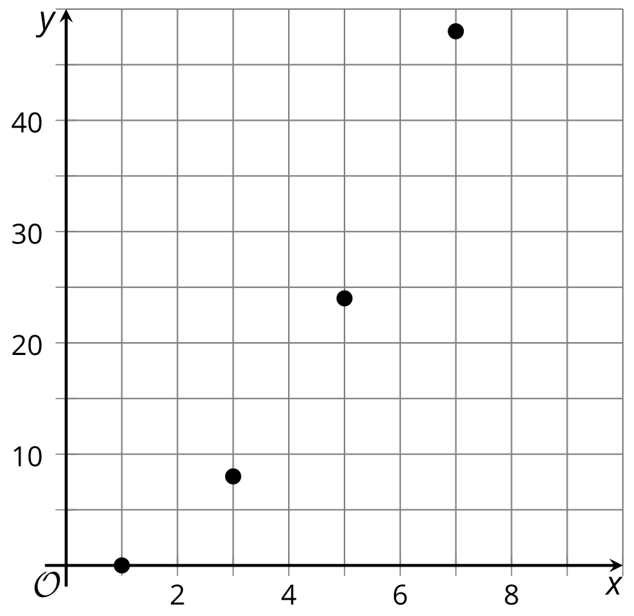

2 Something about 400

Student Task Statement
- Describe in words how the two quantities in each table are related.
  - Table A
- number of laps, $x$ | - 0 | - 1 | - 2.5 | - 6 | - 9
- meters run, $y$ | - 0 | - 400 | - 1,000 | - 2,400 | - 3,600
  - Table B
- meters from home, $x$ | - 0 | - 75 | - 128 | - 319 | - 396
- meters from school, $y$ | - 400 | - 325 | - 272 | - 81 | - 4
  - Table C
- electricity bills in dollars, $x$ | - 85 | - 124 | - 309 | - 816
- total expenses in dollars, $y$ | - 485 | - 524 | - 709 | - 1,216
  - Table D
- monthly salary in dollars, $x$ | - 872 | - 998 | - 1,015 | - 2,110
- amount deposited in dollars, $y$ | - 472 | - 598 | - 615 | - 1,710
- Match each table to an equation that represents the relationship.
  - Equation 1: $400+x=y$
  - Equation 2: $x−400=y$
  - Equation 3: $x+y=400$
  - Equation 4: $400⋅x=y$

3 What are the Relationships?

Student Task Statement
- The table represents the relationship between the base length and the height of some parallelograms. Both measurements are in inches.
- base length (inches) | - height (inches)
- 1 | - 48
- 2 | - 24
- 3 | - 16
- 4 | - 12
- 6 | - 8
- What is the relationship between the base length and the height of these parallelograms?
- Visitors to a carnival are invited to guess the number of beans in a jar. The person who guesses the correct number wins $300. If multiple people guess correctly, the prize will be divided evenly among them.
- What is the relationship between the number of people who guess correctly and the amount of money each person will receive?
- A $\frac{1}{2}$-gallon jug of milk can fill 8 cups, while 32 fluid ounces of milk can fill 4 cups.
- What is the relationship between number of gallons and ounces? If you get stuck, try creating a table.
© CC BY 2019 by Illustrative Mathematics®

