Lesson 11 Practice Problems
- Select all true statements about the graph that represents $y=2x\left(x−11\right)$.
  - Its $x$-intercepts are at $\left(\text{-}2,0\right)$ and $\left(11,0\right)$.
  - Its $x$-intercepts are at $\left(0,0\right)$ and $\left(11,0\right)$.
  - Its $x$-intercepts are at $\left(2,0\right)$ and $\left(\text{-}11,0\right)$.
  - It has only one $x$-intercept.
  - The $x$-coordinate of its vertex is -4.5.
  - The $x$-coordinate of its vertex is 11.
  - The $x$-coordinate of its vertex is 4.5.
  - The $x$-coordinate of its vertex is 5.5.
- Select all equations whose graphs have a vertex with $x$-coordinate 2.
  - $y=\left(x−2\right)\left(x−4\right)$
  - $y=\left(x−2\right)\left(x+2\right)$
  - $y=\left(x−1\right)\left(x−3\right)$
  - $y=x\left(x+4\right)$
  - $y=x\left(x−4\right)$
- Determine the $x$-intercepts and the $x$-coordinate of the vertex of the graph that represents each equation.
- equation | - $x$-intercepts | - $x$-coordinate of the vertex
- $y=x\left(x−2\right)$
- $y=\left(x−4\right)\left(x+5\right)$
- $y=\text{-}5x\left(3−x\right)$
- Which one is the graph of the equation $y=\left(x−3\right)\left(x+5\right)$?

- Graph A
- 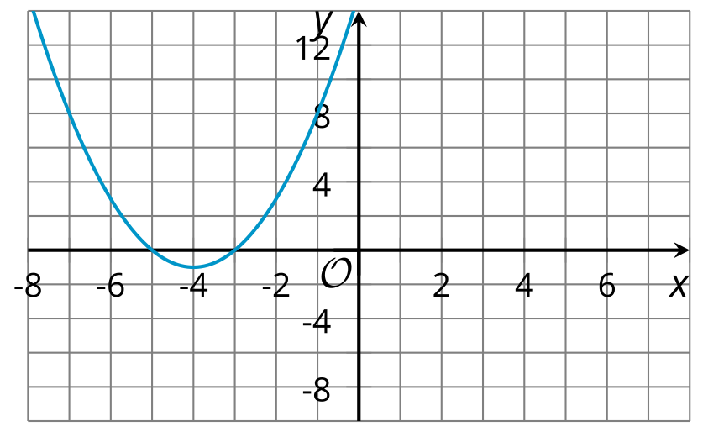

- Graph B
- 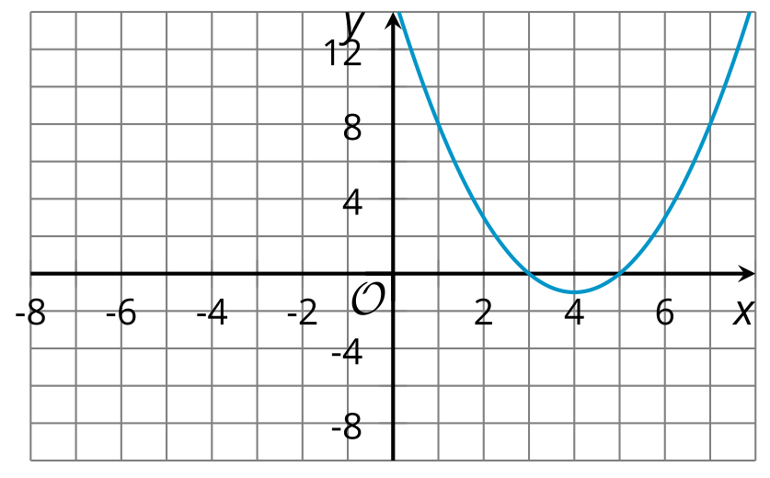

- Graph C
- 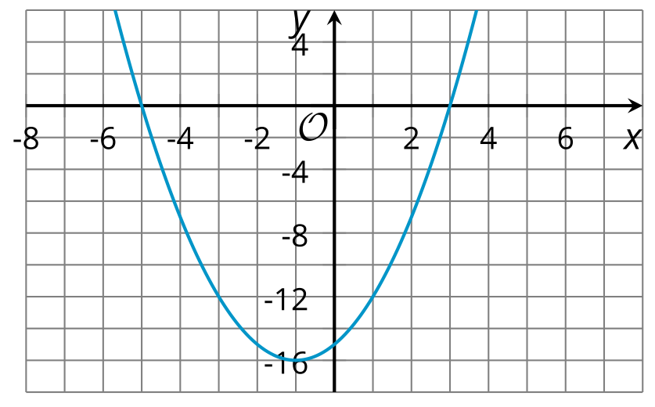

- Graph D
- 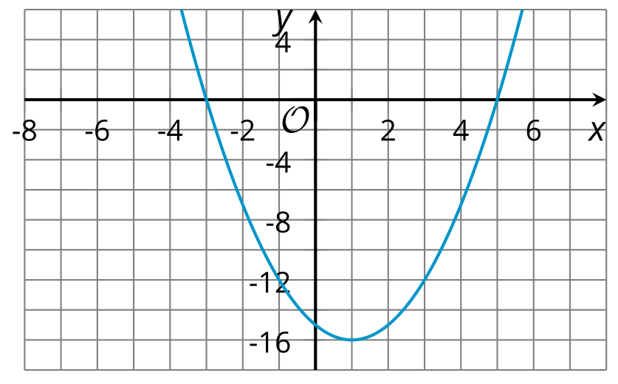
  - Graph A
  - Graph B
  - Graph C
  - Graph D

  - What are the $x$-intercepts of the graph of $y=\left(x−2\right)\left(x−4\right)$?
  - Find the coordinates of another point on the graph. Show your reasoning.
  - Sketch a graph of the equation $y=\left(x−2\right)\left(x−4\right)$.
- A company sells calculators. If the price of the calculator in dollars is $p$, the company estimates that it will sell $10,​000−120p$ calculators.
- Write an expression that represents the revenue in dollars from selling calculators if a calculator is priced at $p$ dollars.
- (From Unit 6, Lesson 7.)
- Is ${\left(s+t\right)}^{2}$ equivalent to $s^{2}+2st+t^{2}$? Explain or show your reasoning.
- (From Unit 6, Lesson 8.)
- Tyler is shopping for a truck. He found two trucks that he likes. One truck sells for $7,200. A slightly older truck sells for 15% less. How much does the older truck cost?
- (From Unit 5, Lesson 14.)
- Here are graphs of two exponential functions, $f$ and $g$.
- The function $f$ is given by $f\left(x\right)=100⋅2^{x}$ while $g$ is given by $g\left(x\right)=a⋅b^{x}$.
- Based on the graphs of the functions, what can you conclude about $a$ and $b$?
- 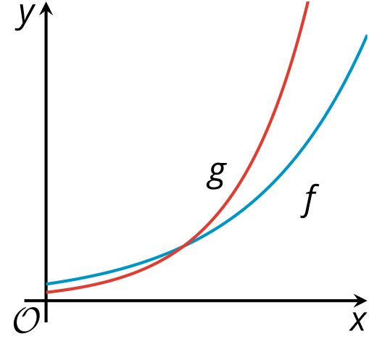
- (From Unit 5, Lesson 13.)
- Suppose $G$ takes a student’s grade and gives a student’s name as the output. Explain why $G$ is not a function.
- (From Unit 4, Lesson 2.)
© CC BY 2019 by Illustrative Mathematics®

