Lesson 15 Practice Problems
- Select all of the quadratic expressions in vertex form.
  - ${\left(x−2\right)}^{2}+1$
  - $x^{2}−4$
  - $x\left(x+1\right)$
  - ${\left(x+3\right)}^{2}$
  - ${\left(x−4\right)}^{2}+6$
- Here are two equations. One defines function $m$ and the other defines function $p$.
- $m\left(x\right)=x\left(x+6\right)$
- $p\left(x\right)={\left(x+3\right)}^{2}−9$
  - Show that the expressions defining $m$ and $p$ are equivalent.
  - What is the vertex of the graph of $m$? Explain how you know.
  - What are the $x$-intercepts of the graph of $p$? Explain how you know.
- Which equation is represented by the graph?
- 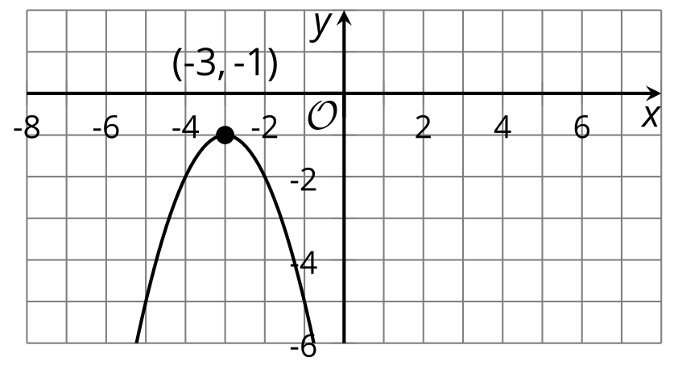
  - $y={\left(x−1\right)}^{2}+3$
  - $y={\left(x−3\right)}^{2}+1$
  - $y=\text{-}{\left(x+3\right)}^{2}−1$
  - $y=\text{-}{\left(x−3\right)}^{2}+1$
- For each equation, write the coordinates of the vertex of the graph that represents the equation.
  - $y={\left(x−3\right)}^{2}+5$
  - $y={\left(x+7\right)}^{2}+3$
  - $y={\left(x−4\right)}^{2}$
  - $y=x^{2}−1$
  - $y=2{\left(x+1\right)}^{2}−5$
  - $y=\text{-}2{\left(x+1\right)}^{2}−5$
- For each function, write the coordinates of the vertex of its graph and tell whether the graph opens up or down.
- function | - coordinates of vertex | - graph opens up or down?
- $f\left(x\right)={\left(x−4\right)}^{2}−5$
- $g\left(x\right)=\text{-}x^{2}+5$
- $h\left(x\right)=2{\left(x+1\right)}^{2}−4$
- Here is a graph that represents $y=x^{2}$.
  - Describe what would happen to the graph if the original equation were modified as follows:
    - $y=\text{-}x^{2}$
    - $y=3x^{2}$
    - $y=x^{2}+6$
  - 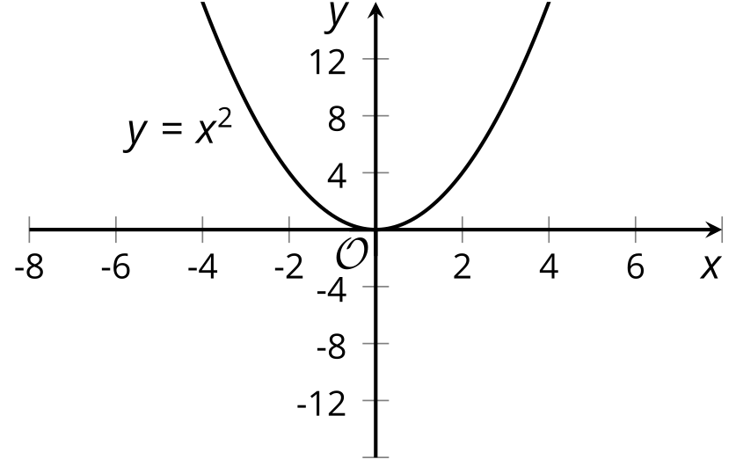
  - Sketch the graph of the equation $y=\text{-}3x^{2}+6$ on the same coordinate plane as $y=x^{2}$.
- (From Unit 6, Lesson 12.)
- Noah is going to put $2,000 in a savings account. He plans on putting the money in an account and leaving it there for 5 years. He can put the money in an account that pays 1% interest monthly, an account that pays 6% interest every six months, or an account that pays 12% interest annually.
- Which account will give him the most money in his account at the end of the 5 years?
- (From Unit 5, Lesson 16.)
- Here are four graphs. Match each graph with a quadratic equation that it represents.

- Graph A
- 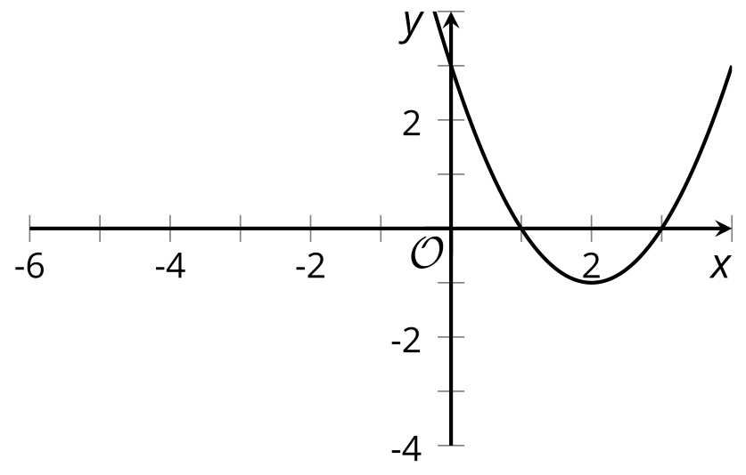

- Graph B
- 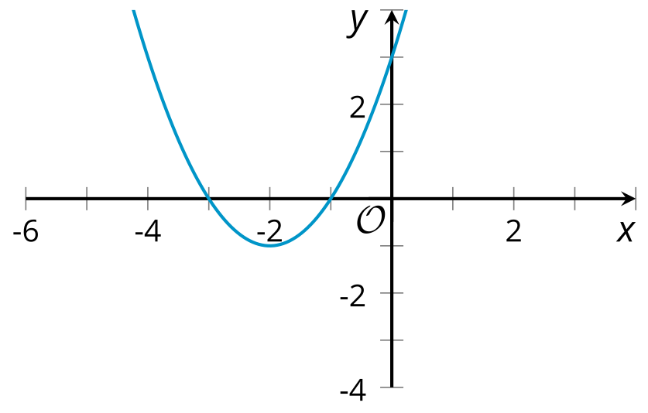

- Graph C
- 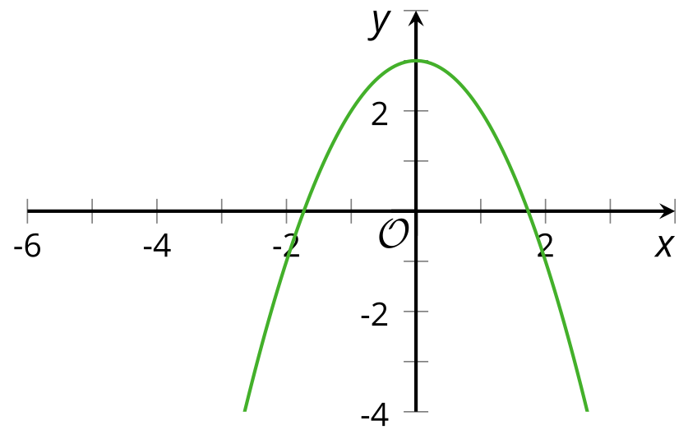

- Graph D
- 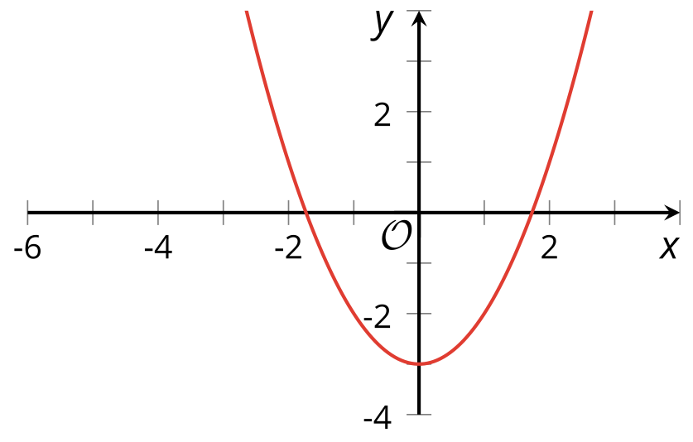
  - Graph A
  - Graph B
  - Graph C
  - Graph D
  - $y=\text{-}x^{2}+3$
  - $y=\left(x+1\right)\left(x+3\right)$
  - $y=x^{2}−3$
  - $y=\left(x−1\right)\left(x−3\right)$
- (From Unit 6, Lesson 12.)
- The table shows some input and output values of function $f$. Describe a possible rule for the function by using words or by writing an equation.
- $x$ | - $f\left(x\right)$
- -3 | - -8
- 0 | - -2
- 4 | - 6
- 10 | - 18
- (From Unit 4, Lesson 5.)
© CC BY 2019 by Illustrative Mathematics®

