Lesson 1 Practice Problems
- Which of these statements describes a key distinction between an observational study and an experimental study?
  - Experimental studies are more representative of the larger population than observational studies.
  - Data is collected in experimental studies, but not in observational studies.
  - Observational studies try to answer a question, but experimental studies do not.
  - Experimental studies directly influence something to see its effect, but observational studies do not directly influence the subjects.
- Elena is interested in whether music affects plant growth. For a science fair project, she will grow one plant in a room that is normally kept quiet. She will grow another plant in another room that has classical piano music playing all the time. After 2 months, she compares the height of the plants to determine the effect of music on plant growth.
  - What type of study is Elena designing?
  - How could her design be improved to collect data that would be better for answering the question of interest?
- Match the description of the study design with the type of study being conducted.
  - Does a certain multivitamin help people lose weight? Researchers select 100 people to participate in the study and assign them to 2 groups at random. One group is given the multivitamin. The other group is given a fake pill. The weights of all of the participants are recorded daily for the next three months.
  - How do business customers feel about the level of support they receive? The business randomly selects 200 customers and asks them to share their opinions.
  - Do truck drivers get into more accidents than people who drive SUVs? Researchers use police records of automobile accidents over the past year and vehicle registrations to compare the percentage of drivers of vehicles of each type that get into accidents.
  - A survey
  - An observational study that is not a survey
  - An experimental study
- Here are the first 4 stages of a pattern.
- 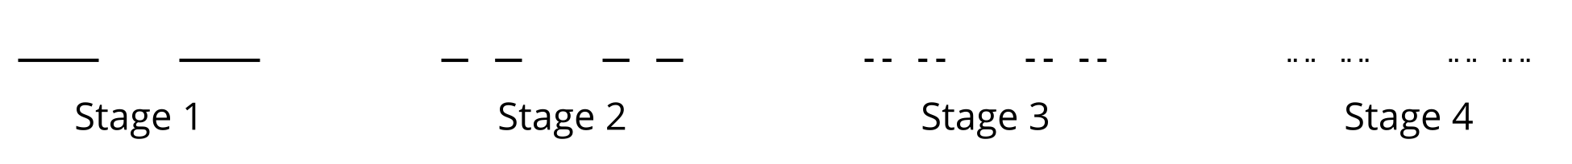
- In stage 1, the middle third of a segment of length 1 is removed. Each successive stage continues to remove the middle third of remaining segments.
  - What is the total length of the segments in stage 1?
  - What is the total length of the segments in stage 2?
  - What is the total length of the segments in stage 3?
  - Priya says that from each stage to the next, the total length of segments is multiplied by a factor of $\frac{2}{3}$. Do you agree with Priya? Explain or show your reasoning.
  - Write an expression for the total length of the segments in stage $n$.
- (From Unit 1, Lesson 11.)
- Mai is using the quadratic formula to solve two different quadratic equations.
- For the first equation, she writes $x=\frac{\text{-}4±\sqrt{4^{2}−4\left(4\right)\left(1\right)}}{2\left(4\right)}$
- For the second equation, she writes $x=\frac{3±\sqrt{{\left(\text{-}3\right)}^{2}−4\left(3\right)\left(5\right)}}{2\left(3\right)}$
- How many real solutions will each equation have? Explain how you know.
- (From Unit 3, Lesson 18.)
- Here are graphs of two functions $f$ and $g$.
- 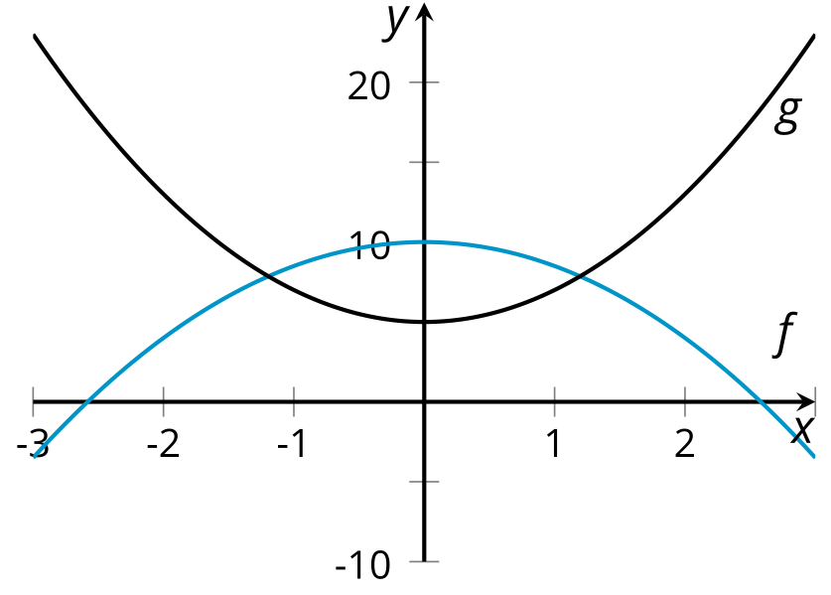
- Which statements are true about the graph of $y=h\left(x\right)$ where $h$ given by $h\left(x\right)=f\left(x\right)−g\left(x\right)$ ? Select all that apply.
  - There is an $x$-intercept between $x=1$ and $x=2$
  - There is an $x$-intercept between $x=2$ and $x=3$
  - The $y$-intercept is positive
  - The $y$ values are positive values when $0<x<1$
  - The $y$ values are negative values when $2<x<3$
- (From Unit 5, Lesson 10.)
© CC BY 2019 by Illustrative Mathematics®

