Grade 2
Unit 3Lesson 6CC BY NC 2024 Illustrative Mathematics®
Unit 3, Lesson 6

Compare Reptile Lengths in Story Problems
- Let’s solve story problems about reptile lengths.
Grade 2
Unit 3Lesson 6CC BY NC 2024 Illustrative Mathematics®

Warm-upNumber Talk: Fives and Tens
Find the value of each expression mentally.
- $5+5$
- $15+5$
- $15+15$
- $15+25$
Grade 2
Unit 3Lesson 6CC BY NC 2024 Illustrative Mathematics®

Activity 1Whose Pet is Longer?
- Lin's pet lizard is 62 cm long. It is 19 cm shorter than Jada's. How long is Jada's pet lizard?
  - Whose pet is longer? ________________________________
  - Circle the diagram that matches the story. Unable to process <img src="/tikz_files/238087.svg">Failed: rsvg-convert --format png --dpi-x 300 --dpi-y 300 /app/tmp/svgtopng-1786380845.602817.svg --output /app/tmp/svgtopng-1786380845.602817.png Backtrace: /app/app/services/script/runner.rb:34:in `block in run_cmd' <internal:kernel>:90:in `tap' /app/app/services/script/runner.rb:32:in `run_cmd' /app/app/services/script/svg_to_png.rb:27:in `convert_svg_to_png' /app/app/services/script/svg_to_png.rb:17:in `to_png' /app/vendor/bundle/ruby/3.3.0/gems/embeddable_content-1.1.0/app/services/embeddable_content/images/image_downloader.rb:37:in `png_rendered_from_svg' /app/vendor/bundle/ruby/3.3.0/gems/embeddable_content-1.1.0/app/services/embeddable_content/images/image_downloader.rb:33:in `raw_image_data' /app/vendor/bundle/ruby/3.3.0/gems/embeddable_content-1.1.0/app/services/embeddable_content/images/image_downloader.rb:13:in `block in save' <internal:kernel>:90:in `tap' /app/vendor/bundle/ruby/3.3.0/gems/embeddable_content-1.1.0/app/services/embeddable_content/images/image_downloader.rb:13:in `save' Unable to process <img src="/tikz_files/238088.svg">Failed: rsvg-convert --format png --dpi-x 300 --dpi-y 300 /app/tmp/svgtopng-1786380845.6513772.svg --output /app/tmp/svgtopng-1786380845.6513772.png Backtrace: /app/app/services/script/runner.rb:34:in `block in run_cmd' <internal:kernel>:90:in `tap' /app/app/services/script/runner.rb:32:in `run_cmd' /app/app/services/script/svg_to_png.rb:27:in `convert_svg_to_png' /app/app/services/script/svg_to_png.rb:17:in `to_png' /app/vendor/bundle/ruby/3.3.0/gems/embeddable_content-1.1.0/app/services/embeddable_content/images/image_downloader.rb:37:in `png_rendered_from_svg' /app/vendor/bundle/ruby/3.3.0/gems/embeddable_content-1.1.0/app/services/embeddable_content/images/image_downloader.rb:33:in `raw_image_data' /app/vendor/bundle/ruby/3.3.0/gems/embeddable_content-1.1.0/app/services/embeddable_content/images/image_downloader.rb:13:in `block in save' <internal:kernel>:90:in `tap' /app/vendor/bundle/ruby/3.3.0/gems/embeddable_content-1.1.0/app/services/embeddable_content/images/image_downloader.rb:13:in `save'
  - Solve. Show your thinking using drawings, numbers, or words.
  - Jada’s pet lizard is ____________ cm long.
- Diego and Mai have pet snakes. Mai’s pet snake is 17 cm longer than Diego’s. Her snake is 71 cm. How long is his pet snake?
  - Whose pet is shorter? ________________________________
  - Circle the diagram that matches the story. Unable to process <img src="/tikz_files/238089.svg">Failed: rsvg-convert --format png --dpi-x 300 --dpi-y 300 /app/tmp/svgtopng-1786380845.7319973.svg --output /app/tmp/svgtopng-1786380845.7319973.png Backtrace: /app/app/services/script/runner.rb:34:in `block in run_cmd' <internal:kernel>:90:in `tap' /app/app/services/script/runner.rb:32:in `run_cmd' /app/app/services/script/svg_to_png.rb:27:in `convert_svg_to_png' /app/app/services/script/svg_to_png.rb:17:in `to_png' /app/vendor/bundle/ruby/3.3.0/gems/embeddable_content-1.1.0/app/services/embeddable_content/images/image_downloader.rb:37:in `png_rendered_from_svg' /app/vendor/bundle/ruby/3.3.0/gems/embeddable_content-1.1.0/app/services/embeddable_content/images/image_downloader.rb:33:in `raw_image_data' /app/vendor/bundle/ruby/3.3.0/gems/embeddable_content-1.1.0/app/services/embeddable_content/images/image_downloader.rb:13:in `block in save' <internal:kernel>:90:in `tap' /app/vendor/bundle/ruby/3.3.0/gems/embeddable_content-1.1.0/app/services/embeddable_content/images/image_downloader.rb:13:in `save' Unable to process <img src="/tikz_files/238090.svg">Failed: rsvg-convert --format png --dpi-x 300 --dpi-y 300 /app/tmp/svgtopng-1786380845.8418748.svg --output /app/tmp/svgtopng-1786380845.8418748.png Backtrace: /app/app/services/script/runner.rb:34:in `block in run_cmd' <internal:kernel>:90:in `tap' /app/app/services/script/runner.rb:32:in `run_cmd' /app/app/services/script/svg_to_png.rb:27:in `convert_svg_to_png' /app/app/services/script/svg_to_png.rb:17:in `to_png' /app/vendor/bundle/ruby/3.3.0/gems/embeddable_content-1.1.0/app/services/embeddable_content/images/image_downloader.rb:37:in `png_rendered_from_svg' /app/vendor/bundle/ruby/3.3.0/gems/embeddable_content-1.1.0/app/services/embeddable_content/images/image_downloader.rb:33:in `raw_image_data' /app/vendor/bundle/ruby/3.3.0/gems/embeddable_content-1.1.0/app/services/embeddable_content/images/image_downloader.rb:13:in `block in save' <internal:kernel>:90:in `tap' /app/vendor/bundle/ruby/3.3.0/gems/embeddable_content-1.1.0/app/services/embeddable_content/images/image_downloader.rb:13:in `save'
  - Solve. Show your thinking using drawings, numbers, or words.
  - Diego’s pet snake is ____________ cm long.
Grade 2
Unit 3Lesson 6CC BY NC 2024 Illustrative Mathematics®

Activity 2Guess My Reptiles
Partner A's reptiles
Partner B's reptiles
1. day gecko, 28 cm

1. ribbon snake, 83 cm
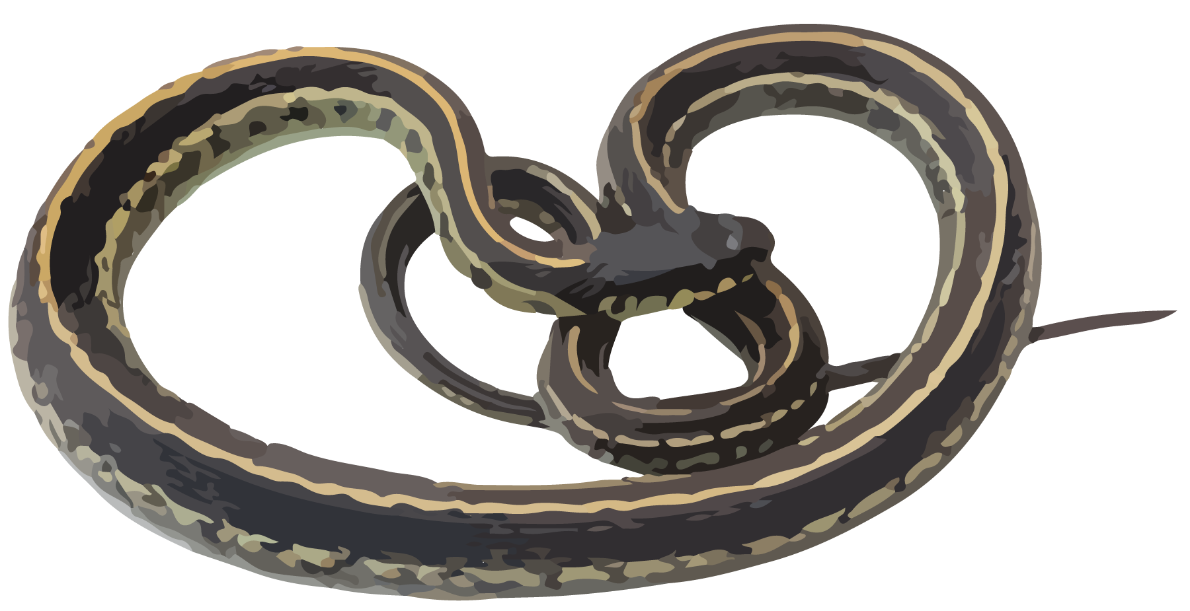
2. Komodo dragon, 98 cm
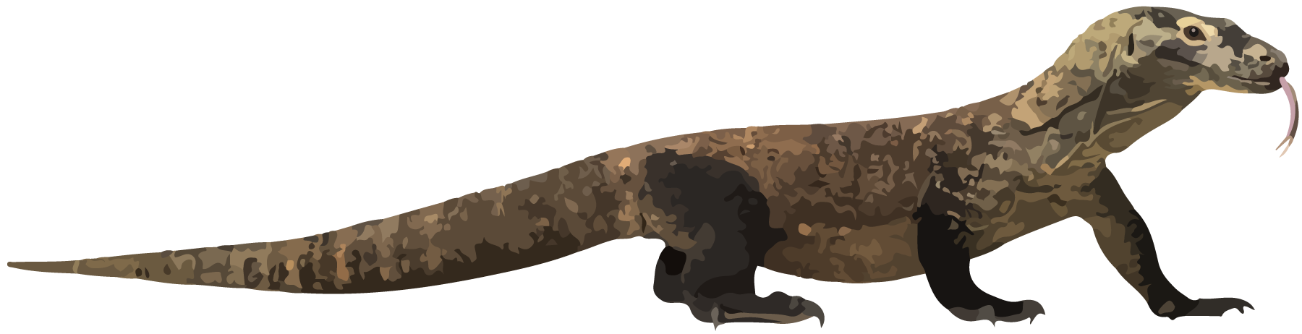
2. Gila monster, 55 cm
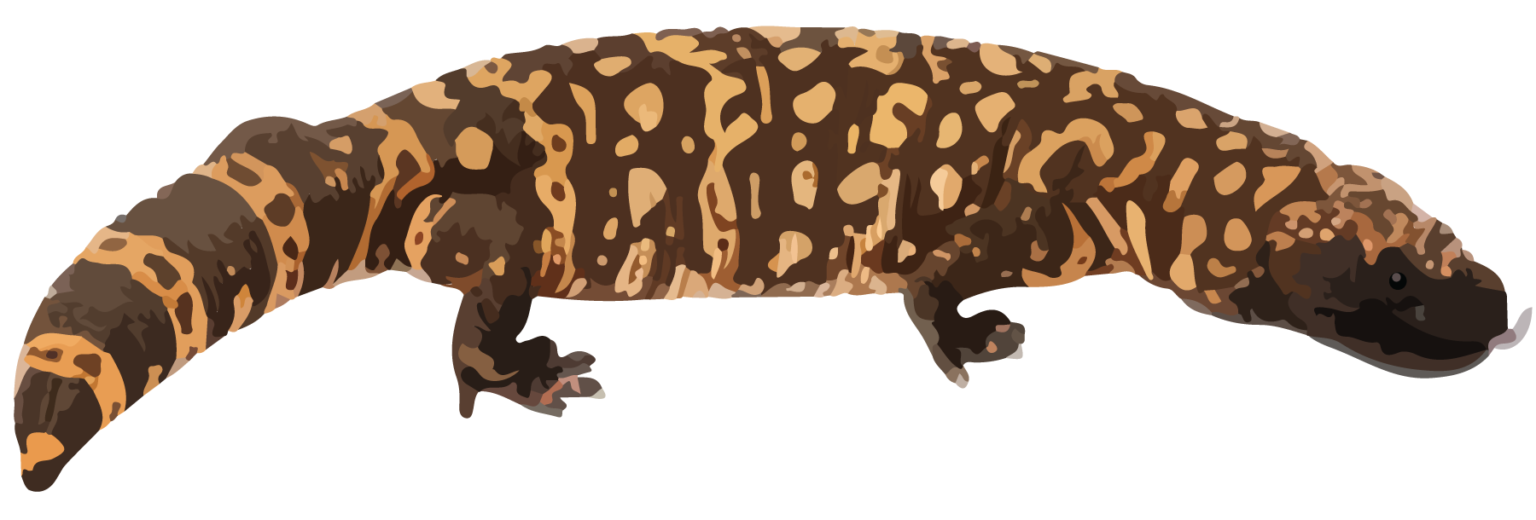
​​​
3. baby cobra, 46 cm
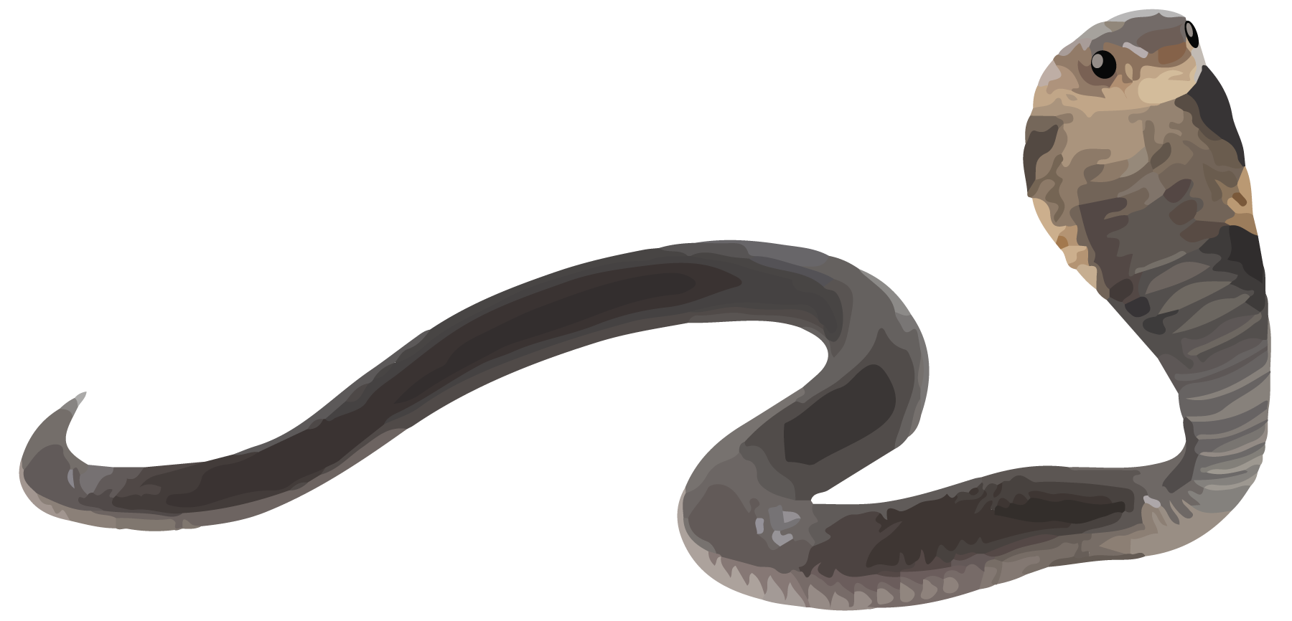
3. baby alligator, 71 cm
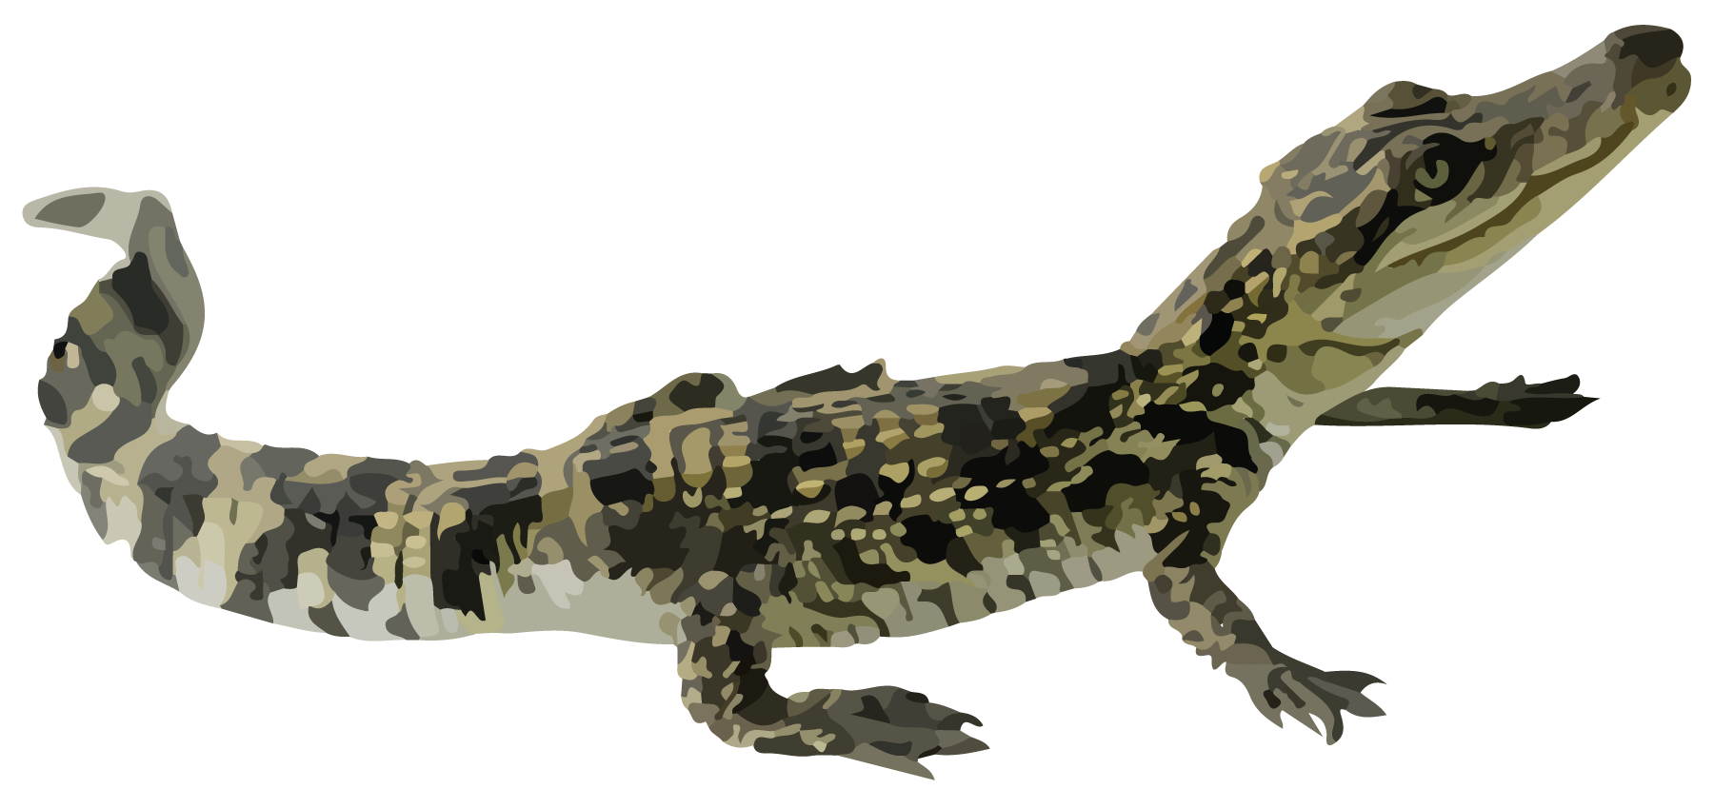
4. iguana, 65 cm
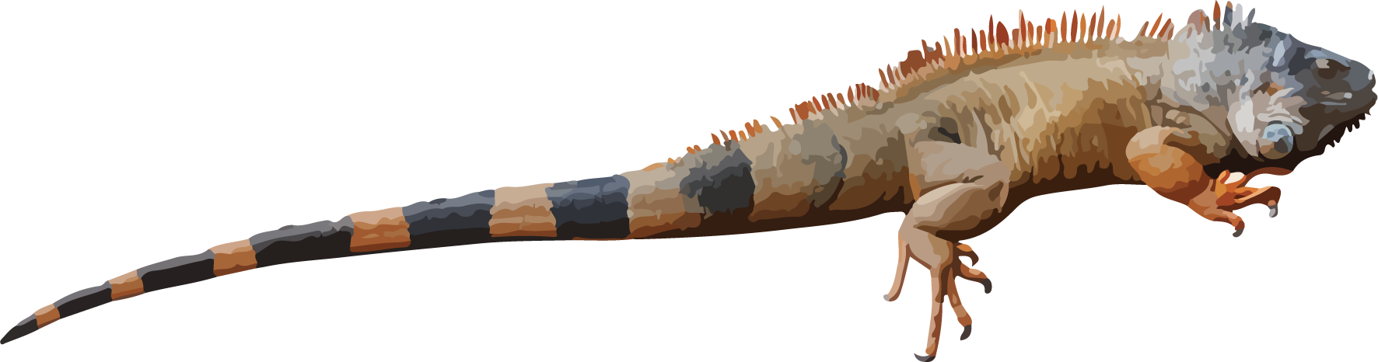
4. ringneck snake, 38 cm
- Choose 1 reptile from your list and 1 reptile from your partner’s list.
- Create a story problem using the lengths of the 2 reptiles you chose.
- My reptile is ____________ cm long.
- It is ____________ cm ________________________________(shorter/longer) than one of your reptiles.
- Which reptiles did your partner choose? Show your thinking using drawings, numbers, or words.

Section A Summary
We measured the length of objects with different length units. We learned that the centimeter is a metric unit of length. We measured objects in centimeters using base-ten blocks, rulers, and meter sticks. A meter is a metric unit of length. There are 100 centimeters in a meter. We learned that rulers represent length units. They use tick marks to show a length away from 0.
Unable to process <img src="/tikz_files/236817.svg">Failed: rsvg-convert --format png --dpi-x 300 --dpi-y 300 /app/tmp/svgtopng-1786380846.5206227.svg --output /app/tmp/svgtopng-1786380846.5206227.png Backtrace: /app/app/services/script/runner.rb:34:in `block in run_cmd' <internal:kernel>:90:in `tap' /app/app/services/script/runner.rb:32:in `run_cmd' /app/app/services/script/svg_to_png.rb:27:in `convert_svg_to_png' /app/app/services/script/svg_to_png.rb:17:in `to_png' /app/vendor/bundle/ruby/3.3.0/gems/embeddable_content-1.1.0/app/services/embeddable_content/images/image_downloader.rb:37:in `png_rendered_from_svg' /app/vendor/bundle/ruby/3.3.0/gems/embeddable_content-1.1.0/app/services/embeddable_content/images/image_downloader.rb:33:in `raw_image_data' /app/vendor/bundle/ruby/3.3.0/gems/embeddable_content-1.1.0/app/services/embeddable_content/images/image_downloader.rb:13:in `block in save' <internal:kernel>:90:in `tap' /app/vendor/bundle/ruby/3.3.0/gems/embeddable_content-1.1.0/app/services/embeddable_content/images/image_downloader.rb:13:in `save' Unable to process <img src="/tikz_files/236818.svg">Failed: rsvg-convert --format png --dpi-x 300 --dpi-y 300 /app/tmp/svgtopng-1786380846.5638037.svg --output /app/tmp/svgtopng-1786380846.5638037.png Backtrace: /app/app/services/script/runner.rb:34:in `block in run_cmd' <internal:kernel>:90:in `tap' /app/app/services/script/runner.rb:32:in `run_cmd' /app/app/services/script/svg_to_png.rb:27:in `convert_svg_to_png' /app/app/services/script/svg_to_png.rb:17:in `to_png' /app/vendor/bundle/ruby/3.3.0/gems/embeddable_content-1.1.0/app/services/embeddable_content/images/image_downloader.rb:37:in `png_rendered_from_svg' /app/vendor/bundle/ruby/3.3.0/gems/embeddable_content-1.1.0/app/services/embeddable_content/images/image_downloader.rb:33:in `raw_image_data' /app/vendor/bundle/ruby/3.3.0/gems/embeddable_content-1.1.0/app/services/embeddable_content/images/image_downloader.rb:13:in `block in save' <internal:kernel>:90:in `tap' /app/vendor/bundle/ruby/3.3.0/gems/embeddable_content-1.1.0/app/services/embeddable_content/images/image_downloader.rb:13:in `save' Unable to process <img src="/tikz_files/237263.svg">Failed: rsvg-convert --format png --dpi-x 300 --dpi-y 300 /app/tmp/svgtopng-1786380846.6202617.svg --output /app/tmp/svgtopng-1786380846.6202617.png Backtrace: /app/app/services/script/runner.rb:34:in `block in run_cmd' <internal:kernel>:90:in `tap' /app/app/services/script/runner.rb:32:in `run_cmd' /app/app/services/script/svg_to_png.rb:27:in `convert_svg_to_png' /app/app/services/script/svg_to_png.rb:17:in `to_png' /app/vendor/bundle/ruby/3.3.0/gems/embeddable_content-1.1.0/app/services/embeddable_content/images/image_downloader.rb:37:in `png_rendered_from_svg' /app/vendor/bundle/ruby/3.3.0/gems/embeddable_content-1.1.0/app/services/embeddable_content/images/image_downloader.rb:33:in `raw_image_data' /app/vendor/bundle/ruby/3.3.0/gems/embeddable_content-1.1.0/app/services/embeddable_content/images/image_downloader.rb:13:in `block in save' <internal:kernel>:90:in `tap' /app/vendor/bundle/ruby/3.3.0/gems/embeddable_content-1.1.0/app/services/embeddable_content/images/image_downloader.rb:13:in `save'

