Algebra 1
Unit 6Lesson 13CC BY NC 2024 Illustrative Mathematics®
Unit 6, Lesson 13

Reasoning about Exponential Graphs (Part 2)
Let’s investigate what we can learn from graphs that represent exponential functions.
Algebra 1
Unit 6Lesson 13CC BY NC 2024 Illustrative Mathematics®

13.1Which Three Go Together: Four Functions
Which three go together? Why do they go together?
$A\left(n\right)=8⋅3^{n}$
$B\left(n\right)=2⋅8^{n}$
$C\left(n\right)=8+2n$
$D\left(n\right)=8⋅{\left(\frac{1}{2}\right)}^{n}$
Algebra 1
Unit 6Lesson 13CC BY NC 2024 Illustrative Mathematics®

13.2Value of a Computer
- Here is a graph representing an exponential function, $f$. The function, $f$, gives the value of a computer, in dollars, as a function of time, $x$, measured in years since the time of purchase.
- 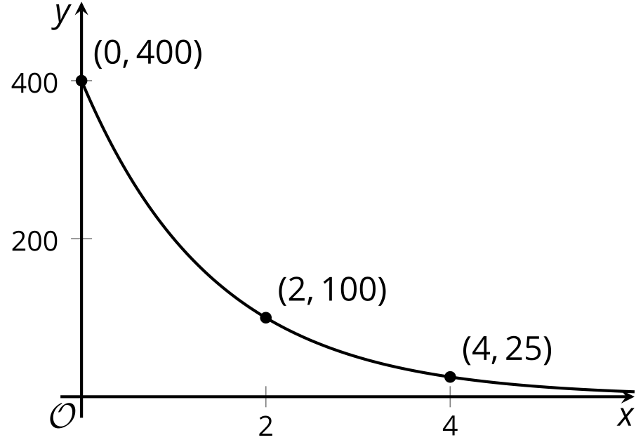
- Based on the graph, what can you say about the following?
  - The purchase price of the computer
  - The value of $f$ when $x$ is 1
  - The meaning of $f\left(1\right)$
  - How the value of the computer is changing each year
  - An equation that defines $f$
  - Whether the value of $f$ will reach 0 after 10 years
- Here are graphs of two exponential functions. For each, write an equation that defines the function, and find the value of the function when $x$ is 5.
  - 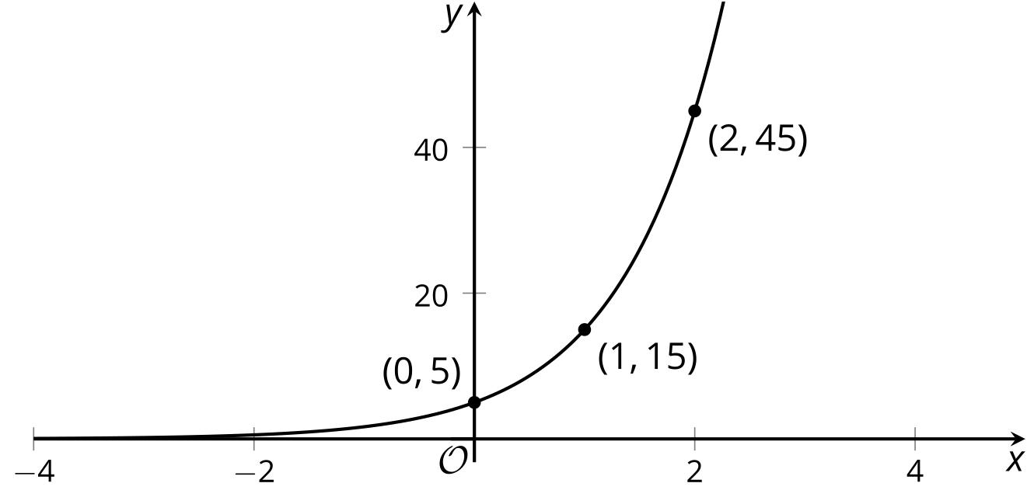
  - 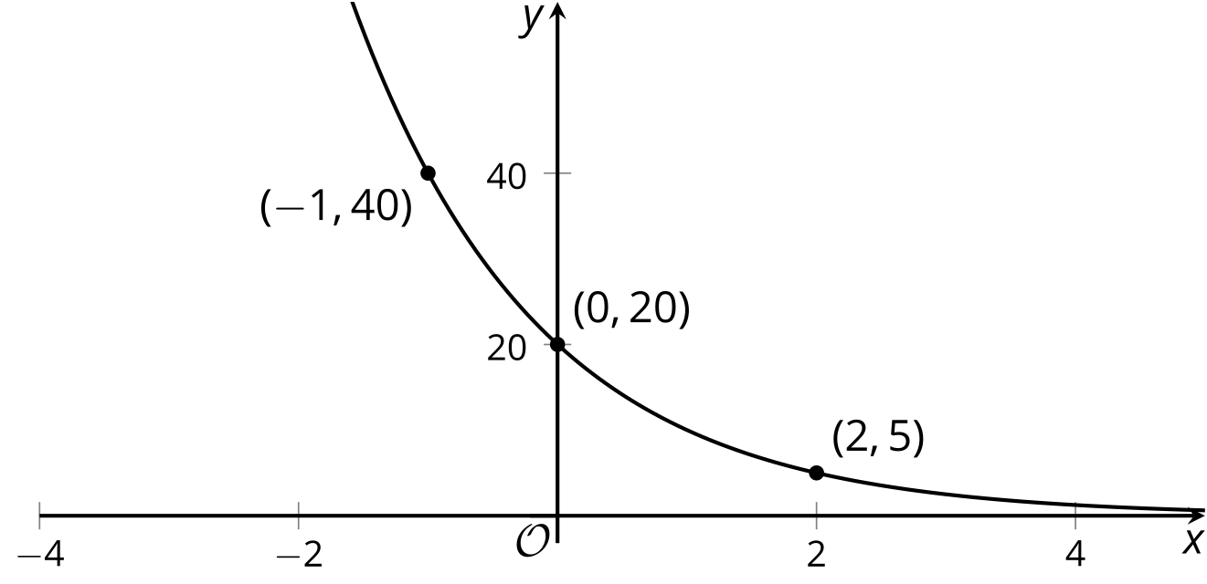

Are you ready for more?
Consider a function $f$ defined by $f\left(x\right)=a⋅b^{x}$.
- If the graph of $f$ goes through the points $\left(2,10\right)$ and $\left(8,30\right)$, would you expect $f\left(5\right)$ to be less than, equal to, or greater than 20?
- If the graph of $f$ goes through the points $\left(2,30\right)$ and $\left(8,10\right)$, would you expect $f\left(5\right)$ to be less than, equal to, or greater than 20?
Algebra 1
Unit 6Lesson 13CC BY NC 2024 Illustrative Mathematics®

13.3Moldy Wall
Here are graphs representing two functions, and descriptions of two functions.
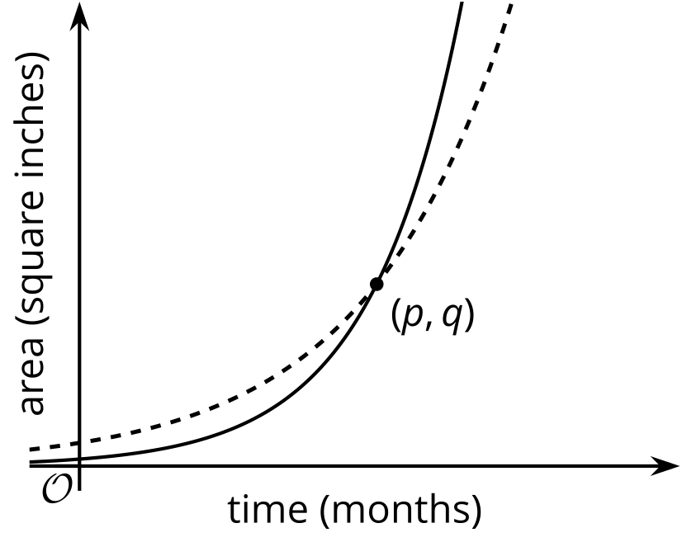
- Function $f$: The area of a wall that is covered by Mold A, in square inches, doubling every month.
- Function $g$: The area of a wall that is covered by Mold B, in square inches, tripling every month.
- Which graph represents each function? Label the graphs accordingly and explain your reasoning.
- When the mold was first spotted and measured, was there more of Mold A or Mold B? Explain how you know.
- What does the point $\left(p,q\right)$ tell us in this situation?

Lesson 13 Summary
If we have enough information about a graph representing an exponential function $f$, we can write a corresponding equation. Here is a graph of $y=f\left(x\right)$.
An equation defining an exponential function has the form $f\left(x\right)=a⋅b^{x}$. The value of $a$ is the starting value or $f\left(0\right)$, so it is the $y$-intercept of the graph. We can see that $f\left(0\right)$ is 500 and that the function is decreasing.
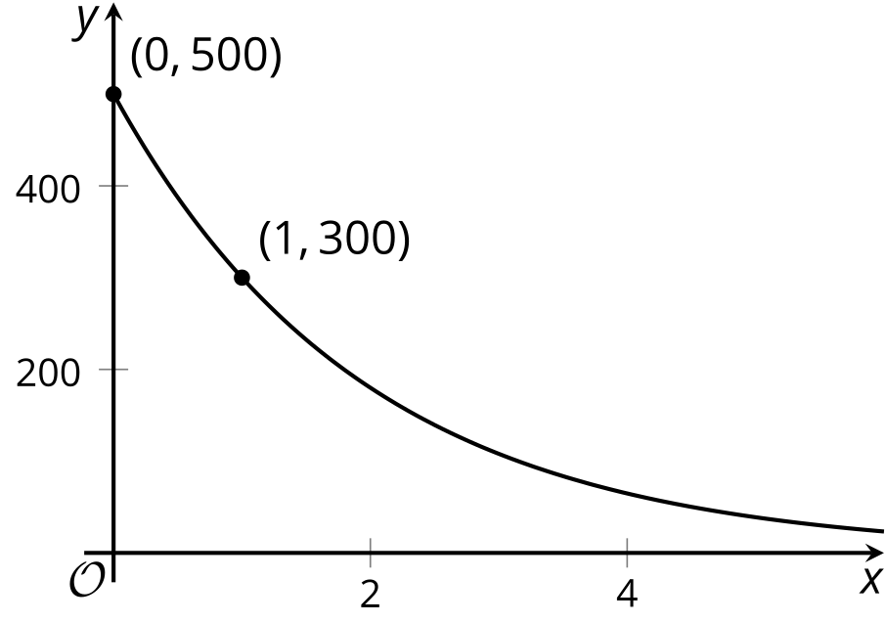
The value of $b$ is the growth factor. It is the number by which we multiply the function’s output at $x$ to get the output at $x+1$. To find this growth factor for $f$, we can calculate $\frac{f\left(1\right)}{f\left(0\right)}$, which is $\frac{300}{500}$ (or $\frac{3}{5}$). So an equation that defines $f$ is:
$f\left(x\right)=500⋅{\left(\frac{3}{5}\right)}^{x}$
We can also use graphs to compare functions. Here are graphs representing two different exponential functions, labeled $g$ and $h$. Each one represents the area of algae (in square meters) in a pond, $x$ days after certain fish were introduced.
- Pond A had 40 square meters of algae. Its area shrinks to $\frac{8}{10}$ of the area on the previous day.
- Pond B had 50 square meters of algae. Its area shrinks to $\frac{2}{5}$ of the area on the previous day.
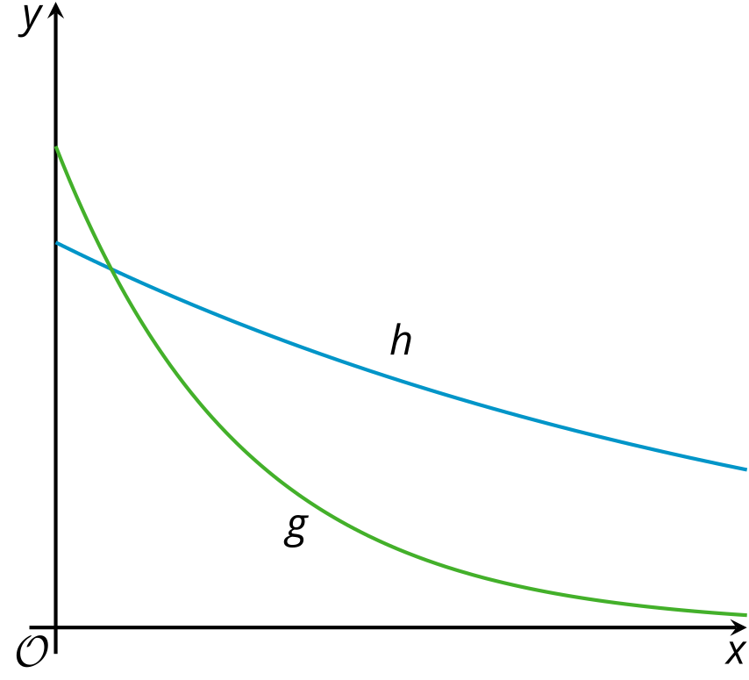
Can you tell which graph corresponds to which algae population?
We can see that the $y$-intercept of $g$'s graph is greater than the $y$-intercept of $h$'s graph. We can also see that $g$ has a smaller growth factor than $h$ because as $x$ increases by the same amount, $g$ is retaining a smaller fraction of its value compared to $h$. This suggests that $g$ corresponds to Pond B, and $h$ corresponds to Pond A.

