Grade 6
Unit 3Lesson 2CC BY NC Illustrative Mathematics, based on IM 6–8 Math, CC BY Open Up Resources.
Unit 3, Lesson 2

Measuring with Different-Size Units
Let’s measure things.
Grade 6
Unit 3Lesson 2CC BY NC Illustrative Mathematics, based on IM 6–8 Math, CC BY Open Up Resources.

2.1Width of a Paper
This picture shows paper clips in two sizes: regular and jumbo.
Does it take more regular or jumbo paper clips lined up end to end to measure the width of a piece of printer paper? Be prepared to explain how you know.
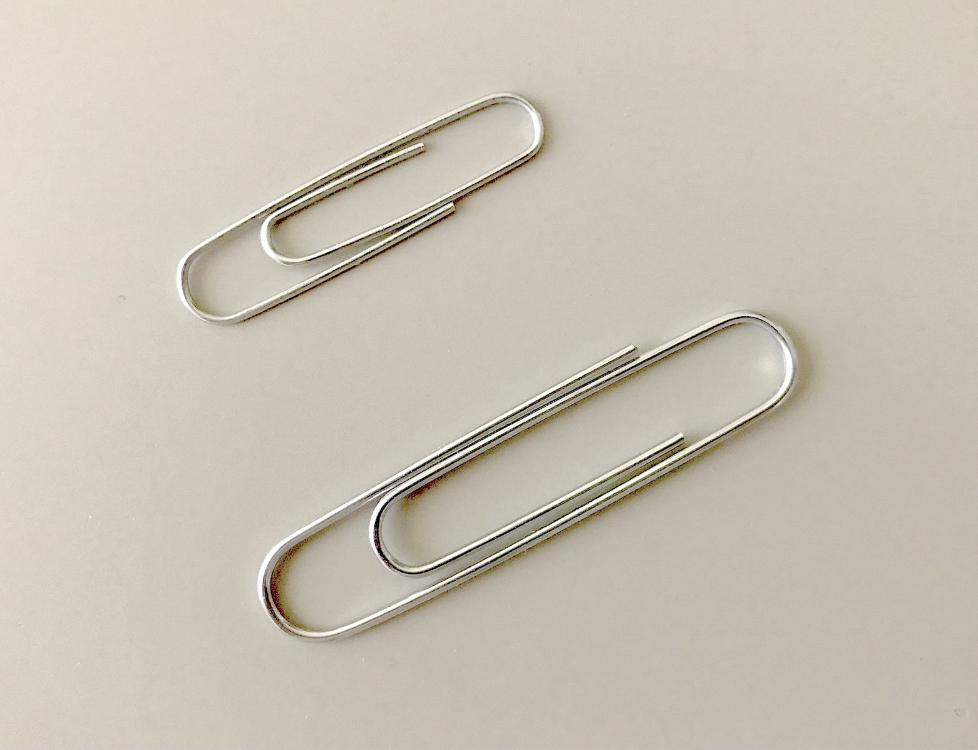
Grade 6
Unit 3Lesson 2CC BY NC Illustrative Mathematics, based on IM 6–8 Math, CC BY Open Up Resources.

2.2Measurement Stations
Station 1: Your teacher prepared a box and some cubes.
- Each large cube is 1 cubic inch. Count how many cubic inches completely fill the box.
- Each small cube is 1 cubic centimeter. Each rod is composed of 10 cubic centimeters. Count how many cubic centimeters completely fill the box.
 | cubic  inches | cubic  centimeters
volume of
the box
Station 2: Your teacher showed you a length and prepared a meter stick and a ruler.
- Use the meter stick to measure the length to the nearest meter.
- Use the ruler to measure the length to the nearest foot.
 | meters | feet
length of
$\underset{_}{​}$
Station 3: Your teacher prepared a gallon of water and some bottles.
- Count how many times you can fill the quart bottle with a gallon of water.
- Count how many times you can fill the liter bottle with a gallon of water.
 | quarts | liters
1 gallon
of water
Station 4: Your teacher prepared several objects and one or more scales.
- Select 2–3 different objects to put on the scale(s).
- Record the weights in grams, kilograms, ounces, and pounds.
- object | - grams | - kilograms | - ounces | - pounds
Station 5: Your teacher prepared a graduated cylinder and a container of salt.
- Count how many level teaspoons of salt fill the graduated cylinder to 20 milliliters, 40 milliliters, and 50 milliliters.
- Pour the salt back into the original container.
 | milliliters | teaspoons
small amount  of salt | 20
medium amount  of salt | 40
large amount  of salt | 50
After rotating through the stations, answer these questions with your group.
- Did more cubic inches or cubic centimeters fit in the cardboard box in Station 1? Why?
- Did it take more feet or meters to measure the indicated length in Station 2? Why?
- Based on your work in Station 3, do you think it would take more quarts or liters to fill a bucket? Explain your reasoning.
- Use the data from Station 4 to put the units of weight and mass in order from smallest to largest. Explain your reasoning.
- Based on your work in Station 5:
  - About how many teaspoons of salt would it take to fill the graduated cylinder to 100 milliliters?
  - If you poured 15 teaspoons of salt into an empty graduated cylinder, about how many milliliters would it fill?
  - How many milliliters per teaspoon are there?
  - How many teaspoons per milliliter are there?

Are you ready for more?
People in the medical field use metric measurements when working with medicine. For example, a doctor might prescribe medication in 10 mg tablets.
Brainstorm a list of reasons why healthcare workers would do this. Organize your thinking so it can be followed by others.

Lesson 2 Summary
The size of the unit that we use to measure something affects the measurement.
If we measure the same quantity with different units, it will take more of the smaller unit and fewer of the larger unit to express the measurement. For example, a room that measures 4 yards in length will measure 12 feet.
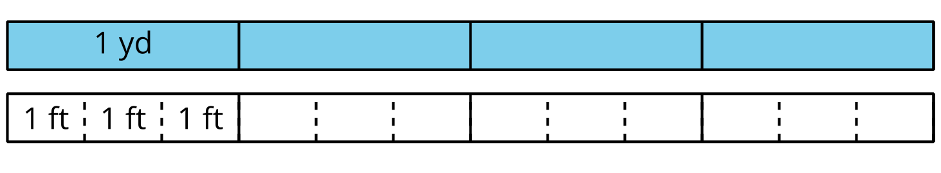
There are 3 feet in a yard, so one foot is $\frac{1}{3}$ of a yard.
- It takes 3 times as many feet to measure the same length as it does with yards.
- It takes $\frac{1}{3}$ as many yards to measure the same length as it does with feet.

