Lesson 9: Measure to Find the Area

Standards Alignments
Addressing | 3.MD.C.7.b, 3.OA.B.5

Teacher-facing Learning Goals
- Find the area of rectangles by measuring and multiplying the side lengths.

Student-facing Learning Goals
- Let’s measure the sides of rectangles and find the area.

Lesson Purpose
The purpose of this lesson is for students to measure side lengths of rectangles to find their area.
In grade 2, students measured length in centimeters and feet. In earlier lessons, they found the area of rectangles in standard units. Here, students measure side lengths of rectangles and multiply them to find area. They also find side lengths that would result in a rectangle with a given area.
Provide rulers for students to use during the cool-down.

Access for:

Students with Disabilities
- Engagement (Activity 2)

English Learners
- MLR8 (Activity 2)

Instructional Routines
Notice and Wonder (Warm-up)

Materials to Gather
- Rulers (centimeters): Activity 1
- Rulers (inches): Activity 2
- Tape (painter's or masking): Activity 2
- Yardsticks: Activity 2

Lesson Timeline
Warm-up | 10 min
Activity 1 | 15 min
Activity 2 | 20 min
Lesson Synthesis | 10 min
Cool-down | 5 min

Teacher Reflection Question
Identify ways the math community you are fostering is going well. What aspects would you like to work on? What actions can you take to improve those areas?

Cool-down
(to be completed at the end of the lesson) 5min
Find the Area

Standards Alignments
Addressing | 3.MD.C.7.b

Student-facing Task Statement
Use your ruler to find the area of the rectangle in square inches.
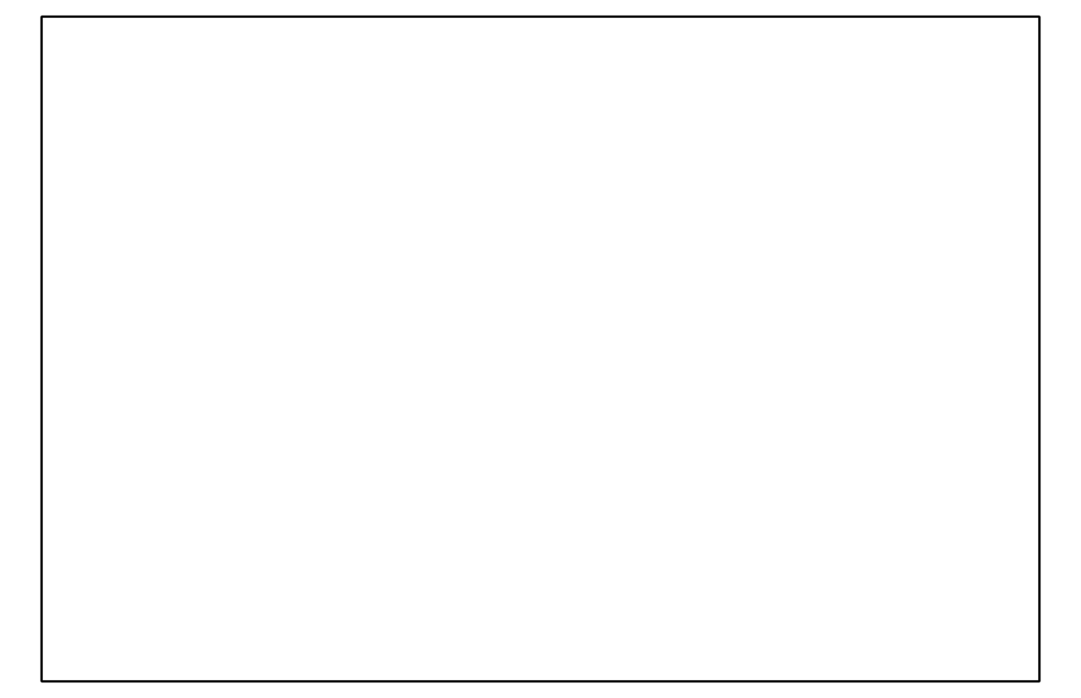

Student Responses
24 square inches.

