Unit 4 Lesson 16: Using Graphs and Logarithms to Solve Problems (Part 2)

1 Two Bank Accounts (Warm up)

Student Task Statement
A business owner opened two different types of investment accounts at the start of the year. The functions $f$ and $g$ represent the values of the two accounts as a function of the number of months after the accounts were opened.
- Here are some true statements about the investment accounts. What does each statement mean?
  - $f\left(3\right)>g\left(3\right)$
  - $f\left(6\right)<g\left(6\right)$
  - $f\left(m\right)=g\left(m\right)$
- If the two functions were graphed on the same coordinate plane, what might it look like? Sketch the two functions.

2 Bacteria in Different Conditions

Student Task Statement
To study the growth of bacteria in different conditions, a scientist measures the area, in square millimeters, occupied by two populations.
The growth of Population A, in square millimeters, can be modeled by $f\left(h\right)=24⋅e^{\left(0.4h\right)}$ where $h$ is the number of hours since the experiment began. The growth of Population B can be modeled by $g\left(h\right)=9⋅e^{\left(0.6h\right)}$. Here are the graphs representing the two populations.
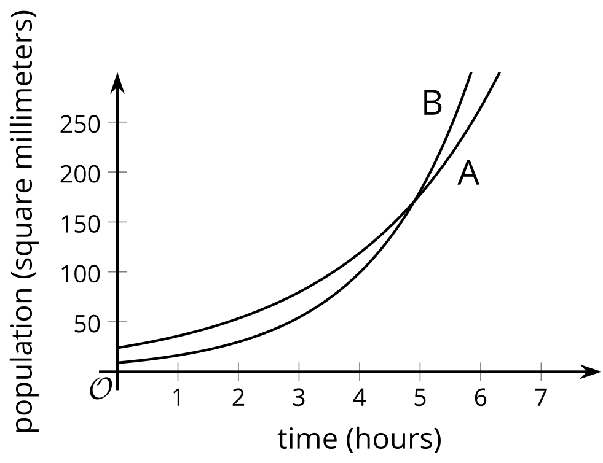
- In this situation, what does the point of intersection of the two graphs tell us?
- Suppose the population coordinate of the point of intersection is 171. Explain why we can find the corresponding time coordinate by:
  - solving $f\left(h\right)=171$ or $g\left(h\right)=171$
  - solving the equation $f\left(h\right)=g\left(h\right)$
- Solve either $f\left(h\right)=171$ or $g\left(h\right)=171$. Show your reasoning.
- Solve $f\left(h\right)=g\left(h\right)$. Show your reasoning.

3 Populations of Two Countries

Student Task Statement
The population, in millions, of Country C is given by the equation $f\left(t\right)=16⋅e^{\left(0.02t\right)}$. The population of Country D is given by $g\left(t\right)=17.5⋅e^{\left(0.025t\right)}$. In both equations, $t$ is the number of years since 1980.
- Will there be a time when the two populations are equal? Explain or show your reasoning.
- At some point in time, the population of Country C reached 30 million. When does this happen? Explain or show your reasoning.
© CC BY 2019 by Illustrative Mathematics®

