Grade 2
Unit 1Lesson 1CC BY NC 2024 Illustrative Mathematics®
Unit 1, Lesson 1

Add and Subtract within 10
- Let’s add and subtract within 10.
Grade 2
Unit 1Lesson 1CC BY NC 2024 Illustrative Mathematics®

Warm-upWhat Do You Know about Math?
What do you know about math?
Grade 2
Unit 1Lesson 1CC BY NC 2024 Illustrative Mathematics®

Activity 1Check It Off: Add or Subtract within 10
- Choose 2 cards. Find the value of the sum or difference.
- Check off the number you found. Write the expression.
- The partner who checks off the most numbers wins.
 | found it! | expression
0
1
2
3
4
5
6
7
8
9
10
Grade 2
Unit 1Lesson 1CC BY NC 2024 Illustrative Mathematics®

Activity 2What’s the Value?
- Match each expression to the value of the sum or difference.
  - $5+3$
  - $3−1$
  - $10−1$
  - $4+5$
  - $6+3$
  - $6−5$
  - $1+6$
  - $9−5$
  - $8−5$
  - $3+6$
  - 9
  - 3
  - 8
  - 7
  - 1
  - 4
  - 2
- Circle the addition expressions with a value of 10.
- 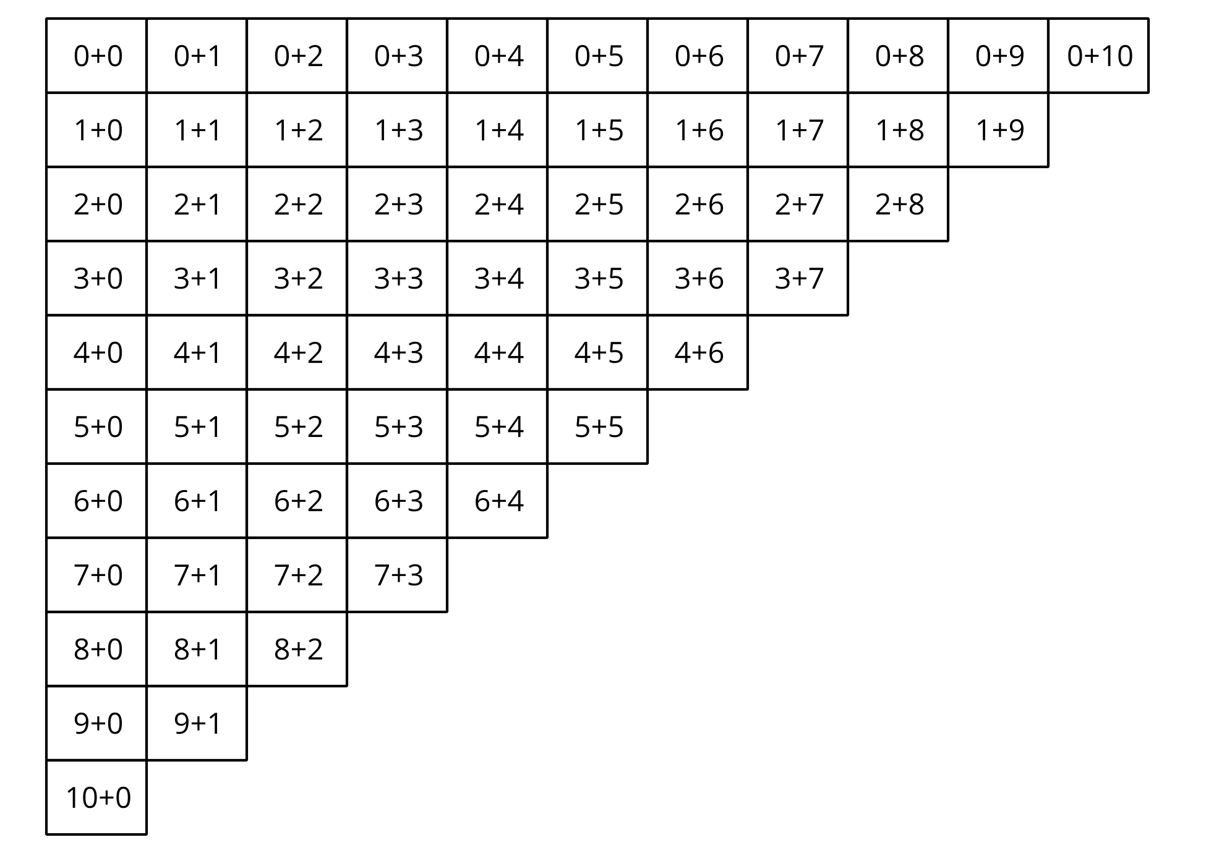
- What patterns do you notice in the expressions with a value of 10?

