Grade 2
Unit 8Lesson 11CC BY NC 2024 Illustrative Mathematics®
Unit 8, Lesson 11

Arrays and Rectangles
- Let’s make arrays and rectangles using tiles.
Grade 2
Unit 8Lesson 11CC BY NC 2024 Illustrative Mathematics®

Warm-upWhich Three Go Together: All Kinds of Arrays
Which 3 go together?
Unable to process <img src="/tikz_files/240143.svg">Failed: rsvg-convert --format png --dpi-x 300 --dpi-y 300 /app/tmp/svgtopng-1786381385.7476885.svg --output /app/tmp/svgtopng-1786381385.7476885.png Backtrace: /app/app/services/script/runner.rb:34:in `block in run_cmd' <internal:kernel>:90:in `tap' /app/app/services/script/runner.rb:32:in `run_cmd' /app/app/services/script/svg_to_png.rb:27:in `convert_svg_to_png' /app/app/services/script/svg_to_png.rb:17:in `to_png' /app/vendor/bundle/ruby/3.3.0/gems/embeddable_content-1.1.0/app/services/embeddable_content/images/image_downloader.rb:37:in `png_rendered_from_svg' /app/vendor/bundle/ruby/3.3.0/gems/embeddable_content-1.1.0/app/services/embeddable_content/images/image_downloader.rb:33:in `raw_image_data' /app/vendor/bundle/ruby/3.3.0/gems/embeddable_content-1.1.0/app/services/embeddable_content/images/image_downloader.rb:13:in `block in save' <internal:kernel>:90:in `tap' /app/vendor/bundle/ruby/3.3.0/gems/embeddable_content-1.1.0/app/services/embeddable_content/images/image_downloader.rb:13:in `save'
B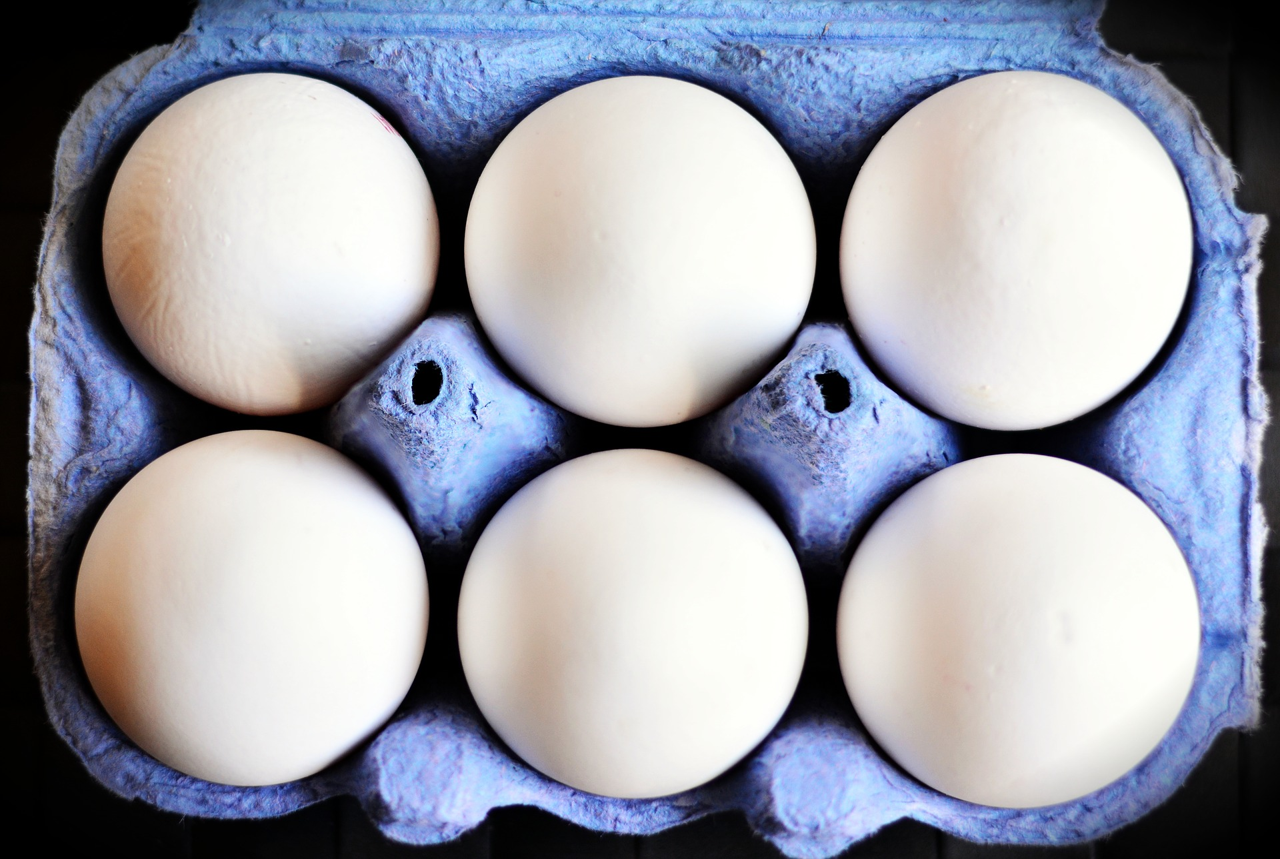
Unable to process <img src="/tikz_files/240144.svg">Failed: rsvg-convert --format png --dpi-x 300 --dpi-y 300 /app/tmp/svgtopng-1786381385.9948106.svg --output /app/tmp/svgtopng-1786381385.9948106.png Backtrace: /app/app/services/script/runner.rb:34:in `block in run_cmd' <internal:kernel>:90:in `tap' /app/app/services/script/runner.rb:32:in `run_cmd' /app/app/services/script/svg_to_png.rb:27:in `convert_svg_to_png' /app/app/services/script/svg_to_png.rb:17:in `to_png' /app/vendor/bundle/ruby/3.3.0/gems/embeddable_content-1.1.0/app/services/embeddable_content/images/image_downloader.rb:37:in `png_rendered_from_svg' /app/vendor/bundle/ruby/3.3.0/gems/embeddable_content-1.1.0/app/services/embeddable_content/images/image_downloader.rb:33:in `raw_image_data' /app/vendor/bundle/ruby/3.3.0/gems/embeddable_content-1.1.0/app/services/embeddable_content/images/image_downloader.rb:13:in `block in save' <internal:kernel>:90:in `tap' /app/vendor/bundle/ruby/3.3.0/gems/embeddable_content-1.1.0/app/services/embeddable_content/images/image_downloader.rb:13:in `save' Unable to process <img src="/tikz_files/240145.svg">Failed: rsvg-convert --format png --dpi-x 300 --dpi-y 300 /app/tmp/svgtopng-1786381386.083918.svg --output /app/tmp/svgtopng-1786381386.083918.png Backtrace: /app/app/services/script/runner.rb:34:in `block in run_cmd' <internal:kernel>:90:in `tap' /app/app/services/script/runner.rb:32:in `run_cmd' /app/app/services/script/svg_to_png.rb:27:in `convert_svg_to_png' /app/app/services/script/svg_to_png.rb:17:in `to_png' /app/vendor/bundle/ruby/3.3.0/gems/embeddable_content-1.1.0/app/services/embeddable_content/images/image_downloader.rb:37:in `png_rendered_from_svg' /app/vendor/bundle/ruby/3.3.0/gems/embeddable_content-1.1.0/app/services/embeddable_content/images/image_downloader.rb:33:in `raw_image_data' /app/vendor/bundle/ruby/3.3.0/gems/embeddable_content-1.1.0/app/services/embeddable_content/images/image_downloader.rb:13:in `block in save' <internal:kernel>:90:in `tap' /app/vendor/bundle/ruby/3.3.0/gems/embeddable_content-1.1.0/app/services/embeddable_content/images/image_downloader.rb:13:in `save'
Grade 2
Unit 8Lesson 11CC BY NC 2024 Illustrative Mathematics®

Activity 1 Use Tiles to Make Arrays
Choose a number of tiles.
12 | 15 | 16 | 18 | 20

Arrange all the tiles in an array. Then push them together to make a rectangle.
- Shade squares on this grid to show the rectangle.
- Unable to process <img src="/tikz_files/240146.svg">Failed: rsvg-convert --format png --dpi-x 300 --dpi-y 300 /app/tmp/svgtopng-1786381386.1497507.svg --output /app/tmp/svgtopng-1786381386.1497507.png Backtrace: /app/app/services/script/runner.rb:34:in `block in run_cmd' <internal:kernel>:90:in `tap' /app/app/services/script/runner.rb:32:in `run_cmd' /app/app/services/script/svg_to_png.rb:27:in `convert_svg_to_png' /app/app/services/script/svg_to_png.rb:17:in `to_png' /app/vendor/bundle/ruby/3.3.0/gems/embeddable_content-1.1.0/app/services/embeddable_content/images/image_downloader.rb:37:in `png_rendered_from_svg' /app/vendor/bundle/ruby/3.3.0/gems/embeddable_content-1.1.0/app/services/embeddable_content/images/image_downloader.rb:33:in `raw_image_data' /app/vendor/bundle/ruby/3.3.0/gems/embeddable_content-1.1.0/app/services/embeddable_content/images/image_downloader.rb:13:in `block in save' <internal:kernel>:90:in `tap' /app/vendor/bundle/ruby/3.3.0/gems/embeddable_content-1.1.0/app/services/embeddable_content/images/image_downloader.rb:13:in `save'
- How many rows of squares does your rectangle have? ______
- How many columns does your rectangle have? ______
- How many squares are in your rectangle? ______
- Write 2 equations to represent the number of squares in your rectangle.
Grade 2
Unit 8Lesson 11CC BY NC 2024 Illustrative Mathematics®

Activity 2Make Equal-Size Squares

  - Draw lines to fill the rectangle with equal-size squares.
  - Unable to process <img src="/tikz_files/240147.svg">Failed: rsvg-convert --format png --dpi-x 300 --dpi-y 300 /app/tmp/svgtopng-1786381386.197217.svg --output /app/tmp/svgtopng-1786381386.197217.png Backtrace: /app/app/services/script/runner.rb:34:in `block in run_cmd' <internal:kernel>:90:in `tap' /app/app/services/script/runner.rb:32:in `run_cmd' /app/app/services/script/svg_to_png.rb:27:in `convert_svg_to_png' /app/app/services/script/svg_to_png.rb:17:in `to_png' /app/vendor/bundle/ruby/3.3.0/gems/embeddable_content-1.1.0/app/services/embeddable_content/images/image_downloader.rb:37:in `png_rendered_from_svg' /app/vendor/bundle/ruby/3.3.0/gems/embeddable_content-1.1.0/app/services/embeddable_content/images/image_downloader.rb:33:in `raw_image_data' /app/vendor/bundle/ruby/3.3.0/gems/embeddable_content-1.1.0/app/services/embeddable_content/images/image_downloader.rb:13:in `block in save' <internal:kernel>:90:in `tap' /app/vendor/bundle/ruby/3.3.0/gems/embeddable_content-1.1.0/app/services/embeddable_content/images/image_downloader.rb:13:in `save'
  - Color the rows different colors.
  - How many rows of equal-size squares are there?
  - How many squares are in each row?
  - Write an equation to represent the sum of the squares in each row.

  - Draw lines to fill the rectangle with equal-size squares.
  - Unable to process <img src="/tikz_files/240148.svg">Failed: rsvg-convert --format png --dpi-x 300 --dpi-y 300 /app/tmp/svgtopng-1786381386.2377415.svg --output /app/tmp/svgtopng-1786381386.2377415.png Backtrace: /app/app/services/script/runner.rb:34:in `block in run_cmd' <internal:kernel>:90:in `tap' /app/app/services/script/runner.rb:32:in `run_cmd' /app/app/services/script/svg_to_png.rb:27:in `convert_svg_to_png' /app/app/services/script/svg_to_png.rb:17:in `to_png' /app/vendor/bundle/ruby/3.3.0/gems/embeddable_content-1.1.0/app/services/embeddable_content/images/image_downloader.rb:37:in `png_rendered_from_svg' /app/vendor/bundle/ruby/3.3.0/gems/embeddable_content-1.1.0/app/services/embeddable_content/images/image_downloader.rb:33:in `raw_image_data' /app/vendor/bundle/ruby/3.3.0/gems/embeddable_content-1.1.0/app/services/embeddable_content/images/image_downloader.rb:13:in `block in save' <internal:kernel>:90:in `tap' /app/vendor/bundle/ruby/3.3.0/gems/embeddable_content-1.1.0/app/services/embeddable_content/images/image_downloader.rb:13:in `save'
  - Color the columns different colors.
  - How many columns of equal-size squares are there?
  - How many squares are in each column?
  - Write an equation to represent the sum of the squares in each column.

  - Draw lines to fill the rectangle with equal-size squares.
  - Unable to process <img src="/tikz_files/240149.svg">Failed: rsvg-convert --format png --dpi-x 300 --dpi-y 300 /app/tmp/svgtopng-1786381386.2852368.svg --output /app/tmp/svgtopng-1786381386.2852368.png Backtrace: /app/app/services/script/runner.rb:34:in `block in run_cmd' <internal:kernel>:90:in `tap' /app/app/services/script/runner.rb:32:in `run_cmd' /app/app/services/script/svg_to_png.rb:27:in `convert_svg_to_png' /app/app/services/script/svg_to_png.rb:17:in `to_png' /app/vendor/bundle/ruby/3.3.0/gems/embeddable_content-1.1.0/app/services/embeddable_content/images/image_downloader.rb:37:in `png_rendered_from_svg' /app/vendor/bundle/ruby/3.3.0/gems/embeddable_content-1.1.0/app/services/embeddable_content/images/image_downloader.rb:33:in `raw_image_data' /app/vendor/bundle/ruby/3.3.0/gems/embeddable_content-1.1.0/app/services/embeddable_content/images/image_downloader.rb:13:in `block in save' <internal:kernel>:90:in `tap' /app/vendor/bundle/ruby/3.3.0/gems/embeddable_content-1.1.0/app/services/embeddable_content/images/image_downloader.rb:13:in `save'
  - How many columns of equal-size squares are there? How many squares are in each column?
  - How many rows of equal-size squares are there? How many squares are in each row?
  - Write 2 equations to represent the total number of squares in the rectangle.

