Unit 7 Lesson 14: Wax Prints

WU Notice and Wonder: Textiles (Warm up)

Student Task Statement
What do you notice? What do you wonder?


1 Create a Wax Print Pattern

Student Task Statement
Your teacher will give you some dot paper for drawing.
- Use the dot paper to design your own wax print pattern. Your pattern should:
  - use a rhombus, rectangle, or square
  - use a quadrilateral that is not a rhombus, rectangle, or square
  - have each shape repeat at least 5 times
- Color the pattern in a way that highlights the shapes you chose or choices you made.


2 Info Gap: The Bundle

Student Task Statement


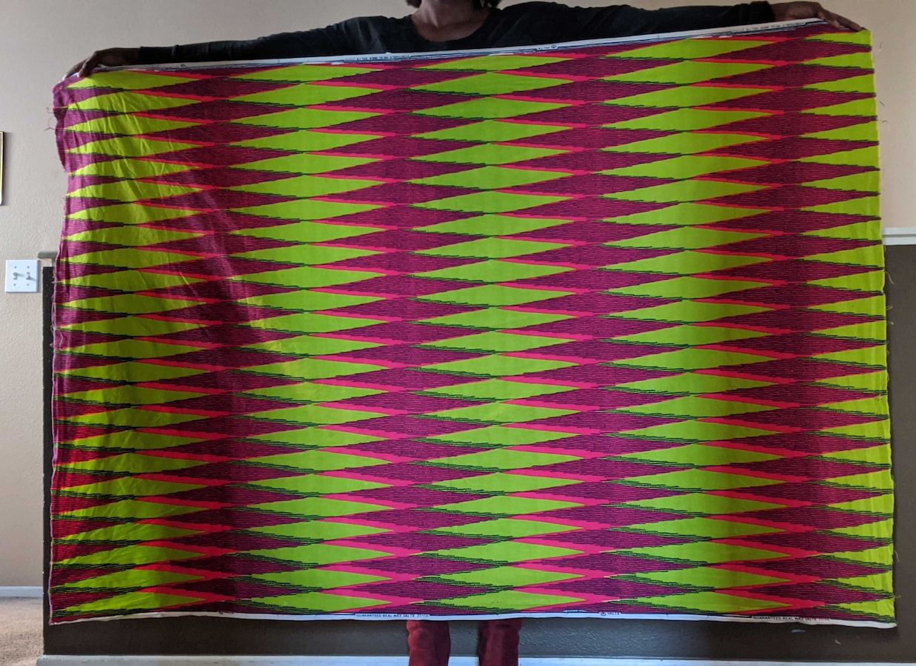
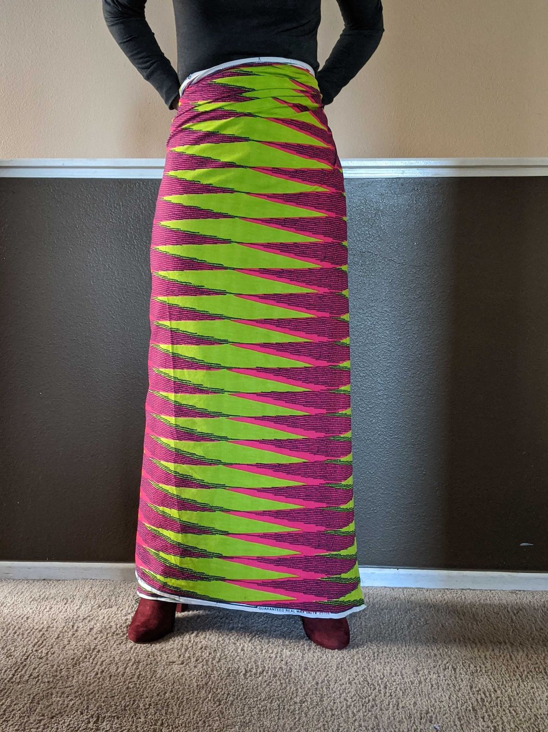
Your teacher will give you either a problem card or a data card. Do not show or read your card to your partner.
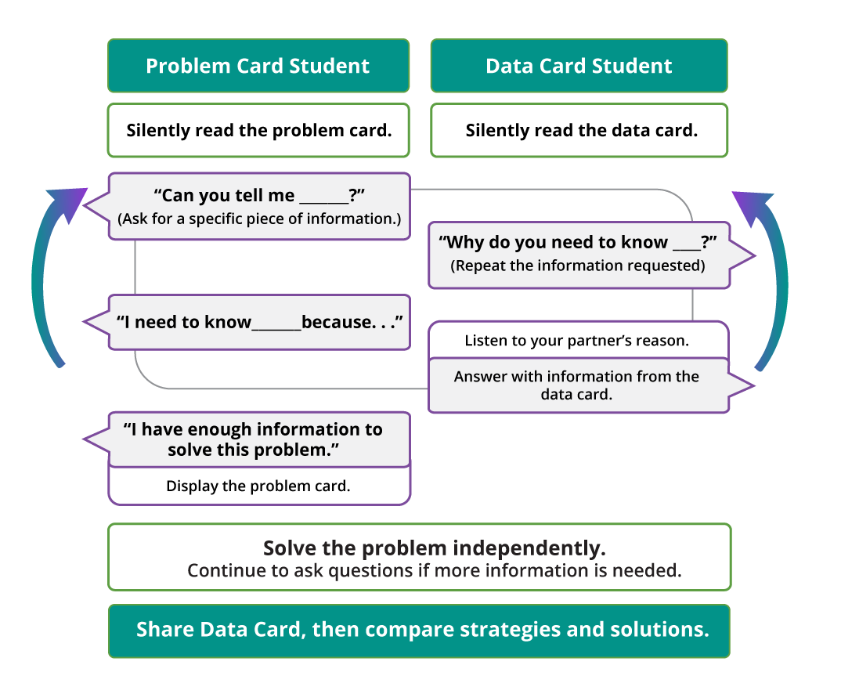
Pause here so your teacher can review your work. Ask your teacher for a new set of cards and repeat the activity, trading roles with your partner.
© CC BY 2021 Illustrative Mathematics®

