Grade 6
Unit 7Lesson 2CC BY NC Illustrative Mathematics, based on IM 6–8 Math, CC BY Open Up Resources.
Unit 7, Lesson 2

Points on the Number Line
Let’s plot positive and negative numbers on the number line.
Grade 6
Unit 7Lesson 2CC BY NC Illustrative Mathematics, based on IM 6–8 Math, CC BY Open Up Resources.

2.1A Point on the Number Line
Which of the following numbers could be represented by point $B$?
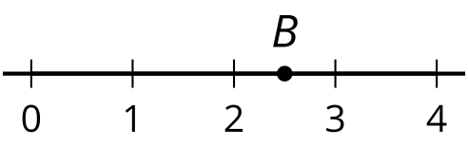
2.45
$\frac{2}{5}$
$\frac{5}{2}$
$\frac{35}{10}$
2.11
-2.5
Grade 6
Unit 7Lesson 2CC BY NC Illustrative Mathematics, based on IM 6–8 Math, CC BY Open Up Resources.

2.2What’s the Temperature?
- Here are five thermometers. The first four thermometers show temperatures in degrees Celsius $\left(​^{∘}\text{C}\right)$. Write the temperatures in the blanks.
- 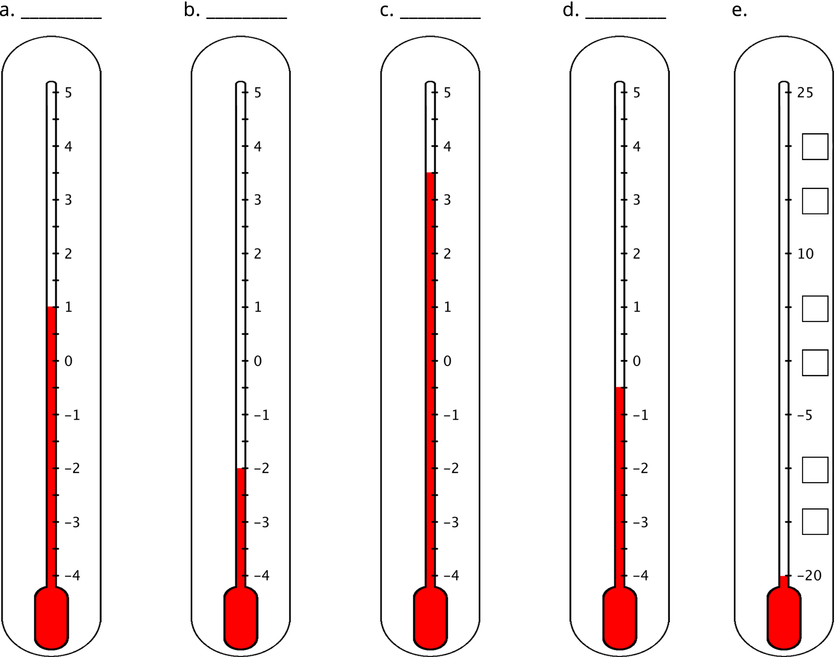
- The last thermometer is missing some numbers. Write them in the boxes.
- Elena says that the thermometer shown here reads $\text{-}{2.5}^{∘}\text{C}$ because the line is above $\text{-}2^{∘}\text{C}$. Jada says that it is $\text{-}{1.5}^{∘}\text{C}$. Do you agree with either of them? Explain your reasoning.
- 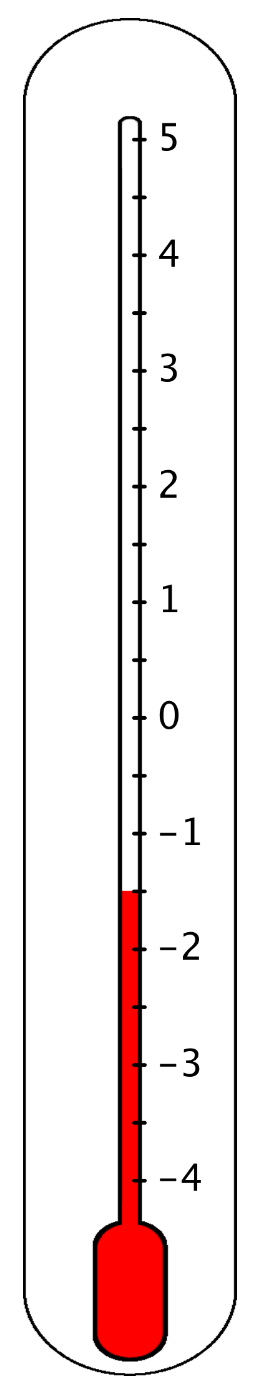
Grade 6
Unit 7Lesson 2CC BY NC Illustrative Mathematics, based on IM 6–8 Math, CC BY Open Up Resources.

2.3Folded Number Lines
Your teacher will give you a sheet of tracing paper. Follow the steps to make your own number line.
- Use a straightedge or a ruler to draw a horizontal line. Mark the middle point of the line, and label it 0.
- To the right of 0, draw tick marks that are 1 centimeter apart. Label the tick marks 1, 2, 3, . . . , 10. This represents the positive side of your number line.
- Fold your paper so that a vertical crease goes through 0 and the two sides of the number line match up perfectly.
- Use the fold to help you trace the tick marks that you already drew onto the opposite side of the number line. Unfold and label the tick marks -1, -2, -3. . . -10. This represents the negative side of your number line.
- Use your number line to answer these questions:
  - Which number is the same distance away from 0 as is the number 4?
  - Which number is the same distance away from 0 as is the number -7?
  - Two numbers that are the same distance from 0 on the number line are called opposites. Find another pair of opposites on the number line.
  - Choose a positive number and a negative number that is each farther away from 0 than is the number 5.
  - Choose a positive number and a negative number that is each farther away from 0 than is the number -2.
- Pause here so your teacher can review your work.
- Here is a number line with some points labeled with letters. What are the locations of points $P$, $X$, and $Y$? Be prepared to explain or show your reasoning.
- 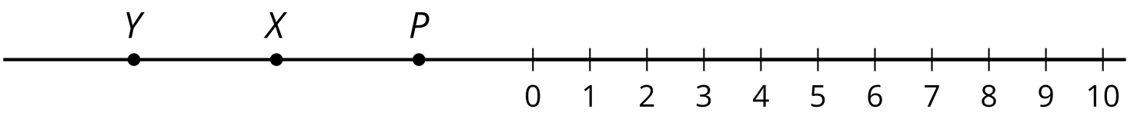

Are you ready for more?
​At noon, the temperatures in Portland, Maine, and Phoenix, Arizona, had opposite values. The temperature in Portland was ${18}^{∘}\text{C}$ lower than in Phoenix. What was the temperature in each city? Explain your reasoning.

Lesson 2 Summary
Two numbers that are the same distance from 0 and on different sides of the number line are opposites. For example, points A and B are opposites because they are both 2.5 units away from 0 and on opposite sides of 0.
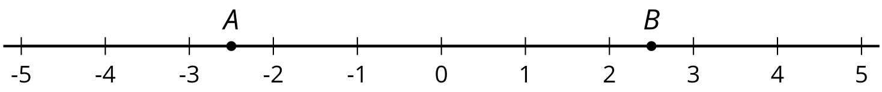
We can also say that the opposite of 8.3 is -8.3, and the opposite of $\text{-}\frac{3}{2}$ is $\frac{3}{2}$. The opposite of 0 is itself.
Here is another labeled number line with some rational numbers. A rational number is a number that can be written as a positive or negative fraction.
The number 4 is positive, and its location is 4 units to the right of 0 on the number line. The number 4 can be written as $\frac{4}{1}$ or $\frac{16}{4}$ or any other equivalent fraction.
The number $\text{-}\frac{2}{3}$ is negative, and its location is $\frac{2}{3}$ units to the left of 0 on the number line. To locate $\text{-}\frac{2}{3}$ on the number line, we can divide the distance between 0 and -1 into thirds and then count 2 thirds to the left of 0.
All fractions and their opposites are rational numbers.

