Lesson 4 Practice Problems
- A rectangle with area 12 square units is dilated by a scale factor of $k$. Find the area of the image for each given value of $k$.
  - $k=2$
  - $k=5$
  - $k=1$
  - $k=\frac{1}{4}$
  - $k=1.2$
- The area of a circle of radius 1 is $π$ units squared. Use scaling to explain why the area of a circle of radius $r$ is $πr^{2}$ units squared.
- Trapezoid $A^{′}B^{′}C^{′}D$ was created by dilating trapezoid $ABCD$ using $D$ as the center of dilation.
- 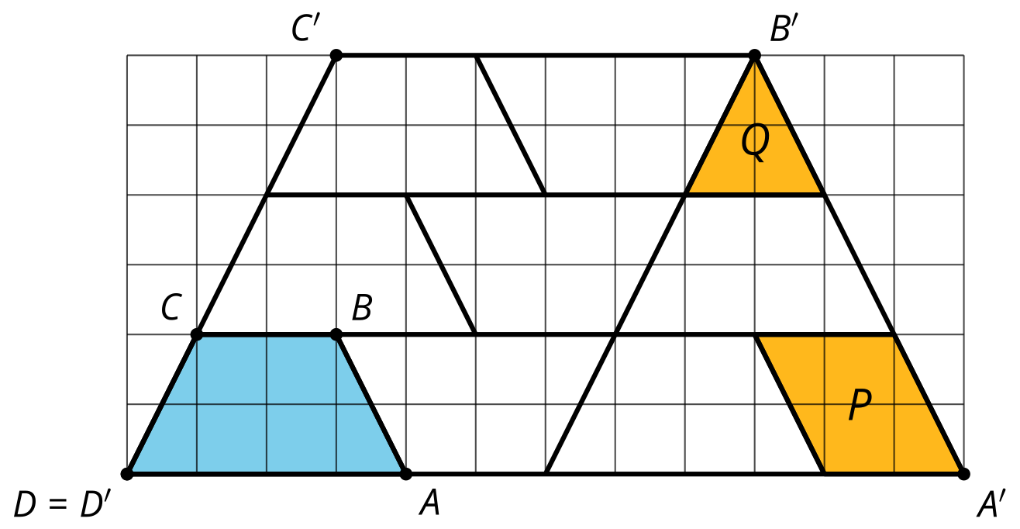
  - What was the scale factor of the dilation?
  - Based on the scale factor, how many copies of $ABCD$, including the original, should fit inside $A^{′}B^{′}C^{′}D$?
  - How can you see your answer to these questions in the diagram?
- Each image shows a quadrilateral in a plane. The quadrilateral has been dilated using a center above the plane and a scale factor between 0 and 1. Estimate the scale factor that was used for each dilation.

- Dilation A
- 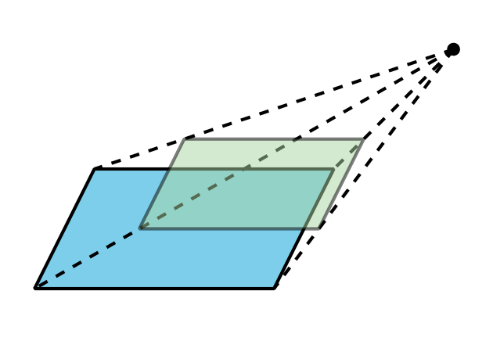

- Dilation B
- 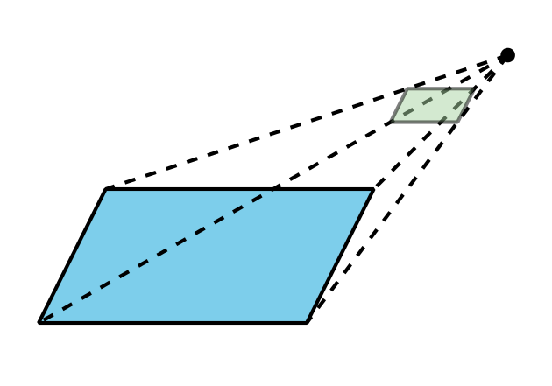

- Dilation C
- 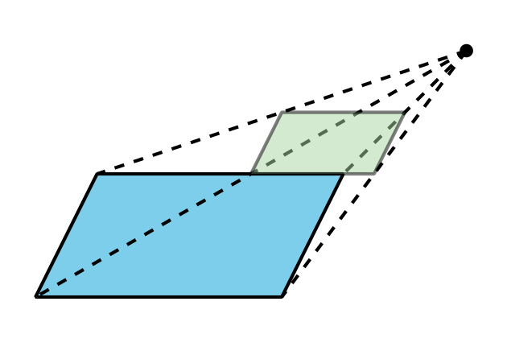
- (From Unit 5, Lesson 3.)
- Select the solid whose cross sections are dilations of some two-dimensional shape using a point directly above the shape as a center and scale factors ranging from 0 to 1.
  - cone
  - cube
  - cylinder
  - triangular prism
- (From Unit 5, Lesson 3.)
- Select all figures for which at least one cross section is a circle.
  - triangular pyramid
  - square pyramid
  - rectangular prism
  - cube
  - cone
  - cylinder
  - sphere
- (From Unit 5, Lesson 2.)
- If the two-dimensional figures are rotated around the vertical axes of rotation shown, what solids are formed?
- 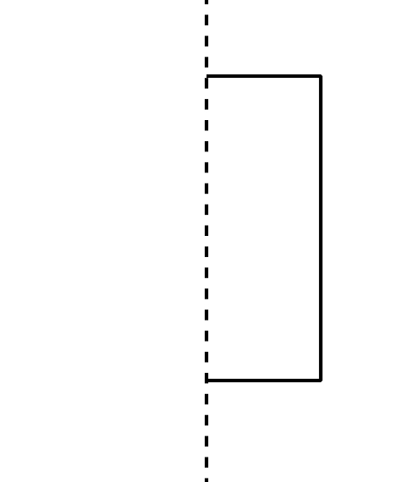
- 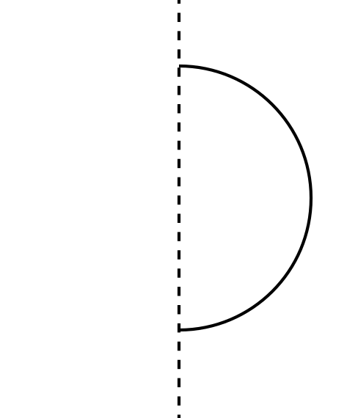
- (From Unit 5, Lesson 1.)
- Tyler and Jada wish to find the value of $x$, the length of side $BC$ in this triangle. Tyler decides to set up the equation $tan\left(56\right)=\frac{8}{x}$. Jada says she prefers an equation that has $x$ in the numerator. What is an equation she could use instead?
- 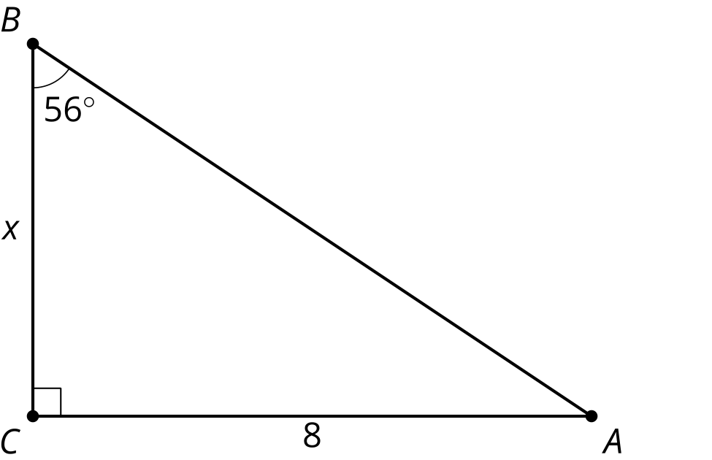
- ​​​​
- (From Unit 4, Lesson 8.)
- Triangles $ACD$ and $BCD$ are isosceles. Angle $DBC$ has a measure of 110 degrees and angle $BDA$ has a measure of 22 degrees. Find the measure of angle $BAC$.

- $\overset{¯}{AD}≅\overset{¯}{AC}$ and $\overset{¯}{BD}≅\overset{¯}{BC}$
- 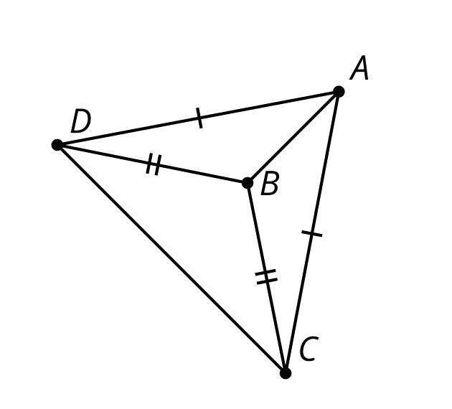
- (From Unit 2, Lesson 6.)
© CC BY 2019 by Illustrative Mathematics®

