Lesson 15: Expressions and Drawings
- Let’s match expressions to drawings.

Warm-up: Notice and Wonder: Shapes and Numbers
What do you notice?
What do you wonder?
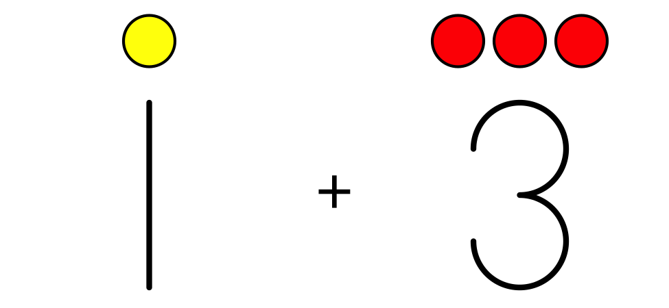

15.1: Match Drawings to Expressions
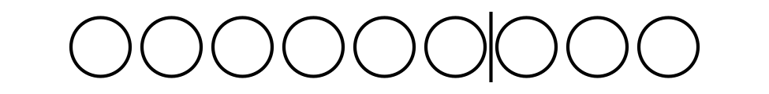
$9−2$

$6−3$

$4+2$
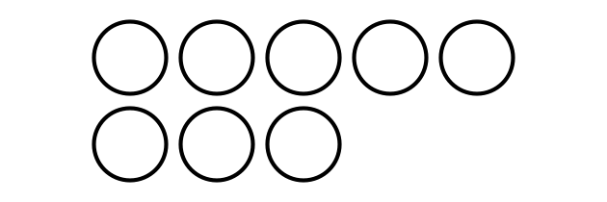
$6+3$

$5+3$
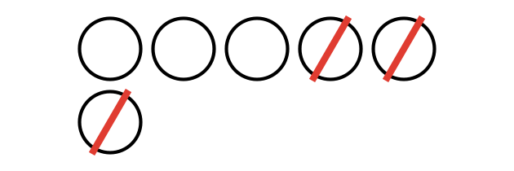
$7+0$

15.2: Create Expressions and Drawings
Fill in the missing expressions and drawings.
$4+3$

$4−0$
$\underset{_}{}−\underset{_}{}$

$5+3$
Fill in the missing expressions and drawings.
$8−2$
$\underset{_}{}+\underset{_}{}$

$1+6$
$\underset{_}{}−\underset{_}{}$

15.3: Introduce Shake and Spill, Represent
Choose a center.
Shake and Spill

Number Race
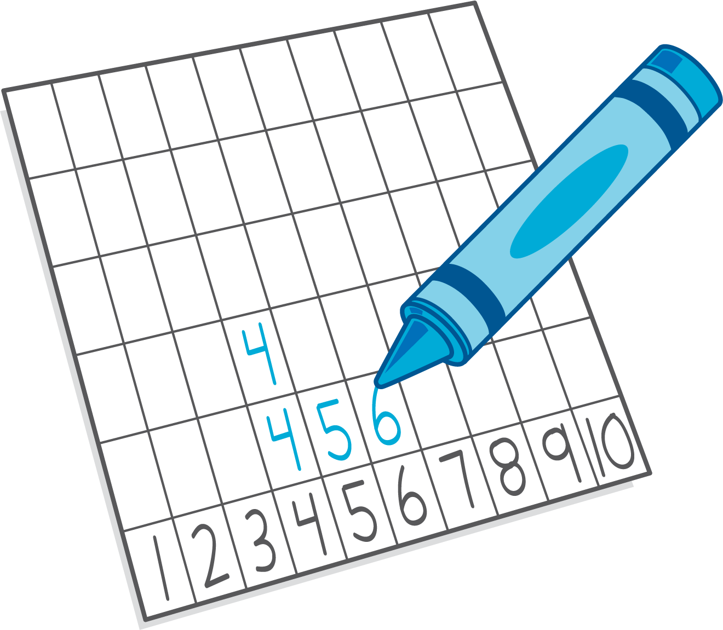
Math Stories
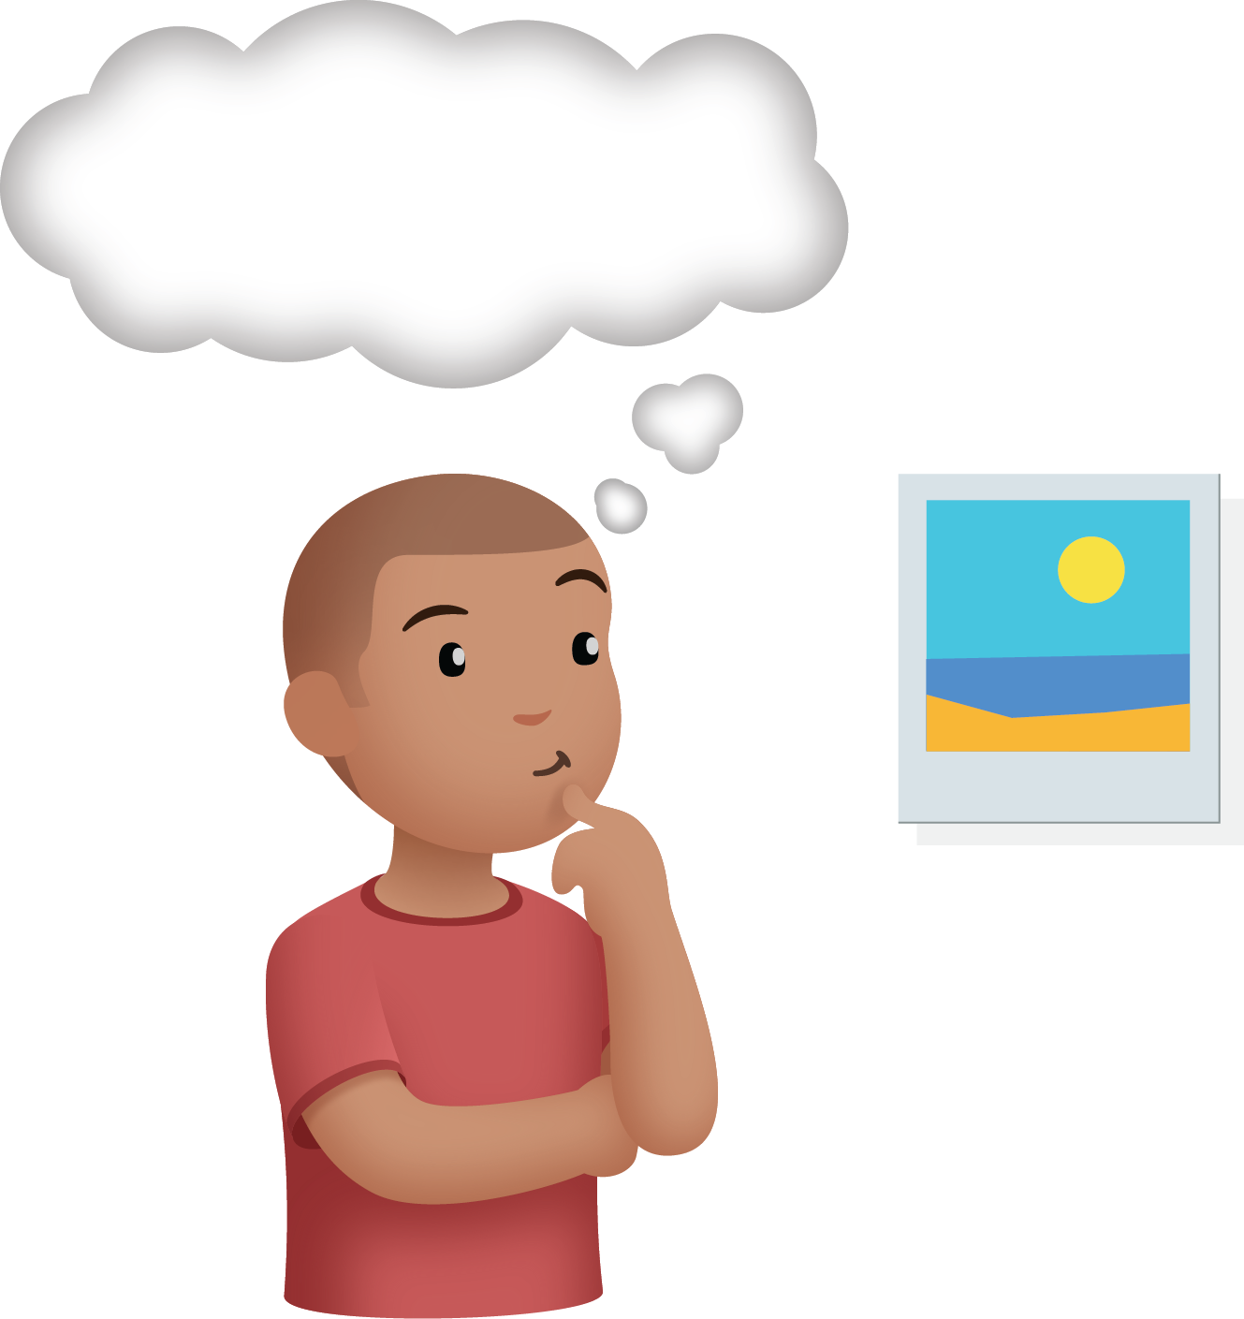
© CC BY 2021 Illustrative Mathematics®

