Grade 2
Unit 3Lesson 17CC BY NC 2024 Illustrative Mathematics®
Unit 3, Lesson 17

Center Day 3
- Let's measure to create line plots and add and subtract within 100.
Grade 2
Unit 3Lesson 17CC BY NC 2024 Illustrative Mathematics®

Warm-upNumber Talk: Subtract from a Multiple of 10
Find the value of each expression mentally.
- $60−10$
- $60−11$
- $60−21$
- $70−32$
Grade 2
Unit 3Lesson 17CC BY NC 2024 Illustrative Mathematics®

Activity 2Centers: Choice Time
Choose a center.
Estimate and Measure

Number Puzzles
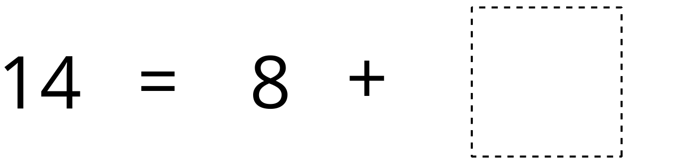
Target Measurements


