Grade 6
Unit 3Lesson 11CC BY NC Illustrative Mathematics, based on IM 6–8 Math, CC BY Open Up Resources.
Unit 3, Lesson 11

Representing Percentages with Double Number Line Diagrams
Let’s use double number line diagrams to represent percentages.
Grade 6
Unit 3Lesson 11CC BY NC Illustrative Mathematics, based on IM 6–8 Math, CC BY Open Up Resources.

11.1Saving for a Hat
Priya was saving money to buy a $10 hat.
- After one week, she had saved 50% of the cost of the hat.
- After two weeks, she had saved 75% of the cost of the hat.
- After three weeks, Priya had $15.
- How much money is 100% of the cost of the hat?
- Label the double number line diagram to represent the amounts and percentages in this situation.
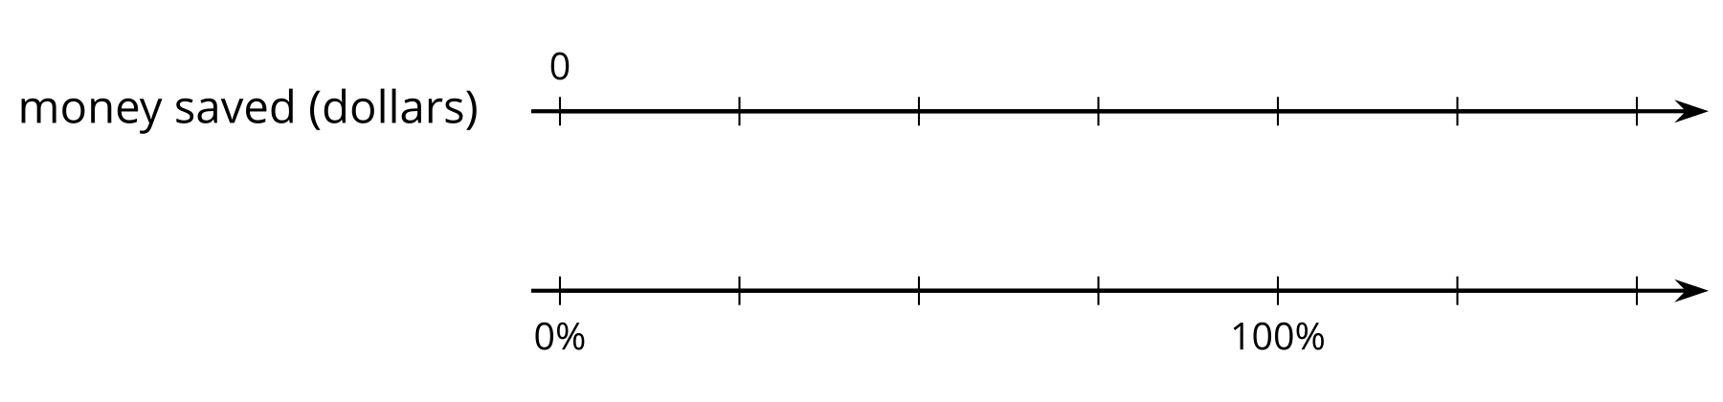
Grade 6
Unit 3Lesson 11CC BY NC Illustrative Mathematics, based on IM 6–8 Math, CC BY Open Up Resources.

11.2Fundraising Goal
Lin, Diego, Tyler, and Clare had the goal of raising $40 each.
- Lin raised 100% of her goal.
- Diego raised 50% of his goal.
- Tyler raised 150% of his goal.
- Clare raised 200% of her goal.
How much money did each person raise? Show your reasoning. Use the double number line diagram, if you find it helpful.
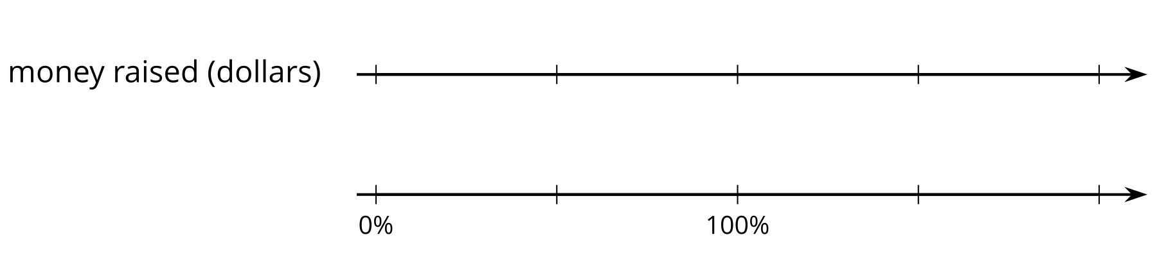
Grade 6
Unit 3Lesson 11CC BY NC Illustrative Mathematics, based on IM 6–8 Math, CC BY Open Up Resources.

11.3Three-Day Biking Trip
For each question, be prepared to explain or show your reasoning. Use the double number line diagrams, if you find them helpful.
- Elena biked 8 miles on Saturday.
  - What is 100% of her Saturday distance?
  - On Sunday, she biked 75% of her Saturday distance. How far was that?
  - On Monday, she biked 125% of her Saturday distance. How far was that?
  - 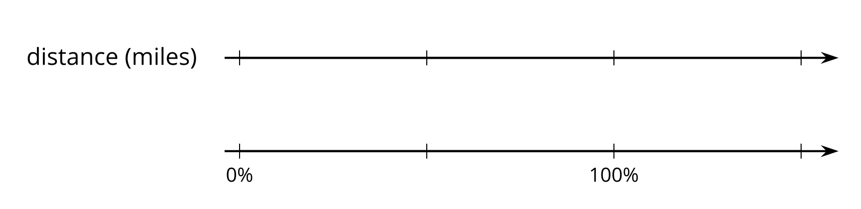
- Han biked 3 miles on Saturday. That distance is 50% of the distance his uncle biked. How many miles did his uncle bike?
- 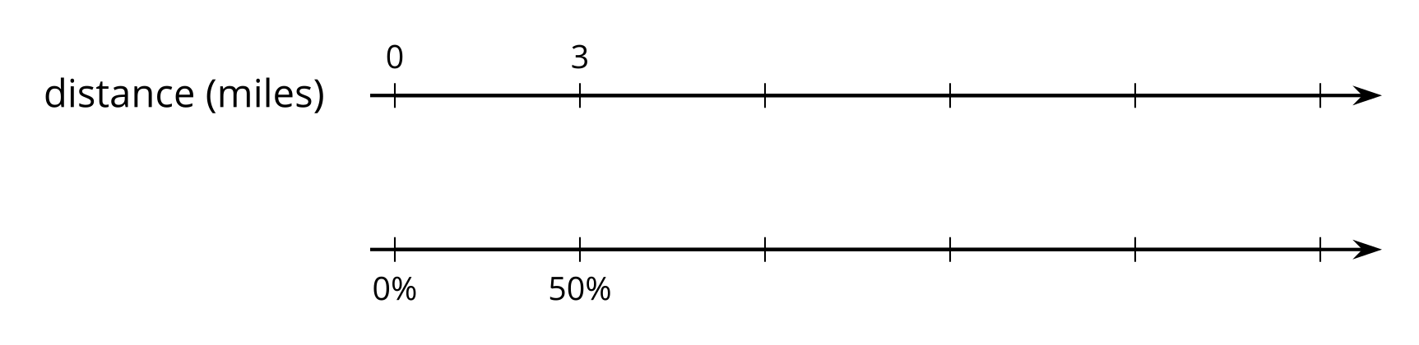

Are you ready for more?
In July 2021, Austrian cyclist Christoph Strasser broke the record for the distance biked in one day. That distance was nearly 8,000% of Elena’s Saturday’s distance. About how many miles did he ride? Explain or show how you know.
Grade 6
Unit 3Lesson 11CC BY NC Illustrative Mathematics, based on IM 6–8 Math, CC BY Open Up Resources.

11.4Puppies Grow Up
- Jada has a new puppy that weighs 9 pounds. The vet says that the puppy is now at about 20% of its adult weight.
- What will be the adult weight of the puppy?
- 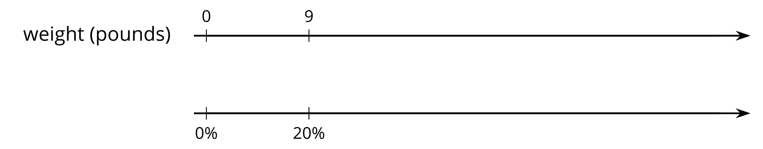
- Andre also has a puppy that weighs 9 pounds. The vet says that this puppy is now at about 30% of its adult weight.
- What will be the adult weight of Andre’s puppy?
- 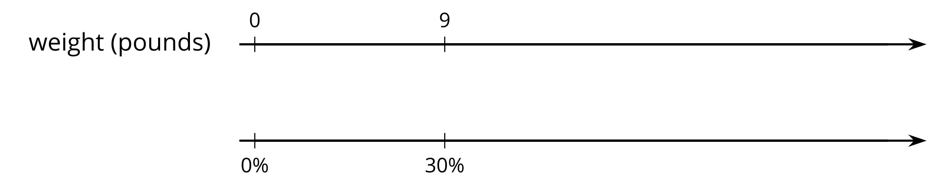
- What is the same about Jada and Andre’s puppies? What is different?

Lesson 11 Summary
Sometimes we are interested in percentages of an amount other than 100 or 1. For example, what is 30% of 50 pounds? We can use a double number line diagram to solve problems about percentages.
Because we are looking for a percentage of 50 pounds, 100% is aligned to 50 pounds on the double number line diagram, like this:
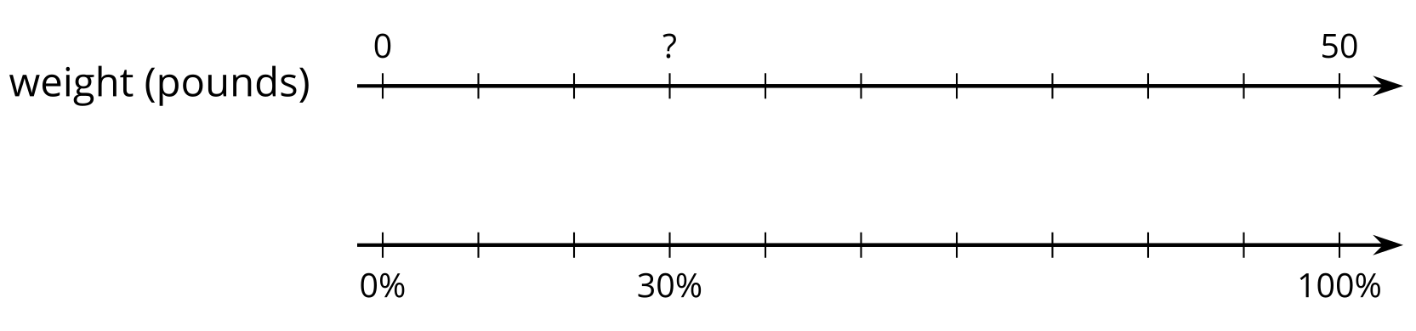
We divide the distance between 0% and 100% and that between 0 and 50 pounds into ten equal parts. The tick marks on the top line can be labeled by counting by 5s ($50÷10=5$). Those on the bottom line can be labeled by counting by 10% ($100÷10=10$). We can see that 30% of 50 pounds is 15 pounds.
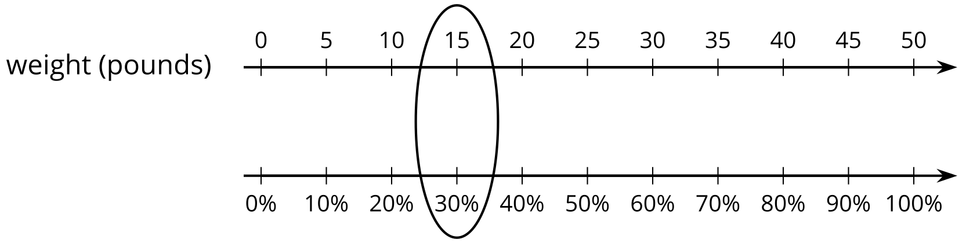
Double number line diagrams can also help us find the value of 100% when we know the value of another percentage.
Suppose Mai read for 90 minutes on Monday and this was 125% as much time as she spent reading on Sunday. How long did she read on Sunday?
In this case, the value we’re looking for is 100% of the number of reading minutes on Sunday. On a double number line diagram, we can align 90 minutes and 125%. Then, we can divide the interval between 0 and 90 and between 0 and 125% into five equal parts.
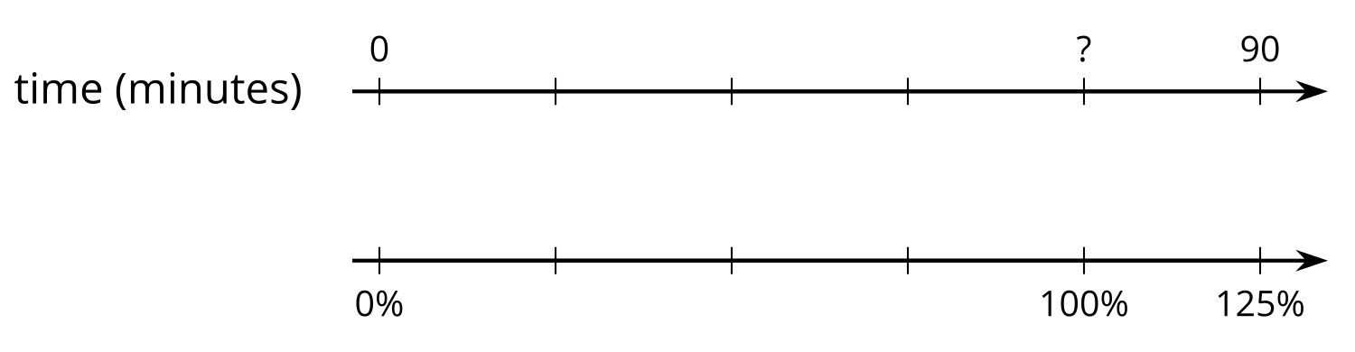
Each part on the top line represents 18 minutes ($90÷5=18$) and each part on the bottom line represents 25% ($125÷5=25$).
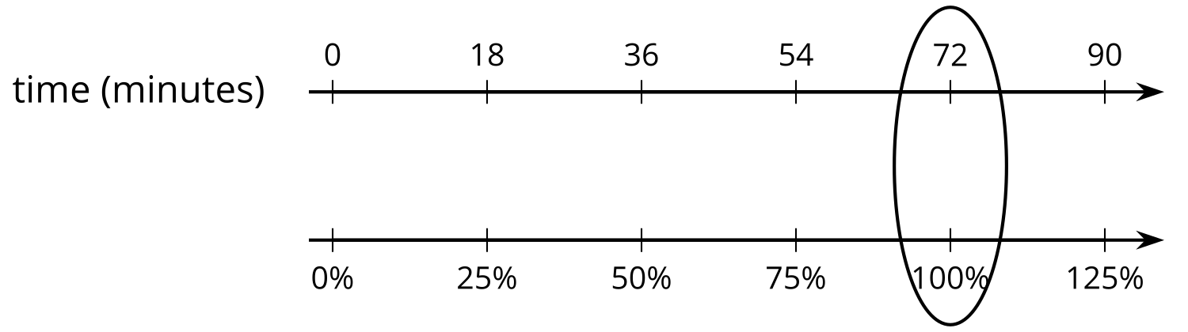
From the diagram, we can see that 72 minutes corresponds to 100%, so Mai read for 72 minutes on Sunday.

