Grade 2
Unit 4Lesson 13CC BY NC 2024 Illustrative Mathematics®
Unit 4, Lesson 13

Represent Story Problems
- Let’s compare representations and solve problems.
Grade 2
Unit 4Lesson 13CC BY NC 2024 Illustrative Mathematics®

Warm-up Notice and Wonder: Compare Representations
What do you notice? What do you wonder?
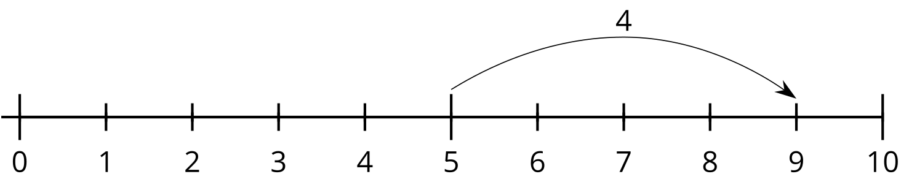
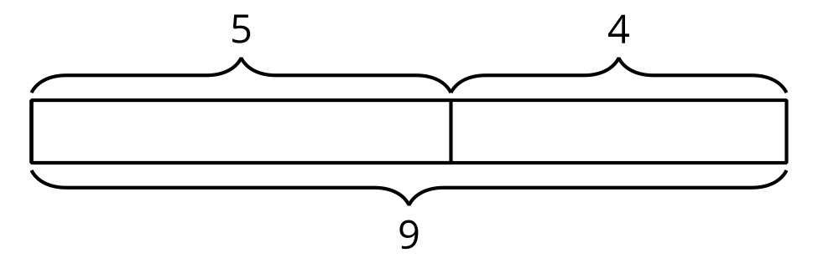
Grade 2
Unit 4Lesson 13CC BY NC 2024 Illustrative Mathematics®

Activity 1Card Sort: Represent Stories
Your teacher will give you a set of cards that show story problems, diagrams, number lines, and equations.
Match each story with a diagram, a number line, and an equation. Be ready to explain your reasoning.
Grade 2
Unit 4Lesson 13CC BY NC 2024 Illustrative Mathematics®

Activity 2 All Kinds of Representations
Solve each problem. Use a number line or diagram if it helps.
- Clare starts with 24 cubes and adds some more. She makes a train with 42 cubes. How many cubes does she add on?
- 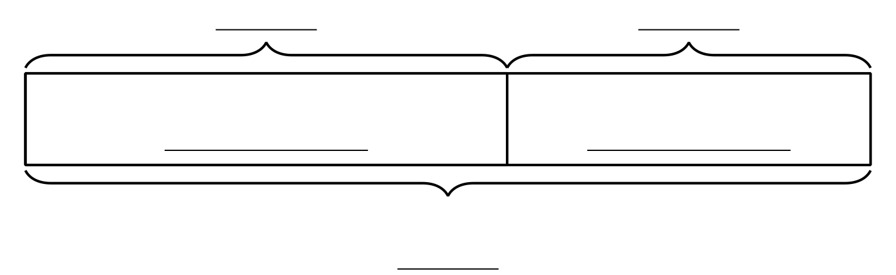
- Andre has 37 cubes. He adds 39 more to make the train longer. How many cubes does he use?
- 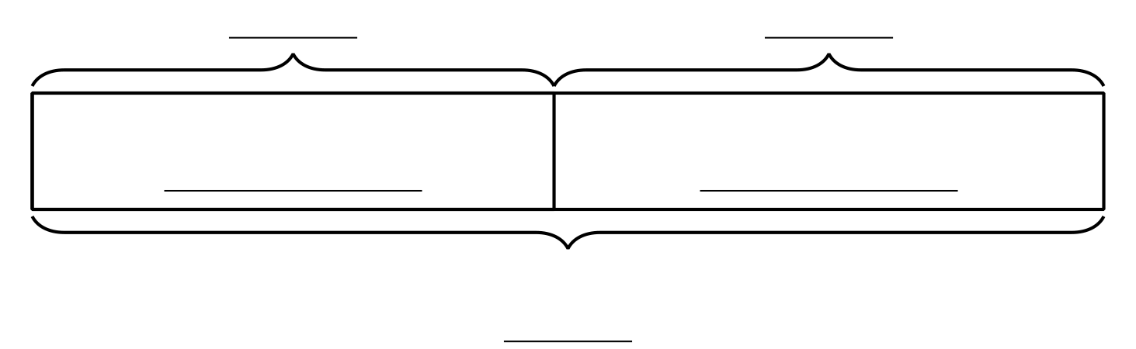
- Mai adds 8 cubes to her train. Now it is 55 cubes long. How long was her train before she added cubes?
- 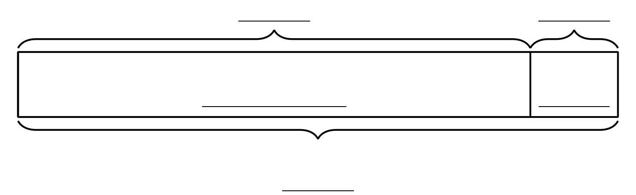

Section B Summary
We solved all types of problems and represented them in different ways. We represented addition and subtraction on number lines. We made connections to equations and strategies. We added and subtracted within 100. We used diagrams, base-ten blocks, number lines, and equations to show our thinking and make sense of stories and situations.
.
