Algebra 1
Unit 1Lesson 13CC BY NC 2024 Illustrative Mathematics®
Unit 1, Lesson 13

More Standard Deviation
- Let’s continue to interpret standard deviation.
Algebra 1
Unit 1Lesson 13CC BY NC 2024 Illustrative Mathematics®

13.1What Do You Want to Know?
100 captive Asian and 100 wild Asian elephants are weighed. There is a meaningful difference between the masses of the 2 groups if the measures of center are at least twice as far apart as the measure of variability. Is there a meaningful difference between the masses of these 2 groups of elephants? Explain your reasoning.
Algebra 1
Unit 1Lesson 13CC BY NC 2024 Illustrative Mathematics®

13.2Information Gap: African and Asian Elephants
Your teacher will give you either a problem card or a data card. Do not show or read your card to your partner.
If your teacher gives you the problem card:
- Silently read your card and think about what information you need to answer the question.
- Ask your partner for the specific information that you need. “Can you tell me _____?”
- Explain to your partner how you are using the information to solve the problem. “I need to know _____ because . . . .”
- Continue to ask questions until you have enough information to solve the problem.
- Once you have enough information, share the problem card with your partner, and solve the problem independently.
- Read the data card, and discuss your reasoning.
If your teacher gives you the data card:
- Silently read your card. Wait for your partner to ask for information.
- Before telling your partner any information, ask, “Why do you need to know _____?”
- Listen to your partner’s reasoning and ask clarifying questions. Only give information that is on your card. Do not figure out anything for your partner!
- These steps may be repeated.
- Once your partner says they have enough information to solve the problem, read the problem card, and solve the problem independently.
- Share the data card, and discuss your reasoning.
Algebra 1
Unit 1Lesson 13CC BY NC 2024 Illustrative Mathematics®

13.3Interpreting Measures of Center and Variability
For each situation, you are given two graphs of data, a measure of center for each, and a measure of variability for each.
- Interpret the measure of center in terms of the situation.
- Interpret the measure of variability in terms of the situation.
- Compare the two data sets.
- The heights of the 40 trees in each of two forests are collected.

- mean: 44.8 feet, standard deviation: 4.72 feet
- 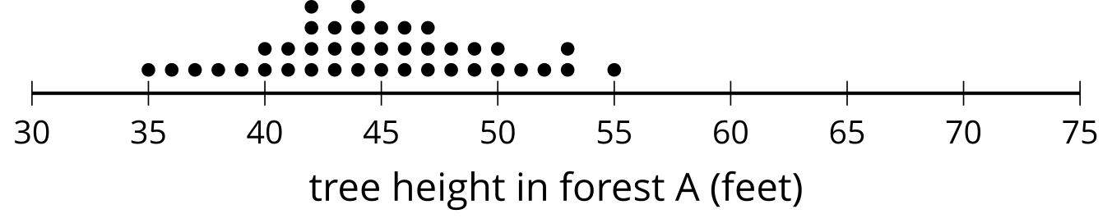

- mean: 56.03 feet, standard deviation: 7.87 feet
- 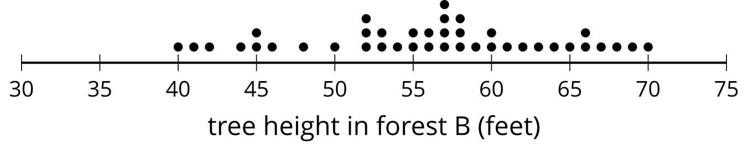
- The number of minutes it takes Lin and Noah to finish their tests in German class is collected for the year.

- mean: 29.48 minutes, standard deviation: 5.44 minutes
- 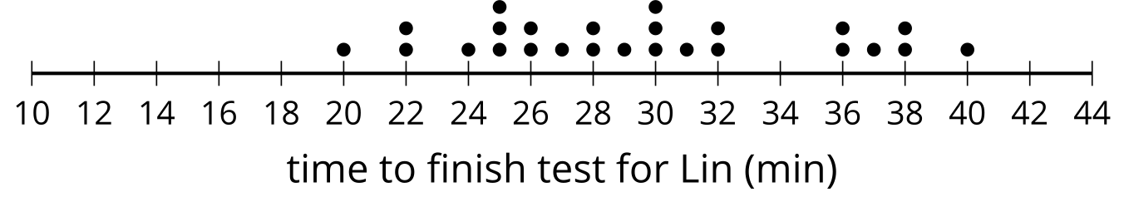

- mean: 28.44 minutes, standard deviation: 7.40 minutes
- 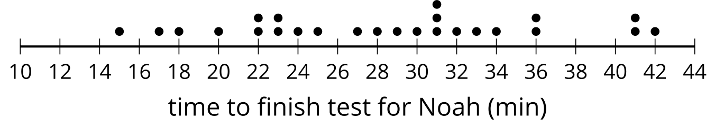
- The number of raisins in a cereal with a name brand and the generic version of the same cereal are collected for several boxes.

- mean: 289.1 raisins, standard deviation: 19.8 raisins
- 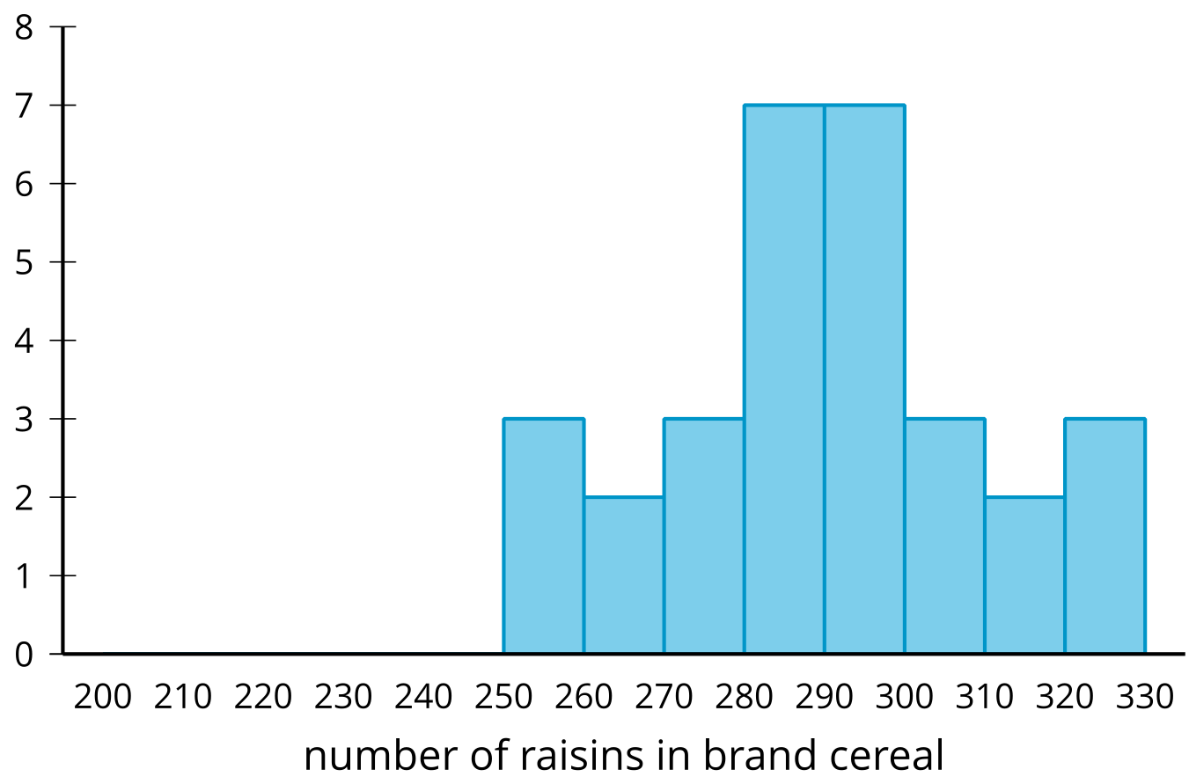

- mean: 249.17 raisins, standard deviation: 26.35 raisins
- 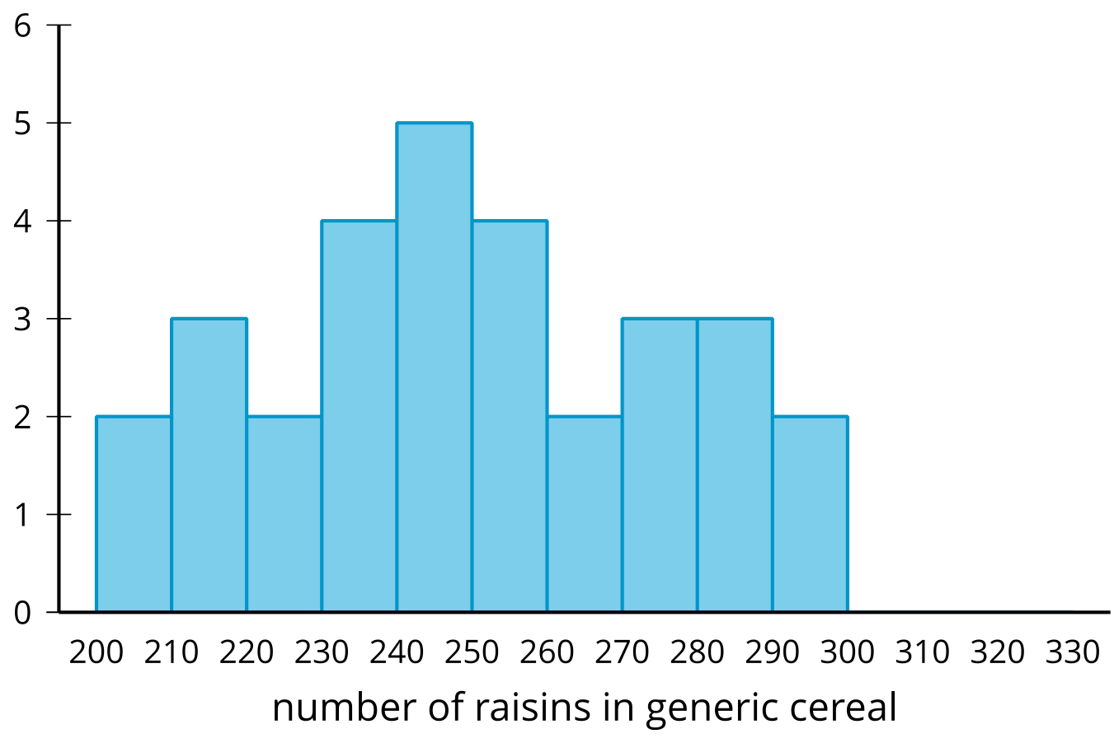

Are you ready for more?
One use of standard deviation is that it gives a natural scale as to how far above or below the mean a data point is. This is incredibly useful for comparing points from two different distributions.
For example, there is a saying that you cannot compare apples and oranges, but here is a way. The average weight of a granny smith apple is 128 grams with a standard deviation of about 10 grams. The average weight of a navel orange is 140 grams with a standard deviation of about 14 grams. If we have a 148 gram granny smith apple and a 161 gram navel orange, we might wonder which is larger for its species even though they are both about 20 grams above their respective mean. We could say that the apple, which is 2 standard deviations above its mean, is larger for its species than the orange, which is only 1.5 standard deviations above its mean.
- How many standard deviations above the mean height of a tree in forest A is its tallest tree?
- How many standard deviations above the mean height of a tree in forest B is its tallest tree?
- Which tree is relatively taller in its forest?

Lesson 13 Summary
The more variation a distribution has, the greater the standard deviation. A more compact distribution will have a lesser standard deviation.
The first dot plot shows the number of points that a player on a basketball team made during each of 15 games. The second dot plot shows the number of points scored by another player during the same 15 games.
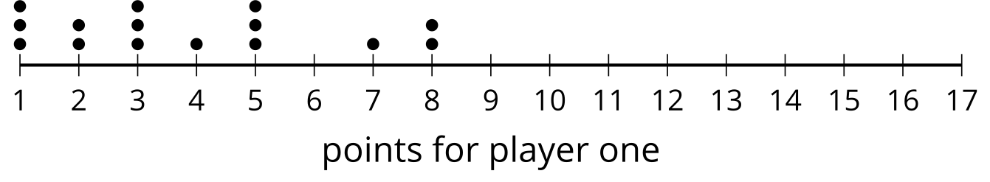
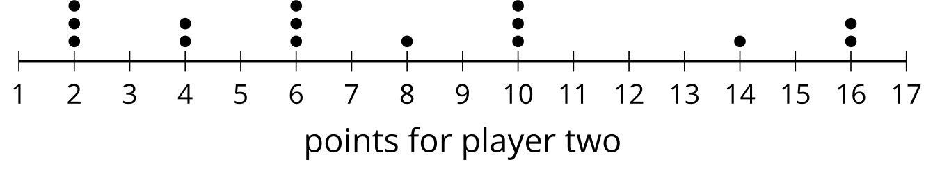
The data in the first plot have a mean of approximately 3.87 points and standard deviation of about 2.33 points. The data in the second plot have a mean of approximately 7.73 points and a standard deviation of approximately 4.67 points. The second distribution has greater variability than the first distribution because the data are more spread out. This is shown in the standard deviation for the second distribution being greater than the standard deviation for the first distribution.
Standard deviation is calculated using the mean, so it makes sense to use it as a measure of variability when the mean is appropriate to use for the measure of center. In cases where the median is a more appropriate measure of center, the interquartile range is still a better measure of variability than standard deviation.

