Grade 2
Unit 1Lesson 11CC BY NC 2024 Illustrative Mathematics®
Unit 1, Lesson 11

Questions about Data
- Let’s ask and answer questions about bar graphs and picture graphs.
Grade 2
Unit 1Lesson 11CC BY NC 2024 Illustrative Mathematics®

Warm-upNumber Talk: Make a Ten with 3 Addends
Find the value of each sum mentally.
- $3+7$
- $3+7+2$
- $5+7$
- $2+4+8$
Grade 2
Unit 1Lesson 11CC BY NC 2024 Illustrative Mathematics®

Activity 1Write Questions Based on Graphs

Bonus question:
Grade 2
Unit 1Lesson 11CC BY NC 2024 Illustrative Mathematics®

Activity 2Answer Questions Using Graphs
Answer your partner’s questions using the graphs.

- How did you find the answers?

Section B Summary
We represented data with picture graphs and bar graphs. We used graphs to answer questions. Data is a collection of facts, such as numbers, measurements, or observations. We used data to answer questions.
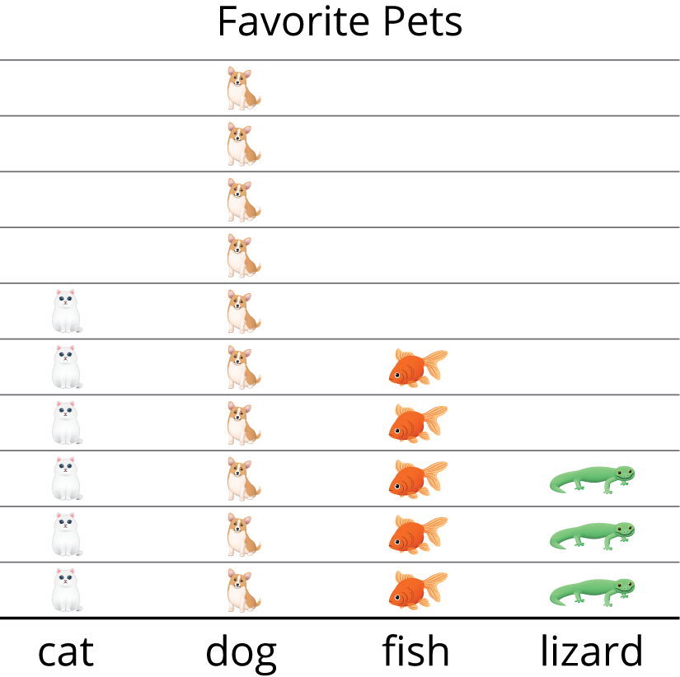
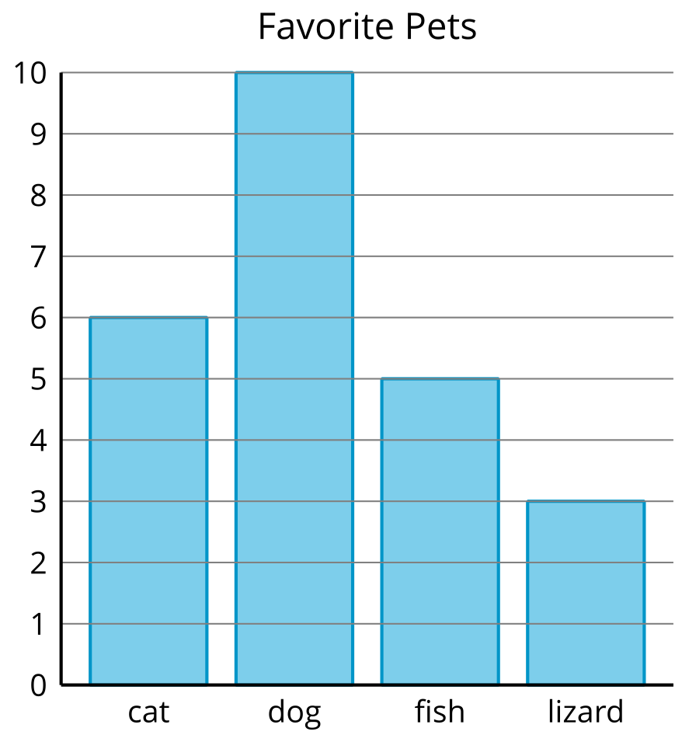
A picture graph shows data using pictures or symbols to represent how many are in each group or category.
A bar graph shows data about a group or category using the height and length of rectangles.
Answer the questions below.
- How many children picked a dog?
- How many more children picked cats than lizards?
- How many children voted?

