Lesson 13: Adding the Angles in a Triangle
Let’s explore angles in triangles.

13.1: Can You Draw It?
- Complete the table by drawing a triangle in each cell that has the properties listed for its column and row. If you think you cannot draw a triangle with those properties, write “impossible” in the cell.
- Share your drawings with a partner. Discuss your thinking. If you disagree, work to reach an agreement.
 | acute (all angles acute) | right (has a right angle) | obtuse (has an obtuse angle)
scalene (side lengths all different)

isosceles (at least two side lengthsare equal)

equilateral (three side lengths equal)

13.2: Find All Three
Your teacher will give you a card with a picture of a triangle.
- The measurement of one of the angles is labeled. Mentally estimate the measures of the other two angles.
- Find two other students with triangles congruent to yours but with a different angle labeled. Confirm that the triangles are congruent, that each card has a different angle labeled, and that the angle measures make sense.
- Enter the three angle measures for your triangle on the table your teacher has posted.

13.3: Tear It Up
Your teacher will give you a page with three sets of angles and a blank space. Cut out each set of three angles. Can you make a triangle from each set that has these same three angles?

Are you ready for more?
- Draw a quadrilateral. Cut it out, tear off its angles, and line them up. What do you notice?
- Repeat this for several more quadrilaterals. Do you have a conjecture about the angles?

Lesson 13 Summary
A ${180}^{∘}$ angle is called a straight angle because when it is made with two rays, they point in opposite directions and form a straight line.
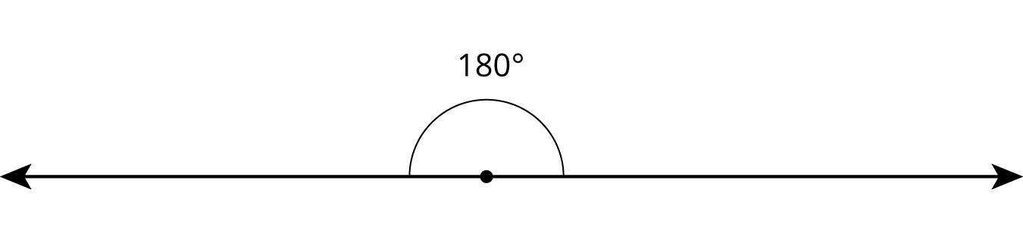
If we experiment with angles in a triangle, we find that the sum of the measures of the three angles in each triangle is ${180}^{∘}$—the same as a straight angle!
Through experimentation we find:
- If we add the three angles of a triangle physically by cutting them off and lining up the vertices and sides, then the three angles form a straight angle.
- If we have a line and two rays that form three angles added to make a straight angle, then there is a triangle with these three angles.
- 
© CC BY Open Up Resources. Adaptations CC BY IM.

