Unit 5 Lesson 1: Solids of Rotation

1 Which One Doesn’t Belong: Solids (Warm up)

Student Task Statement
Which one doesn’t belong?

A


B


C


D
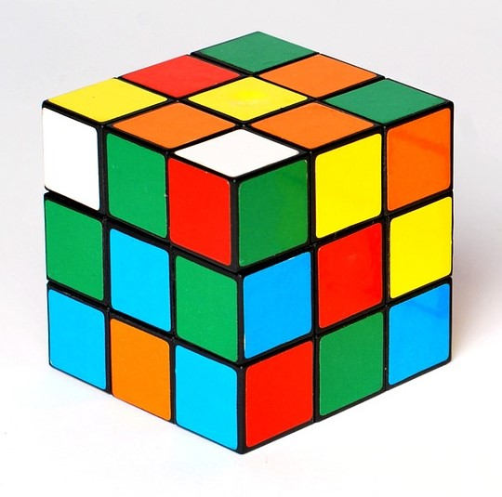

2 Axis of Rotation

Images for Launch
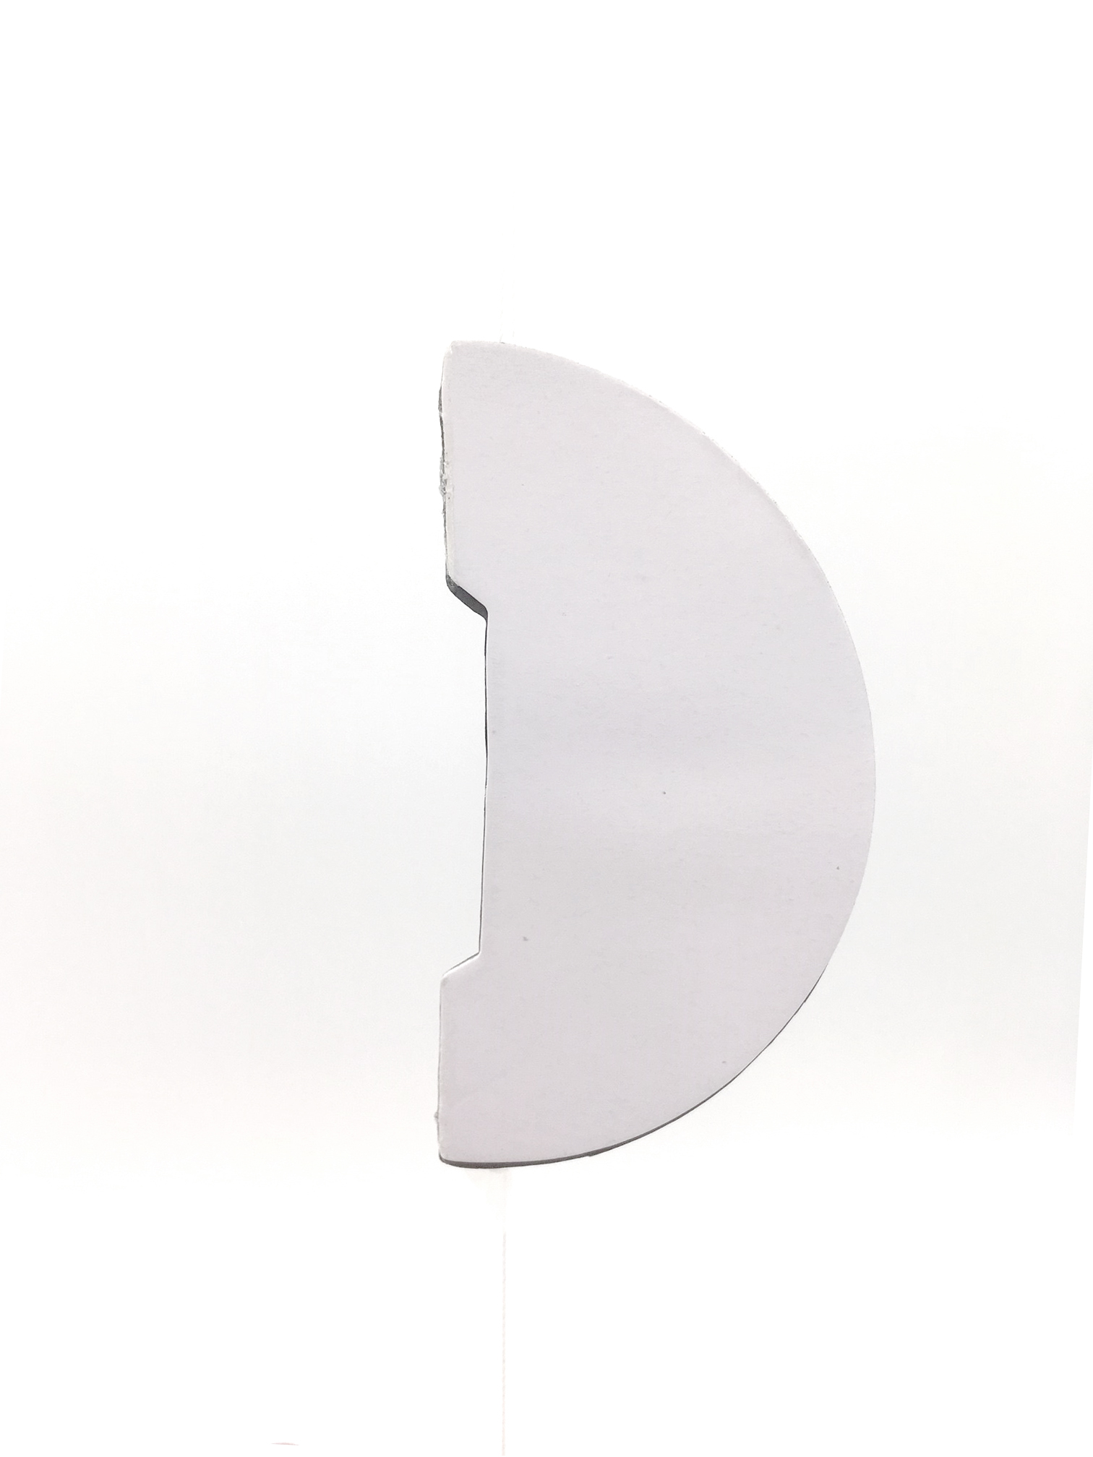
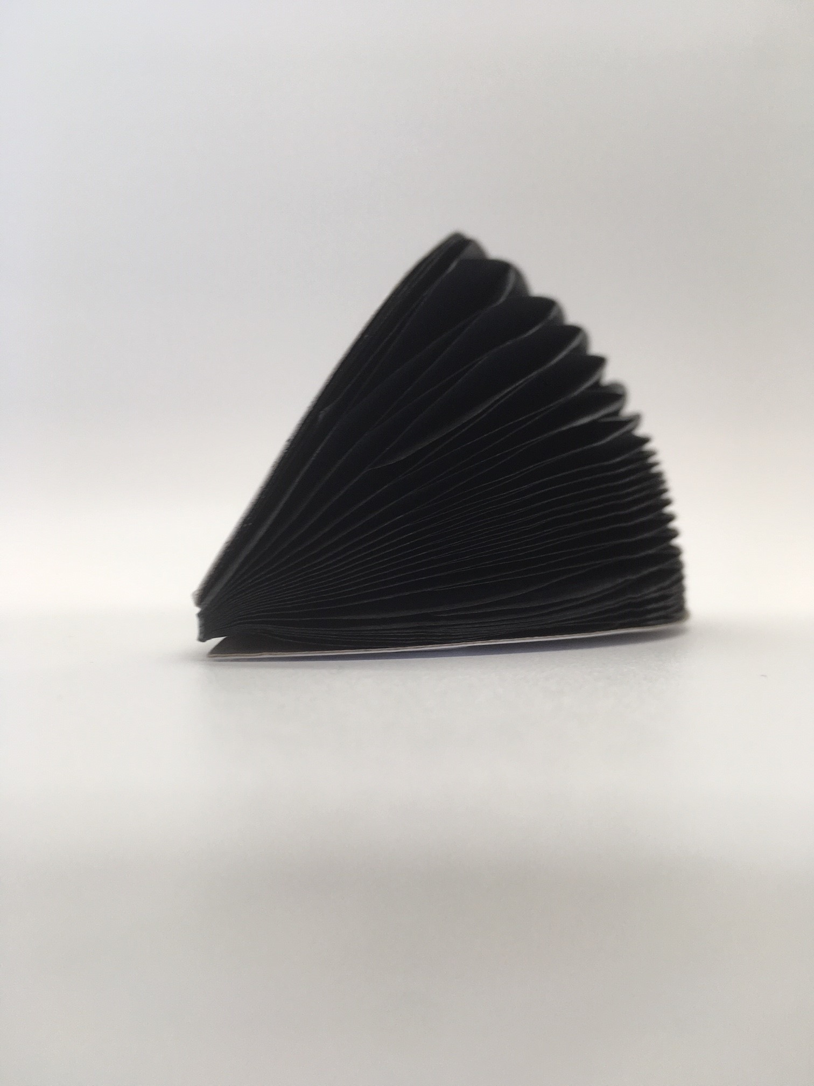
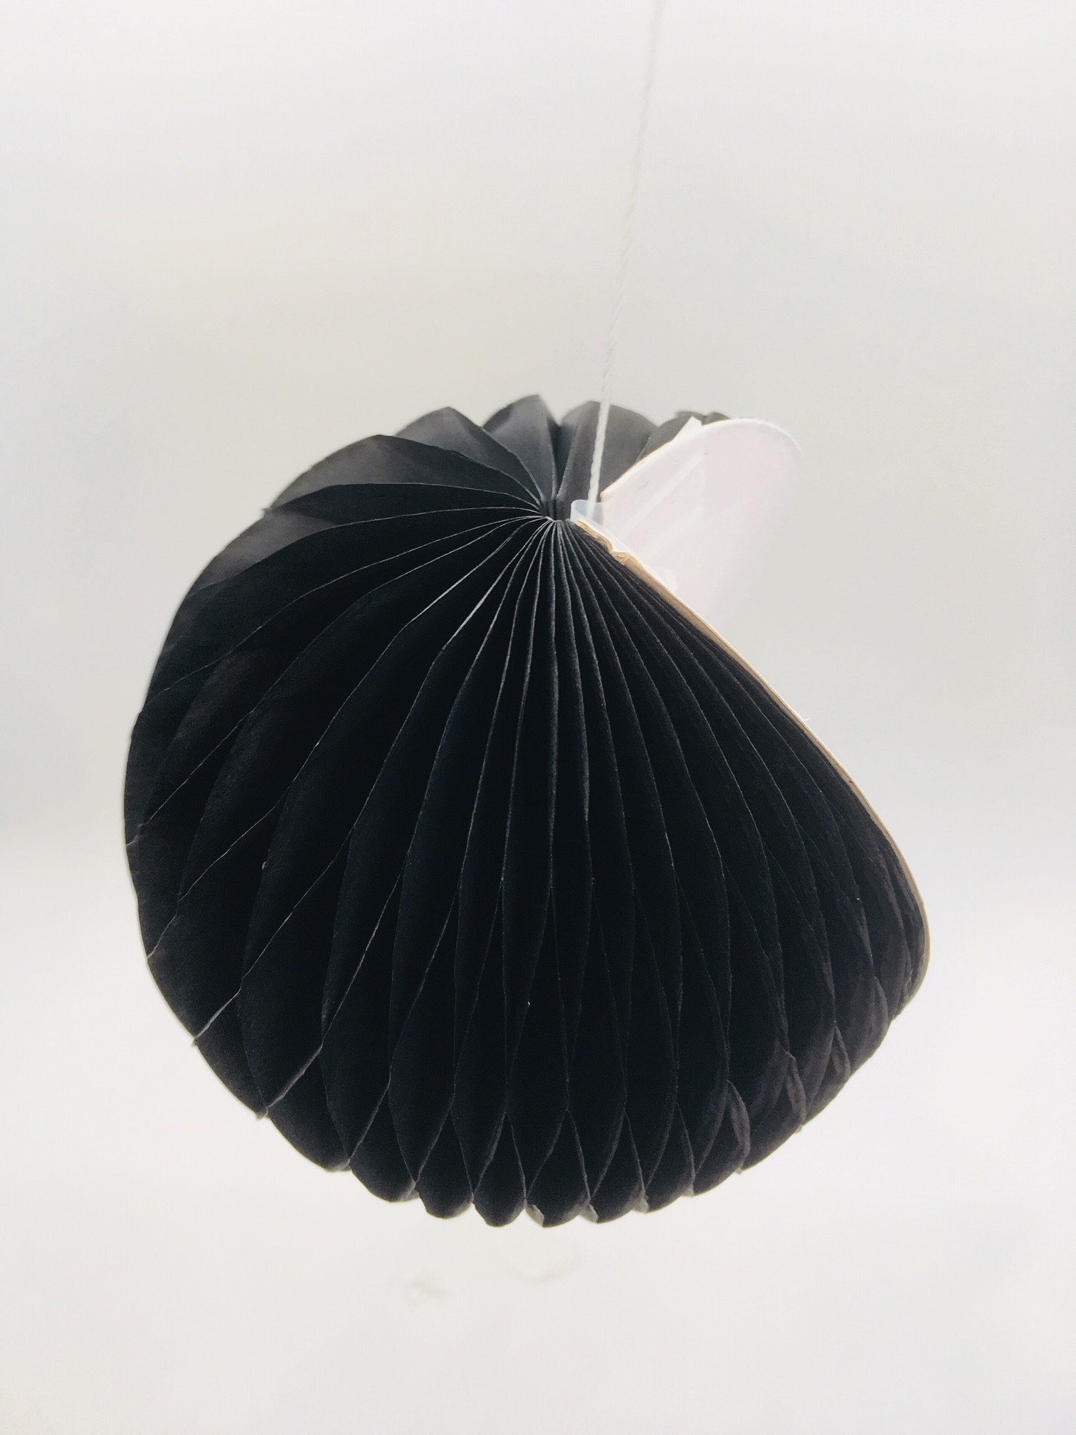
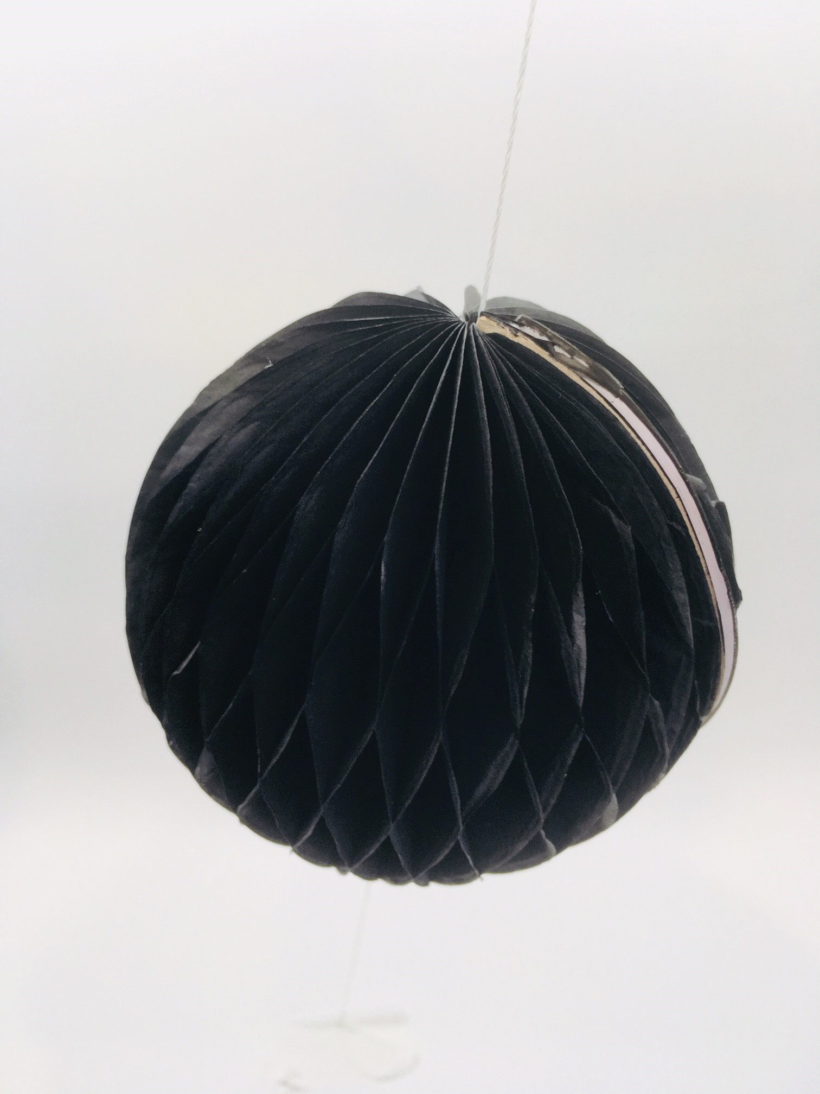

Student Task Statement
Your teacher will give you a shape. Tape 1 side of the shape to a pencil.
- Spin the pencil between your hands. What solid is traced out as you rotate the shape? Draw the solid.
- Predict what solids will be formed by the shapes of other members of your group. Confirm by asking them to rotate their shapes.

Activity Synthesis
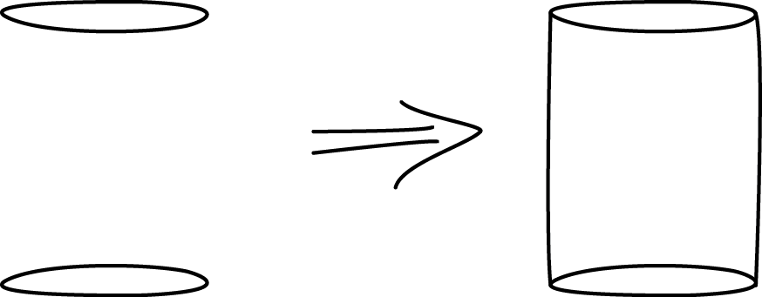
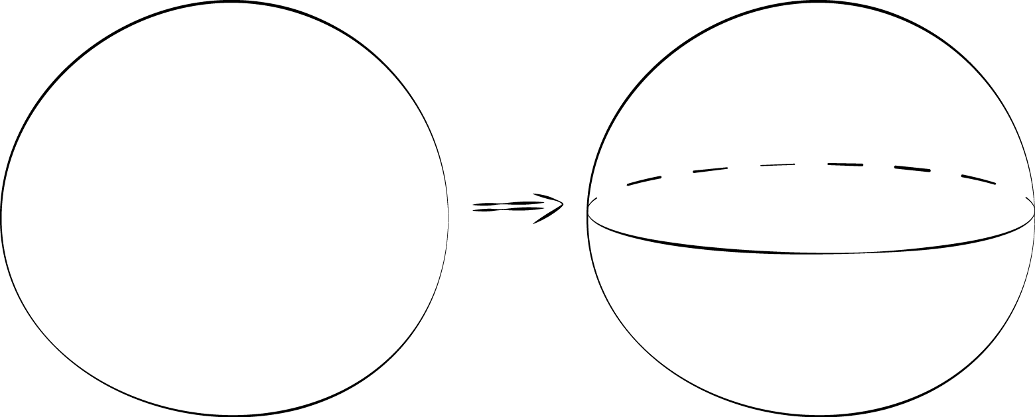
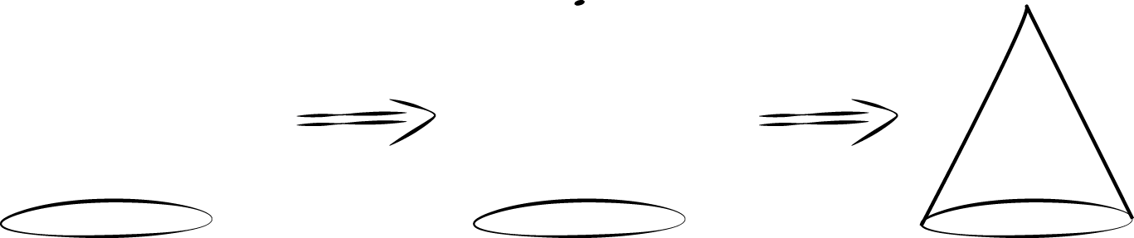

3 From Three Dimensions to Two

Student Task Statement
Draw the two-dimensional shape that, when rotated using the given axis of rotation, produces each solid of rotation. Ignore any non-symmetric aspects of the solid.




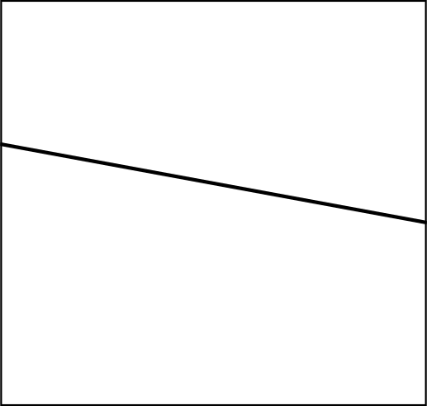


Images for Activity Synthesis
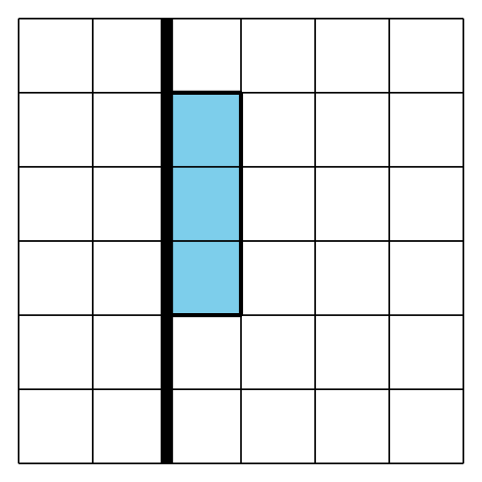
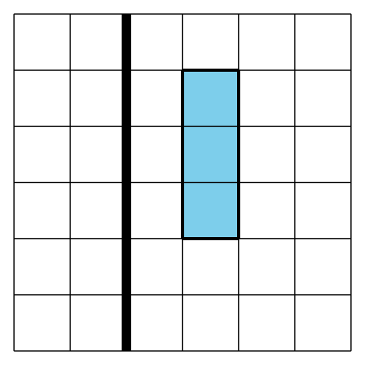
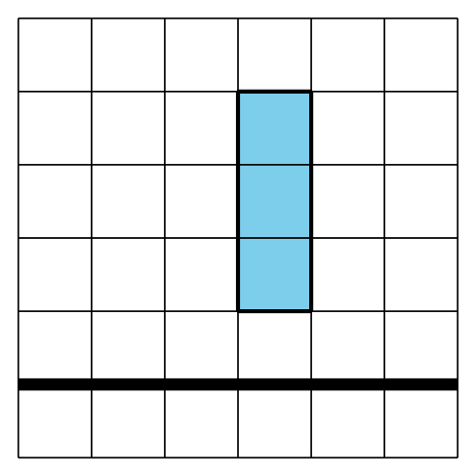
© CC BY 2019 by Illustrative Mathematics®

